**ECE6370 - ADVANCED DIGITAL DESIGN**

**ROM / RAM-based Random Prime Number Guessing Game with Multi-User Authentication, Timer Control, and Score Tracking On FPGA**

**Team SAPRK**

**Sai Chandana Vanam (2205753)**

**Praval Goud (2244585)**

**Akashara movva (2249970)**

**Rahul Verma (2251462)**

**Kavya Sree Gogadi (2199257**

**Contents**

**1.0. Introduction** 3

**2.0. System Architecture** 3

**2.1. Decoder_4to7** 5

**2.4. reset and clock signals** 6

**2.5. ButtonShaper** 6

**2.7. AccessController** 8

**2.8. RNG** 11

**2.9. LFSRbasedOnemsTimer** 12

**2.10.** **OneSecTimer** 13

**2.11. twoDigitTimer** 14

2.12. BCD Counter………………………………………………………………………………

2.13. Psuedo RNG……………………………………………………………………………..

2.14. Authentication……………………………………………………………………………

2.15. Password ID checking……………………………………………………………………

2.16. Password checking……………………………………………………………………….

2.17. Player Score………………………………………………………………………………

2.18. Reconfig Digit Timer…………………………………………………………………….

2.19. 3-digit Timer………………………………………………………………………………

**3.0. Simulation Results** 16

**3.1. Decoder_4to7** 16

**3.2. ButtonShaper** 18

**3.3. AccessController** 19

**3.4. Authentication** 19

**3.5. GameController** 20

**3.6. RNG** 20

**3.7. LFSRbasedOne ms Timer** 21

**3.8. OneSecTimer** 22

**3.9. twoDigitTimer** 22

**3.10. DigitTimer** 24

**3.11. BCD_Counter** 24

**3.12. Pseudo RNG………………………………………………………………………………………………….37**

**3.13. Score Tracking ……………………………………………………………………………………………..37**

3.14.PasswordChecking……………………………………………………………………………………………….38

3.15. ReconfigTimer…………………………………………………………………………………………………..38

3.16. ScoreBoard………………………………………………………………………………………………………39

**4.0. FPGA Board Testing** 40

**5.0. Video Demo** 42

**6.0. Conclusion** 42

**7.0.** **Appendix** 43

**1.0. Introduction:**

Welcome to the FPGA-based Prime Number Guessing Mental Math Binary Game, where mathematical prowess meets digital innovation for an engaging gaming experience. Before diving into the challenge, each player undergoes a thorough ID verification process, ensuring a secure and personalized gaming environment. With their unique IDs authenticated, players proceed to the second stage, where password verification guarantees authorized access to the game. Once inside, players are greeted with a timer prominently displayed on the FPGA board, signaling the commencement of the challenge. With a simple press of the "Game Start" button, the timer begins its countdown, setting the stage for mental agility and strategic thinking. The heart of the game lies in the selection of a random prime number, meticulously sourced from a ROM (Read-Only Memory) embedded within the FPGA system. This ROM houses a curated collection of prime numbers, categorized into different difficulty levels, ranging from 4 bits to 6 bits in width. With up to 97 prime numbers stored within, the ROM ensures a diverse and challenging gameplay experience. Players are tasked with accurately guessing the randomly selected prime number within three attempts, relying on intuitive clues provided by the system. Should a player falter in their guesses, the FPGA offers insightful feedback, indicating whether the guessed number is too large, too small, or simply incorrect. At the conclusion of each round, the scoreboard springs to life, displaying the player's score for that session. Additionally, for a sense of healthy competition, the global scoreboard showcases the highest score achieved among the five players. However, for guests entering the fray, only their individual scores are displayed, maintaining anonymity while fostering a spirit of friendly competition.

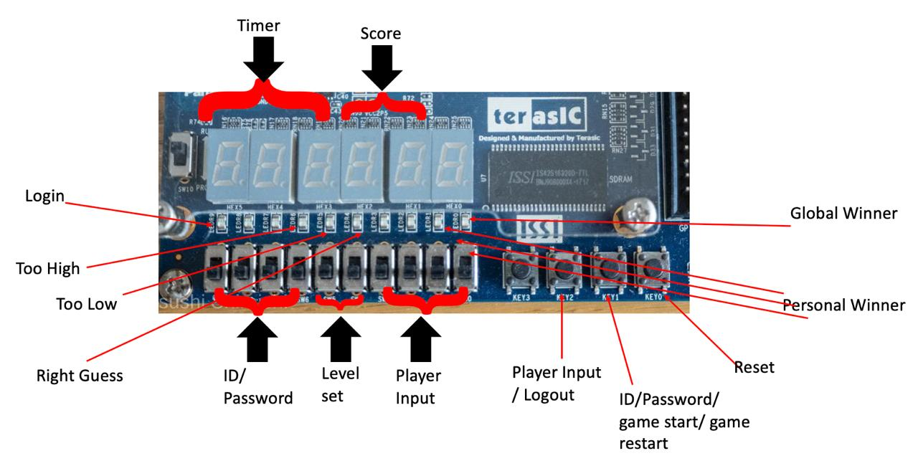

Figure 1.0.1. FPGA user interface.

**2.0. System Architecture Design:**

Image 2.0.1 shows the design's system architecture, which consists of 10 smaller modules. These modules handle different tasks like shaping buttons, controlling the game, tracking player scores, managing authentication and access, displaying scores on a scoreboard, running a timer, and generating random numbers.At the top level, the main module takes in seven inputs, including a clock signal and a reset signal. There are also inputs for players to enter numbers and a game creator to enter a password using slide switches. Another pair of switches set the game difficulty level. Additionally, there are three buttons with multiple functions: one for inputting numbers and logging out, one for entering ID/password and starting or resetting the game, and one for starting or restarting the game.

The main module produces 8 output signals. These include displays for showing player scores, global scores, and the timer. There are also LEDs indicating login status, whether a guessed number is too high, too low, or correct compared to a generated prime number. Two LEDs show if a player surpasses their personal best score or the overall best score.

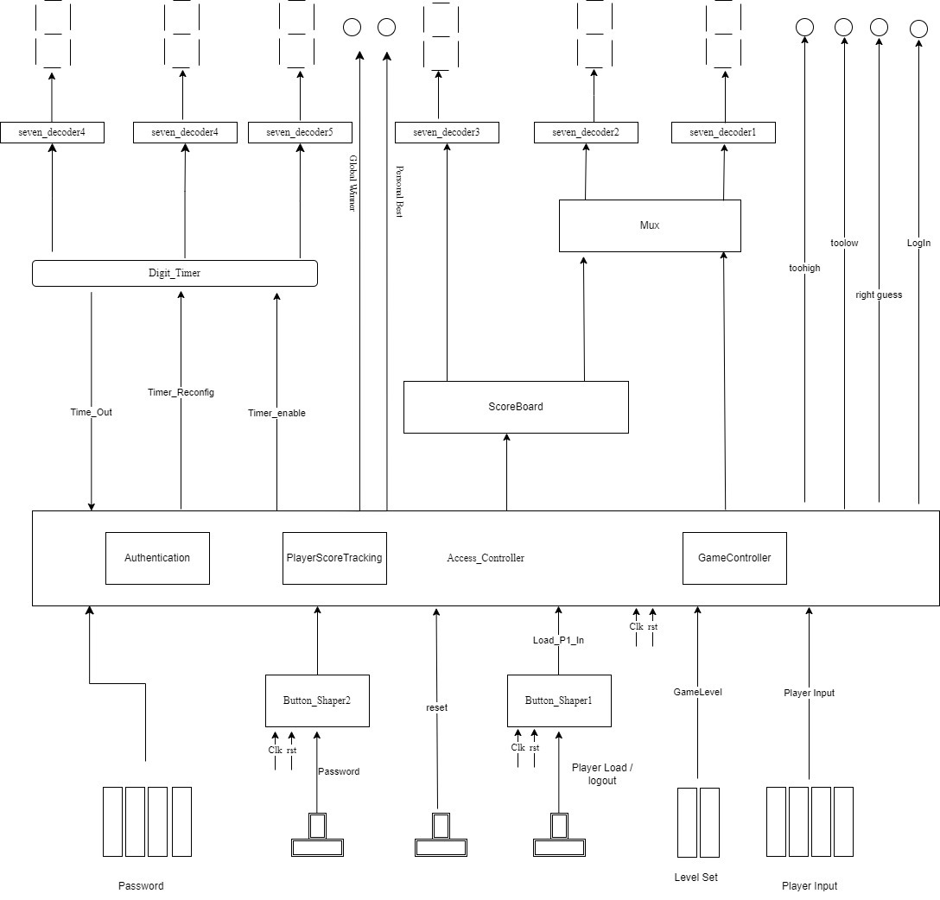

Figure 2.0.1. Top-level module

**Sub Modules:**

**2.1. Decoder_4to7:**

**Description:** This module is created to convert 4-bit binary inputs starting from 0000 to 1111 into 7-bit binary outputs to drive the 7 Segment Display Device to display hexadecimal value of the 4-bit binary inputs. Decoder output is entered manually by checking which segment would be ON/OFF (“0” for ON, “1” for OFF)

**Signals:**

1. decoder_in: Signal used to define 4-bit binary input.

2. decoder_out: Signal used to define 7-bit binary output.

**Symbol of the Module:**

Decoder_4to7

decoder_in decoder_out

Figure 2.1.1. Decoder_4to7 Module

Figure 2.1.1. Decoder_4to7 Module.

**Figure 2.1. Decoder_4to7**

**2.2. reset and clock signals:**

* The reset signal (rst) returns the system to its initial state, which is an active low signal.
* The clock signal (clk) triggers sequential logic at positive edges and has a frequency of 50MHz. This signal is necessary for synchronous sequential circuit.

**2.3. Button Shaper:**

**Description:** The FPGA we use has a frequency of roughly 50MHz, which is equivalent to 20ns per clock cycle. Given that humans are not fast enough to push and release the button within a clock cycle, each press may take hundreds of cycles, so transferring the original long low pulse signal from the push button to the load register would load the register multiple times, which is not practicable in terms of power usage. The button shaper module converts the original 1-bit signal from the push button into a 1-bit single cycle pulse, generating only one pulse for each push-release occurrence. Figure 2.3.1 shows the block diagram for the button shaper module.

**Signals:**

1. B_in: An active low, raw, lengthy, 1-bit input signal form the push button.  
2. B_out: This signal is a 1-bit single pulse with active high state, produced by the ButtonShaper module in response to each push-release operation.

rst

ButtonShaper

B_in B_out

clk

Figure 2.3.1. ButtonShaper module.

The finite state machine illustrates the state changes occurring within the module, as depicted in Figure 2.3.2.

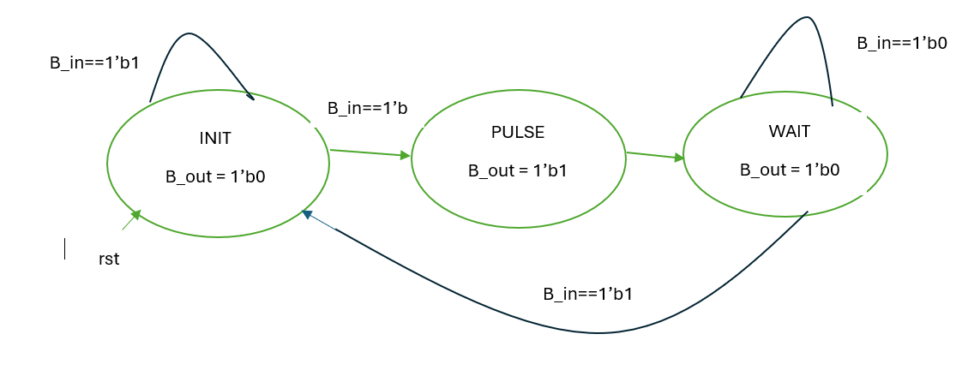

Figure 2.3.2. Button Shaper FSM.

The diagram above illustrates that the button shaper has three states.

1. INIT: The initial state of the module is characterized by low output as long as B_in is high. The state transitions to the PULSE state when the button is pushed when B_in is low.  
2. PULSE: B_out is asserted to high during the precise one clock cycle that the module remains in PULSE. After that, the B_out is pushed down to low, and the state transitions to WAIT.  
3. WAIT: WAIT state maintains B_out at a low level even when the button is pressed after the pulse signal is produced. The module remains in this state until B_in returns to a high level, at which point it reverts to the INIT state.

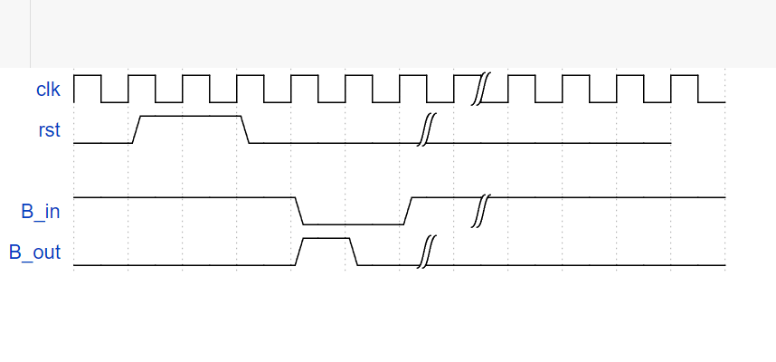

Figure 2.3.3. Expected Timing Diagram

The time diagram for the button shaper module can be seen in Figure 2.5.3. Each time a push-release move is done, we expect to get a single pulse signal. After the pulse is made and until B_in is claimed again, we also plan to keep B_out low.

## **2.4. Access Controller:**

**Description: Access Controller**

AccessController module serves as a vital component within the gaming system, responsible for managing player access, game level selection, and score tracking.

**Inputs and Outputs**

**Inputs:**

**PasswdEnter**: Signal indicating the entry of a new digit of the player's password.

**Load_p_in**: Signal indicating the loading of player information.

**Timeout**: Signal indicating a timeout event.

**clk**: Clock signal for synchronous operation.

**rst**: Reset signal for initializing the module.

**PasswdDigit**: Four-bit signal representing the digit of the password entered.

**GameLevel**: Two-bit signal representing the selected game level.

**Player_in**: Eight-bit signal representing player information.

**Outputs:**

**LogIn**: Signal indicating whether the player is successfully logged in.

**Pulse_in_ScoreBoard**: Signal to pulse the scoreboard for score display.

**Timer_reconfig**: Signal to reconfigure the timer.

**Timer_enable**: Signal to enable the timer.

**rightGuess**, **tooHigh**, **tooLow**: Signals indicating the correctness of the player's guess.

**isPersonal_Winner**, **isGlobal_Winner**: Signals indicating whether the player is a personal or global winner.

**LoadDigitValue_Ones**, **LoadDigitValue_Tens**, **LoadDigitValue_Hund**: Four-bit signals representing the digit values for loading player information.

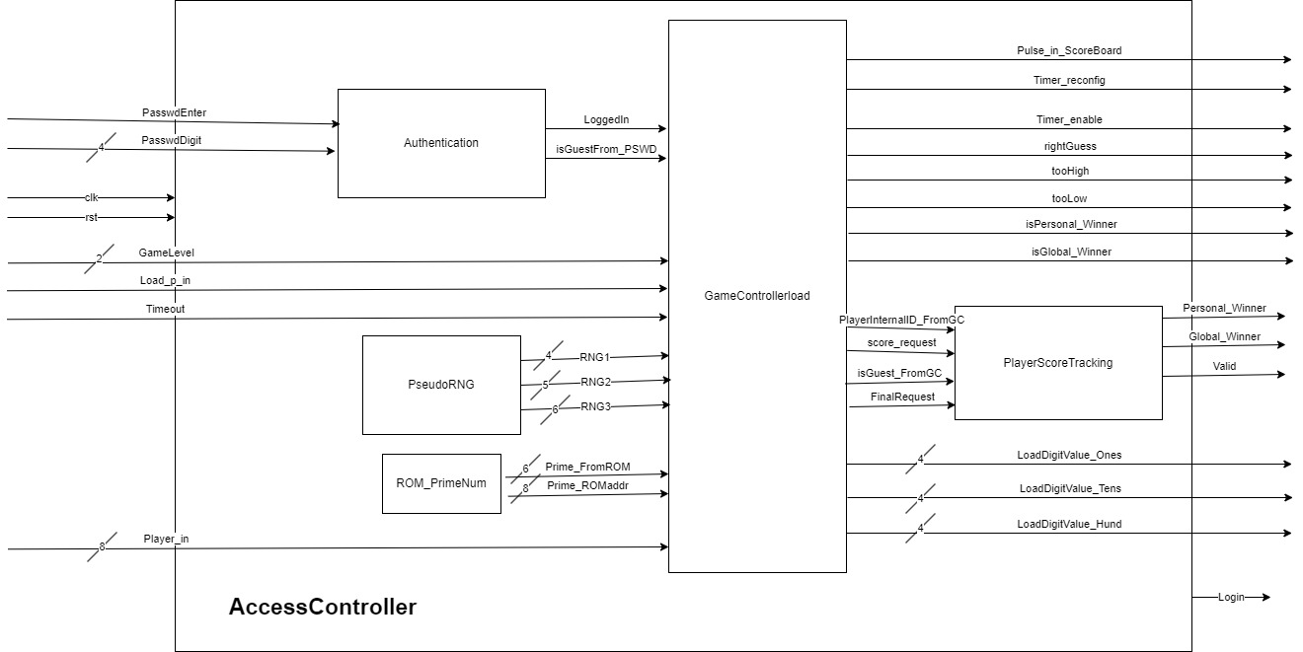

Figure 2.4.1. AccessController module.

**2.5 Game Controller**

The GameController module serves as the core component responsible for managing game operations, player interactions, and score tracking within the gaming system. Its seamless integration of game logic, pseudo-random number generation, and ROM access ensures a compelling and engaging gaming experience for players.

**Inputs and Outputs**

* **Inputs:**
  + **PasswdEnter**: Signal indicating the entry of a new digit of the player's password.
  + **GameLevel**: Two-bit signal representing the selected game level.
  + **Player_in**: Eight-bit signal representing player information.
  + **Load_p_in**: Signal indicating the loading of player information.
  + **LoggedIn**: Signal indicating whether the player is successfully logged in.
  + **PlayerInternalID_FromPSWD**: Three-bit signal representing the internal ID of the player obtained during password authentication.
  + **isGuest_FromPSWD**: Signal indicating whether the player identified during password authentication is a guest.
  + **Timeout**: Signal indicating a timeout event.
  + **clk**: Clock signal for synchronous operation.
  + **rst**: Reset signal for initializing the module.
  + **valid**: Signal indicating the validity of the game state.
  + **Personal_Winner**, **Global_Winner**: Signals indicating whether the player is a personal or global winner.
* **Outputs:**
  + **Pulse_in_ScoreBoard**: Signal to pulse the scoreboard for score display.
  + **Timer_reconfig**: Signal to reconfigure the timer.
  + **Timer_enable**: Signal to enable the timer.
  + **rightGuess**, **tooHigh**, **tooLow**: Signals indicating the correctness of the player's guess.
  + **score_request**: Signal requesting the player's score.
  + **isGuest_FromGC**: Signal indicating whether the player identified by the game controller is a guest.
  + **isPersonal_Winner**, **isGlobal_Winner**: Signals indicating whether the player is a personal or global winner.
  + **Logout_FromGC**: Signal indicating a logout request from the game controller.
  + **LoadDigitValue_Ones**, **LoadDigitValue_Tens**, **LoadDigitValue_Hund**: Four-bit signals representing the digit values for loading player information.
  + **PlayerInternalID_FromGC**: Three-bit signal representing the internal ID of the player obtained from the game controller.
  + **FinalScore**: Eight-bit signal representing the player's final score.

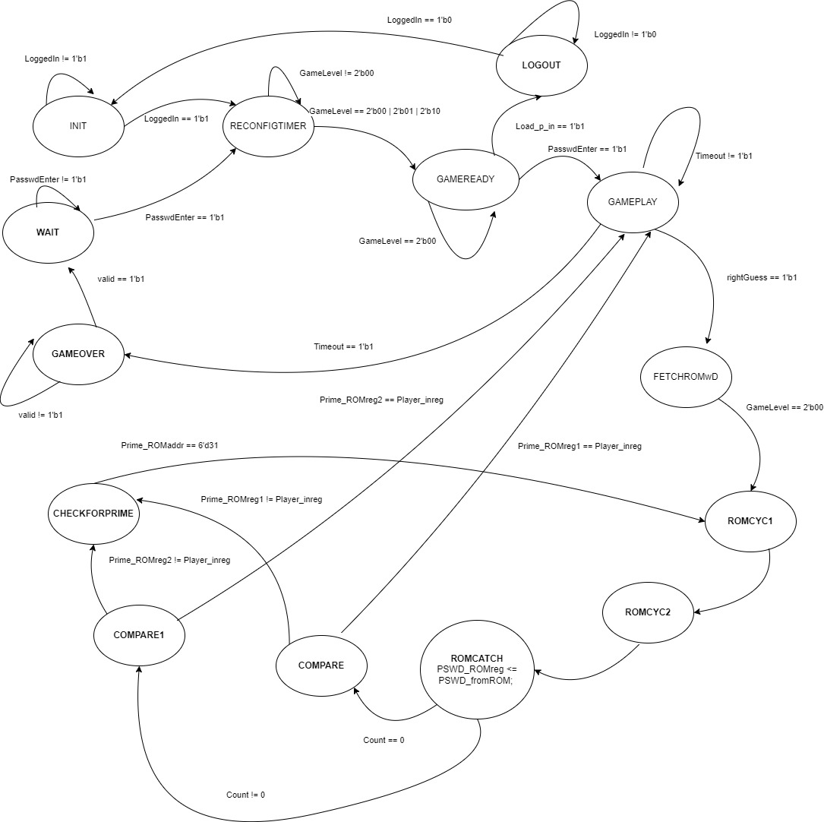

Figure 2.5.1. GameController FSM.

## **2.6. RNG:**

**Description:** This module produces a random number. The random number generator operates based on a 4-bit LFSRbasedCounter module that begins counting from 15 which is the default value of the counter, when the enable (Count) signal is high, as depicted in figure 2.6.1. The counter module receives the inverted long raw signal from a push-button (RNG push button) as the enable signal. Therefore, the duration of the push determines the final value of the counter, which serves as the random number. The consecutive numbers of a LFSRbasedCounter are not same as regular 4-bit counter, you’ll get different sequence form the regular sequence which makes the LFSRbasedCounter to generate more randomness at the output.

**Signals:**

1. Aside from clk and rst, this module has one input.

2. RNG_Gen: This is a long active low signal that comes from the RNG push button and is a 1-bit raw input signal.

3. Random Num: This is a 4-bit binary number produced by the LFSRbasedCounter within the RNG module. This numerical value is exhibited on the 7-segment display.

## **2.7. LFSR based One ms Timer:**

**Description:** The LFSR based One ms Timer module generates a pulse that has a duration of one clock cycle and occurs every 1ms. Figure 2.7.1 illustrates that the module consists of three inputs: Count, clk, and rst. It also has one output, LFSRTimeout. This module functions as a straightforward counter that increments by 50,000 units for every 1ms of time. However, as this module was created using the Linear Feedback Shift Register (LFSR) method, the terminal value is 16'hA168.

LFSRbasedOnemsTimer

rst LFSRTimeout

Count

clk

Figure 2.7.1. LFSRbasedOnemsTimer module.

**Signals:**

1. Aside from clk and rst, this module has one input.

2. Count: This signal is level-triggered and will initiate and maintain the operation of the counter as long as the signal remains high.

3. LFSRTimeout: The system produces a single output signal called LFSRTimeout. This is a single cycle pulse that occurs every 1ms.

## **2.8. OneSecTimer:**

**Description:** The one-second timer module produces a single cycle pulse at intervals of 1 second. Figure 2.8.1 illustrates the presence of three submodules: LFSRbasedOnemsTimer, countTo100, and countTo10. These submodules can be described as counters that have terminal values of 16'hA168, 100, and 10, respectively. Additionally, these submodules provide a timeout signal which is a single cycle pulse that is generated for each terminal value they produce. The Timeout signal serves the purpose of activating the subsequent module, ultimately resulting in the generation of a One Second Timeout signal for each passing second.

**Signals:**

1. clk: This clock signal runs at 50MHZ frequency, triggers the sequential logic at every positive edge of the clock.

2. rst: Reset is an active low signal, when active resets the modules to its initial stage.

3. enable: Enable is an active high signal, when active triggers the counter to start running until the enable signal stays active.

4. OneSec_Timeout: This is a single cycle pulse signal generated for every second within the duration of 50 million clock cycles.

**Symbol of the Module:**

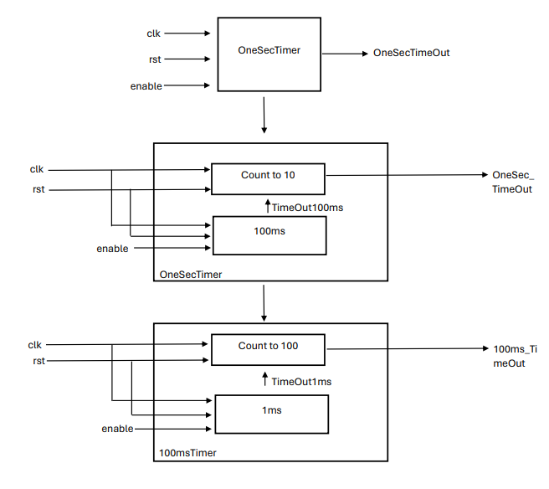

Figure 2.8.1. OneSecTimer module.

## **2.9. twoDigitTimer:**

**Description:** The twoDigitTimer module is a countdown timer that starts at 99 and decreases by one every second until it reaches 0. The underlying concept of this module is a one-second timer that generates a pulse every second. This pulse is then sent to a ones-digit timer, which counts down from 9 to 0 for each pulse it receives. Once the ones-digit timer reaches 0, it sends a pulse to the tens-digit timer. This process continues until both digits reach 0, at which point the timeout signal is activated, indicating that the game is over. Figure 2.9.1. below displays the twoDigitTimer.

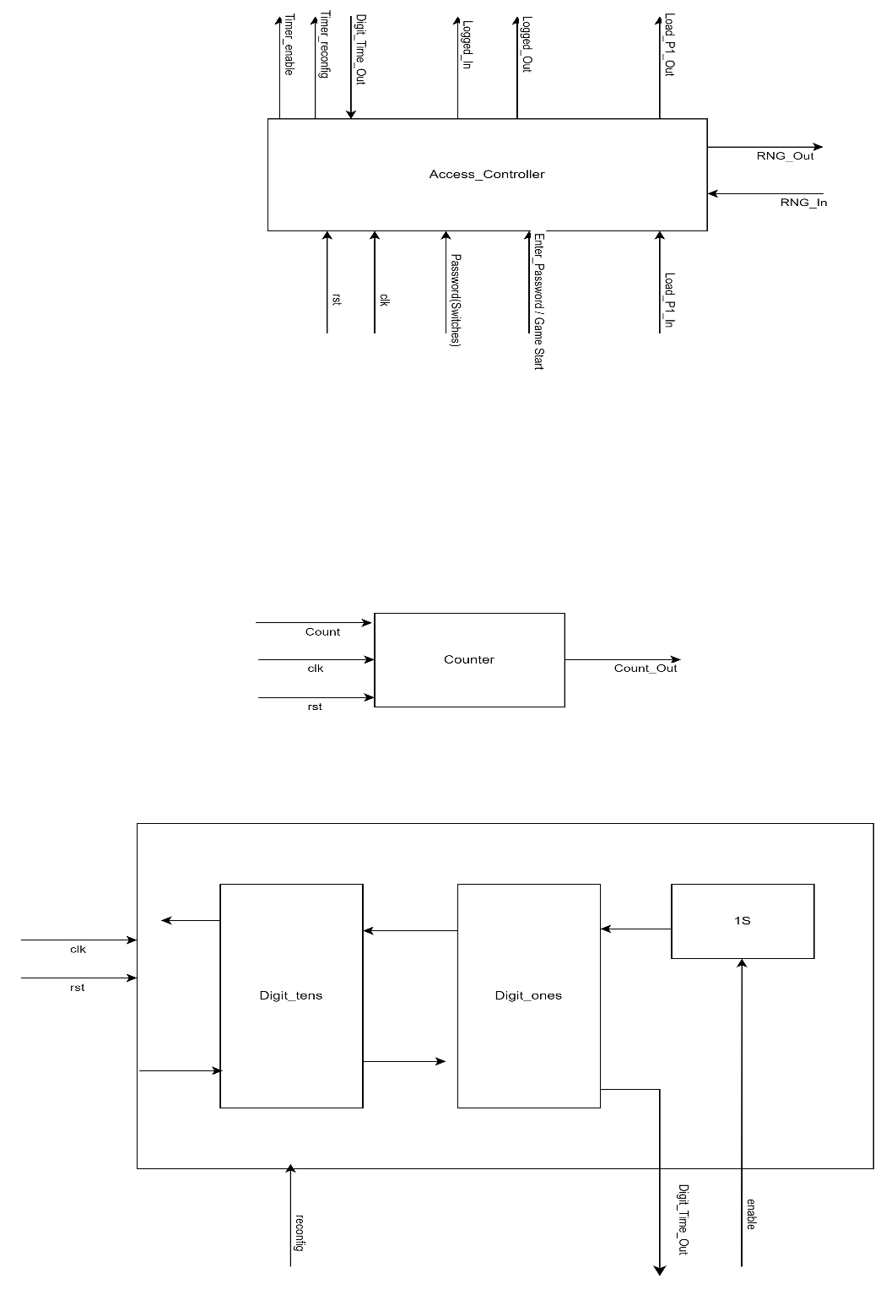

Figure 2.9.1. twoDigitTimer module.

**Signals:**

1. This module contains two more inputs, in addition to clk and rst.  
2. Timer_enable: This is a single-bit input signal originating from the AccessController module. It is set to a high state when the game starts and transitions to a low state when the timer expires.  
3. Timer_reconfig: This is a 1-bit single-cycle pulse from AccessController that sets the timer's digits to 99 so that it is ready to count down when the game begins.

Three signals that are output:

4. Digit_Ones & Digit_Tens: These are 4-bit binary numbers produced by the two DigitTimer modules contained within the twoDigitTimer module. The seven-segment displays shows these numbers.  
5. Timeout: This signal is a single bit that is set to a high state when the digits reach 00 and the timer stops operation.

**2.10. BCD_Counter:**

**Description:** The BCD_Counter module maintains a record of the player's count of correct responses. The BCD_Counter contains a logic of counter that increments from 0 to 9. It has two 4-bit outputs that increment whenever the player "Load_p_out"/Pulse_in is high and the sum is equal to 0xF. Figure 2.12.1 displays the scoreboard module. When “Timer_reconfig”/reconfig is high two output numbers display “0”.

Pulse_in

BCD_Counter

Sum BCD_Ones

reconfig BCD_Tens

clk

rst

Figure 2.12.1. BCD_Counter module.

**Signals:**

1. This module contains three more inputs, excluding clk and rst:  
2. Sum: This is a signal with a 4-bit input that is received from the Adder_4 module. This is used to check if the player's entered number is correct.  
3. Pulse_in: This is a 1-bit pulse signal. When it is high, the output of BCD_Ones increases by 1 when the Sum is F. Additionally, when BCD_Ones reaches 9, it becomes 0 and the BCD_Tens starts to increase by 1.  
4. reconfig: This is a single-bit pulse signal that will reset the digits on the BCD_Ones and BCD_Tens to 00, preparing the scoreboard for counting when the game starts.  
The system produces two output signals:   
5. BCD_Ones and BCD_Tens. The BCD_Counter module generates two 4-bit binary numbers. The 7-segment displays show these numbers.

**2.11. Pseudo RNG Generator**

The random number generator (RNG) works all the time, constantly producing a sequence of 16-bit numbers. Every time the clock ticks, it creates a new set of random numbers: a 4-bit one called RNG1, a 5-bit one called RNG2, and a 6-bit one called RNG3. You can use these numbers whenever you want by pressing the RNG input button.

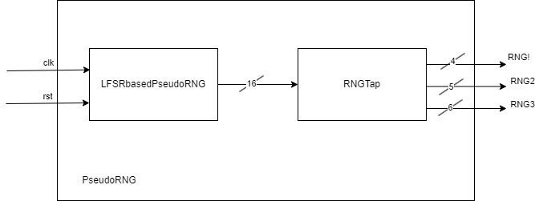

Figure2.11. Pseudo RNG Generator

**2.12 Authentication**

This module is responsible for two step verification of the player. This internally has 4 daughter modules of which 2 are ROMs for storing the ID and Password for each player, the other 2 are IDcheck (for checking the player enterd ID with the ID stored in the ROM_ID) and Pswdcheck (for checking the player entered password with the password stored in the PSWD).

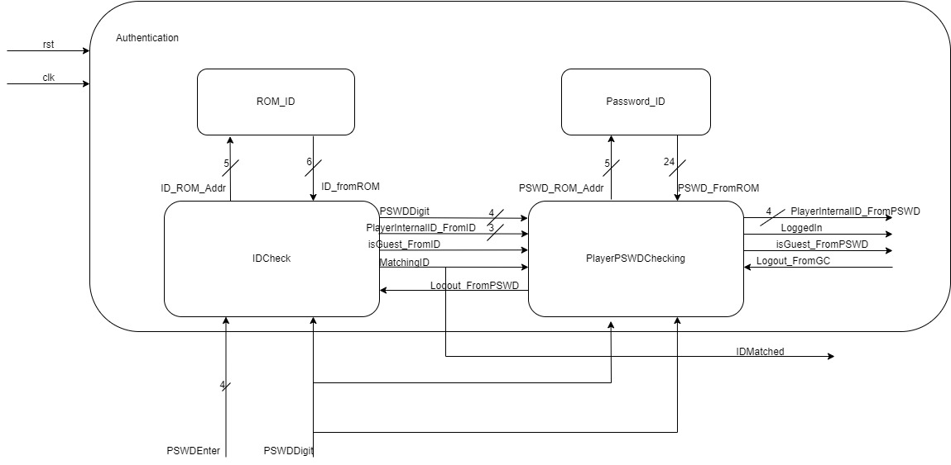

Figure 2.12. Authentication

**2.13. Player ID Checking**

The **PlayerIDChecking** module plays a critical role in ensuring secure access to the system by verifying player identification. The module is designed to manage the process of verifying player identification against a stored ID in ROM (Read-Only Memory). It operates as a finite state machine (FSM), transitioning through various states to handle user input, ROM access, ID comparison, and guest ID identification. This module is crucial for ensuring secure access to the system and determining whether a player is a guest.

**Inputs**

* **IDEnter**: Signal indicating the entry of a new digit of the player's ID.
* **Logout**: Signal indicating the player's request to log out.
* **clk**: Clock signal for synchronous operation.
* **rst**: Reset signal for initializing the module.

**Outputs**

* **ID_ROM_Addr**: Address output for ROM access.
* **MatchingID**: Signal indicating whether the entered ID matches the stored ID.
* **isGuest**: Signal indicating whether the player is identified as a guest.
* **PlayerInternalID**: Internal ID assigned to the player.

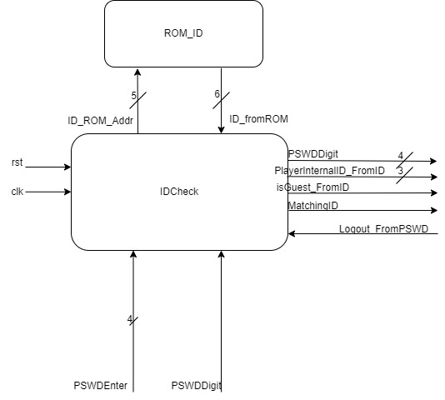

Figure 2.13.1 Block Diagram

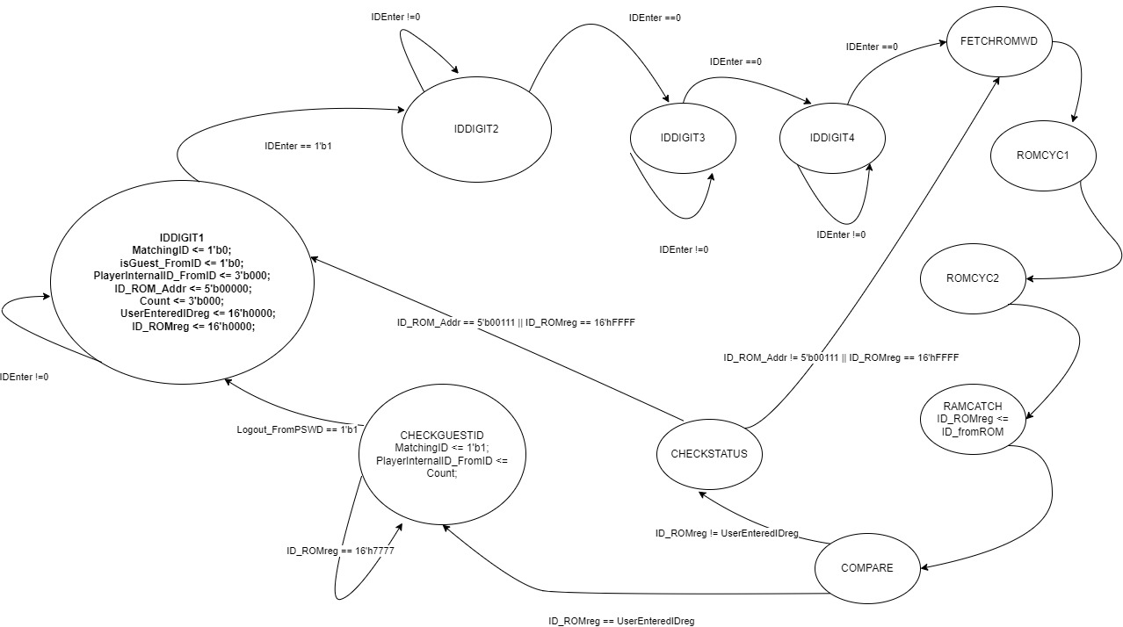

2.13.2. FSM Design

**2.14. Password Checking**

The **PlayerPSWDChecking** module manages the process of verifying a player's password (PSWD) against a stored password in ROM (Read-Only Memory). It facilitates secure access to the system and controls player authentication. This module operates as a finite state machine (FSM), transitioning through various states to handle PSWD entry, ROM access, PSWD comparison, and logout requests.

**Inputs**

* **PSWDEnter**: Signal indicating the entry of a new digit of the player's password.
* **MatchingID**: Signal indicating whether the entered ID matches the stored ID.
* **isGuest_FromID**: Signal indicating whether the player identified from the ID is a guest.
* **Logout_FromGC**: Signal indicating the player's logout request from the game controller.
* **PSWDDigit**: Four-bit signal representing the digit of the password entered.
* **PlayerInternalID_FromID**: Three-bit signal representing the internal ID of the player obtained from the ID check.
* **PSWD_fromROM**: 24-bit signal representing the password read from ROM.

**Outputs**

* **PSWD_ROM_Addr**: Five-bit signal representing the address for ROM access during PSWD verification.
* **LoggedIn**: Signal indicating whether the player is successfully logged in.
* **Logout_FromPSWD**: Signal indicating a logout request due to failed PSWD check or from the player.
* **isGuest_FromPSWD**: Signal indicating whether the player is identified as a guest during PSWD verification.
* **PlayerInternalID_FromPSWD**: Three-bit signal representing the internal ID of the player obtained from the PSWD check.

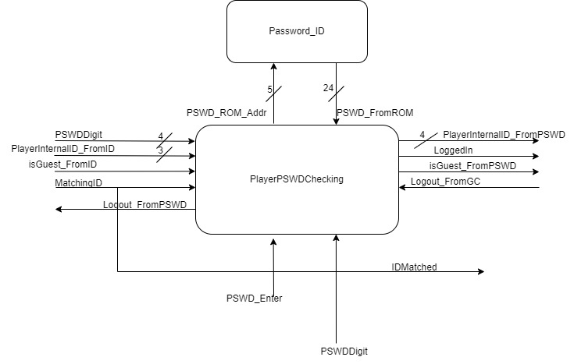

Figure 2.14.1 Player PSWD Checking Block Diagram

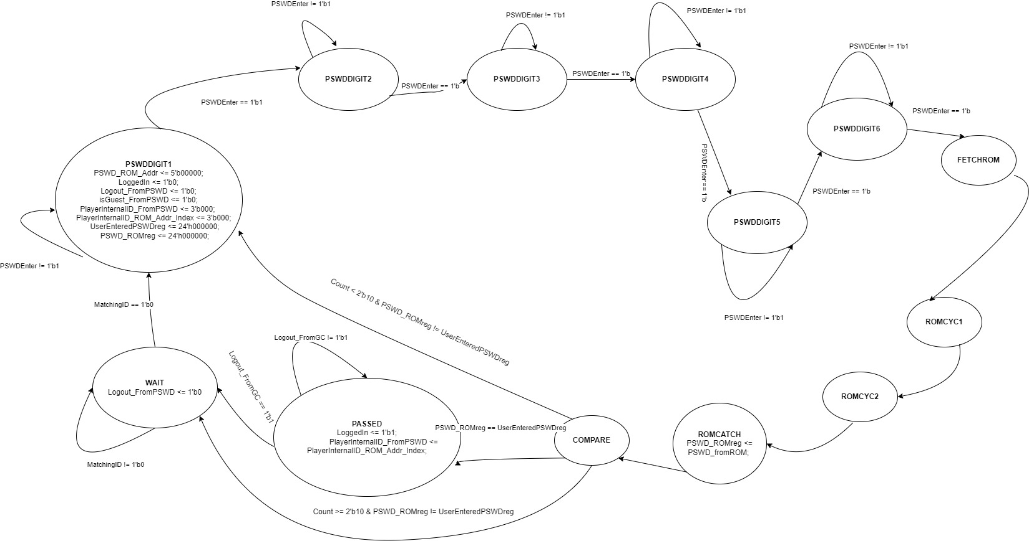

Figure 2.14.2 Player PSWD Checking FSM

**2.15. PlayerScoreTracking Module**

**Description**: This module has two daughter modules namely the RAM_Score module and the ScoreTracking module, which helps in tracking the personal best score, the best score in the team.

* **RAM_ScoreTrack** stores the scores of the players with a 7-bit data buses (Score_RAMdata_out and Score_RAMdata_in) and address bus of 5 bit (Score_RAMaddr). The Score_write_enb signal goes high whenever data is being written to RAM.
* In **ScoreTracking** module it gives out the Global_WinnerScore(6bits), PersonalBestScore which is Score_RAMdatareg-6bits to the multiplexers through a BinarytoBCD converter module so that they can be displayed on seven segment displays. Global_WinnerID(4bits), is directly given as an input to mux to be displayed.
* Personal_Winner, Global_Winner, and valid are sent to the game controller module as signals to indicate if the player has achieved their personal best or the highest score among all the players i.e., global winner. The valid bit is sent as a check signal to the game controller, which helps the game controller determine if it is valid data from the ScoreTracking module.
* It receives Score(6bits), score_request from the game_controller module.
* The isGuest, PlayerInternaID(3bits) come from the Access Controller module indicating if the player is a guest (isGuest going high) and the Internal Player ID from the Access Controller.

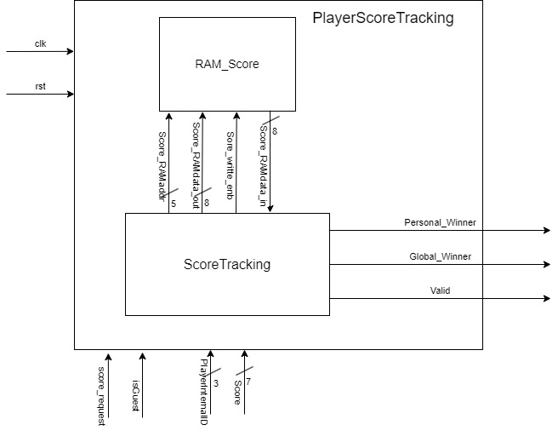Figure 2.15.1. Score tracking Module Block Diagram

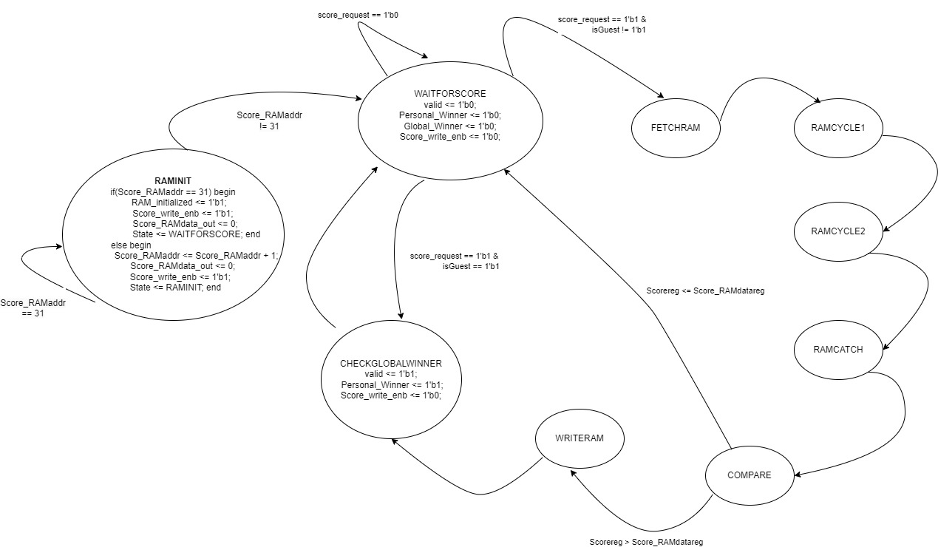

Figure 2.15.2. Score tracking FSM

**Signals**

1. Clk: This clock signal runs at 50MHZ frequency, triggers the sequential logic at every positive edge of the clock.
2. Rst: Reset is an active low signal, when active resets the modules to its initial stage.
3. Score_request: This a signal it receives from the game controller module to request the player score.
4. isGuest: This is a signal which this module receives from the game controller to know whether the player is a guest or not.
5. PlayerInternalID: It is 3 3-bit signal which is the player ID in order to keep track of his score.
6. Score: This is a 7-bit signal received from the game controller to update the score in our ROM.
7. Personal_Winner: This is the output signal to let the game controller know if it is a personal best score of the player or not.
8. Global_Winner: This is the output signal to let the game controller know if it is the global best score of all the players or not.
9. Global_WinnerScore: It is a 7-bit signal giving out the best score among all the players listed.
10. Global_WinnerID: It is a 3-bit output signal giving out the ID of player with the global best score.
11. Valid: The valid bit is sent as a check signal to the game controller, which helps the game controller determine if it is valid data from the ScoreTracking module.
12. Score_RAMdatareg: This signal gives out the personal best score if requested.

**2.16. Reconfig DigitTimer**

**Description**: This is the Digit Timer Reconfiguration module. When the digit is "0" it borrows from upstream and becomes 9 only if it can borrow from upstream. This only happens when the digit in upstream is greater than 0 otherwise a timeout signal is sent to the access controller to stop the 1SecTimer by disabling the 1SecTimer

* It has the enable signal to set the digit time to its start value, "9".
* When it reaches ‘0’, it borrows from upstream and becomes 9.
* If there is NoBorrow signal from upstream it means we won’t be able to borrow.

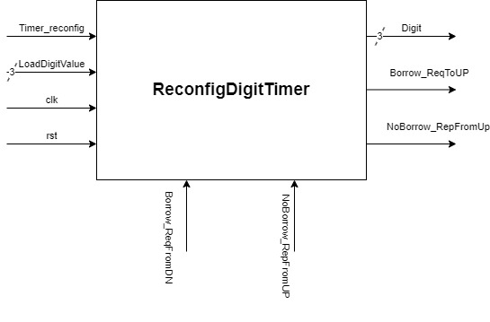

Figure 2.16.1 Reconfig DigitTimer

**Signals:**

1. **Clk**: This clock signal runs at 50MHZ frequency, and triggers the sequential logic at every positive edge of the clock.
2. **Rst**: Reset is an active low signal when active resets the modules to its initial stage.
3. **Borrow_ReqFromDN:** This is an input signal requesting for the borrow from the upstream.
4. **NoBorrow_RepFromUP:** This is an input signal for the no-borrow reply from the upstream.
5. **Borrow_ReqToUP:** This is an output signal for the borrow request that was made.
6. **NoBorrow_RepToDN:** This is an output signal from the upstream saying there is no borrow available.
7. **Digit**: It is a 4-bit output signal updating its value 9 to 0.

**2.17. 3-digit Timer:**

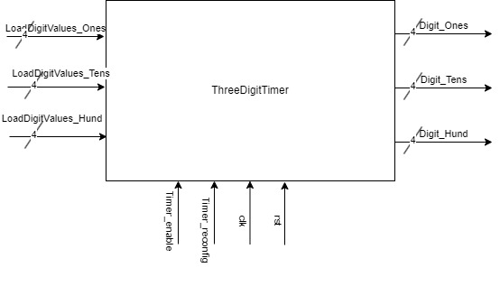

**Figure 2.17.1 3-digit Timer**

**Signal Names and Working:**

**Timer_enable, Timer_reconfig:**

Timer_enable: When asserted, it enables the timer to start counting.

Timer_reconfig: Asserting this signal triggers the reconfiguration of the timer's values.

**LoadDigitValue_Ones, LoadDigitValue_Tens, LoadDigitValue_Hund:**

These inputs determine the values to be loaded into the ones, tens, and hundreds place of the timer's digit during reconfiguration.

**clk, rst:**

clk: Represents the clock signal used for synchronization and timing. rst: The reset signal initializes the system to a known state.

**Digit_Ones, Digit_Tens, Digit_Hund:**

Outputs representing the current values in the ones, tens, and hundreds place of the timer's digit.

**Timeout:**

This output signal indicates when a timeout occurs, marking the end of a specific time interval. Internal wires:

These wires are used for timing control and signaling for borrowing operations between digit places, ensuring accurate countdown behavior.

**Simulation Explanation**

In a simulation, we aim to observe how the system behaves over time under different conditions. Here's a detailed explanation of simulation scenarios and their outcomes:

**Initialization Phase:**

At the start of the simulation, the system is in a reset state (rst == 1'b0).

All signals and registers are initialized to their default values, ensuring a known starting point. Observations: All signals should be in their reset state (0), and the timer should be inactive.

**Timer Operation:**

Upon asserting Timer_enable, the timer starts counting down.

The countdown progresses with each clock cycle (clk), decrementing the timer's value. Observations: As time progresses, the values of Digit_Ones, Digit_Tens, and Digit_Hund should decrement accordingly.

**Reconfiguration Events:**

When Timer_reconfig is asserted, the timer's values are updated based on the provided inputs (LoadDigitValue_*).

This triggers a reconfiguration of the timer's countdown values.

Observations: The timer's countdown values should change to the loaded values specified by LoadDigitValue_*.

**Timeout Handling:**

Timeout signals (Timeout) are generated when the timer reaches terminal counts for each time interval (1 ms, 100 ms, 1 second).

These signals indicate the completion of their respective time intervals.

Observations: Timeout signals should be asserted at the expected time intervals, marking the completion of each time period.

**Borrowing Logic:**

The system implements borrowing logic between digit places to handle countdown operations accurately.

Borrowing occurs when a digit reaches zero, necessitating borrowing from a higher-order digit. Observations: When a digit reaches 0, borrowing should occur, and the higher-order digit should decrement accordingly.

**Edge Cases and Boundary Conditions:**

Special attention should be paid to edge cases, such as when the timer reaches its terminal count (9 in each digit) or rolls over from 9 to 0.

Observations: The system should handle these edge cases correctly, ensuring proper countdown behavior without glitches or errors.

**Stress Testing:**

Simulating under stress conditions, such as rapid reconfigurations or high-frequency clock signals, can reveal any potential timing or synchronization issues.

Observations: The system should maintain correct functionality and timing accuracy even under stressful conditions, without unexpected behavior or errors.

**Verification of Borrowing and Carry Operations:**

Ensure that borrowing and carrying operations between digit places are functioning correctly, as they are critical for accurate countdown behavior.

Observations: Borrowing and carrying should occur as expected, ensuring smooth countdown transitions between digit places.

**Functional Coverage Analysis:**

Perform functional coverage analysis to ensure that all aspects of the system's functionality have been adequately tested.

Observations: The simulation should cover a wide range of scenarios, ensuring comprehensive verification of the system's behavior.

By systematically observing and analyzing these aspects during simulation, we can verify the correctness, robustness, and performance of the timer system under various conditions and inputs. Any discrepancies or anomalies observed during simulation can be debugged and resolved to ensure the system functions as intended.

**3.0. Simulation Results:**

**3.1. Decoder_4to7:**

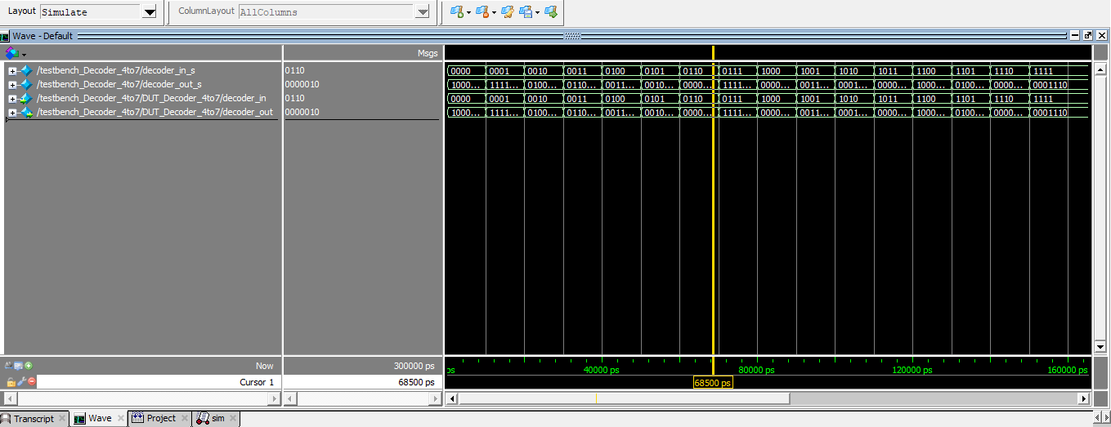

Figure 3.1.1. Decoder_4to7 Module Simulation (1).

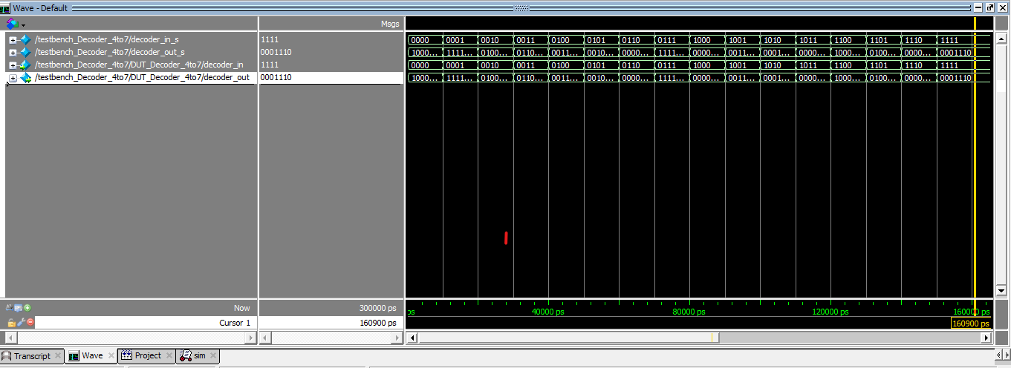

Figure 3.1.2. Decoder_4to7 Module Simulation (2).

The Decoder_4to7 is tested with total of 16 test cases from 0000 to 1111 as you can see in these pictures since we are taking 4-bit binary input and decode it to 7-bit binary output to drive the 7-segment display device. For example, we are displaying “0” on display that means the binary input is “0000”, To display “0” all segments need to light up expect segment naming as 6, So for ON we take 0 as output and for OFF we take 1 as output, so to display “0” on display the output of decoder should be “1000000”.

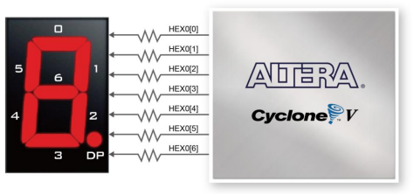

Figure 3.1.3. 7-Segment Display.

**3.2. ButtonShaper:**

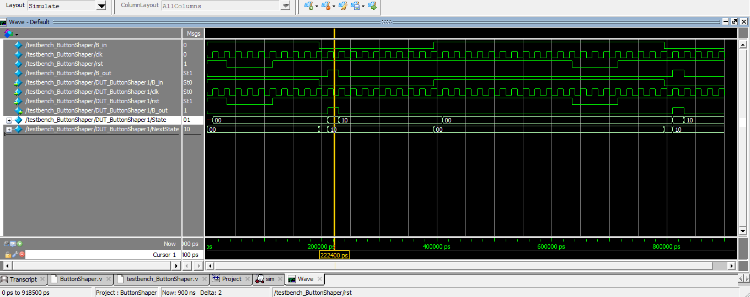

Figure 3.2.1. ButtonShaper module Simulation.

Figure 3.2.1 displays the simulation results obtained by ModelSim. When B_in is set to low by pushing the button, a single-cycle pulse is created at B_out. The B_out remains low until the B_in signal gets lower again.

**3.3. Access Controller:**

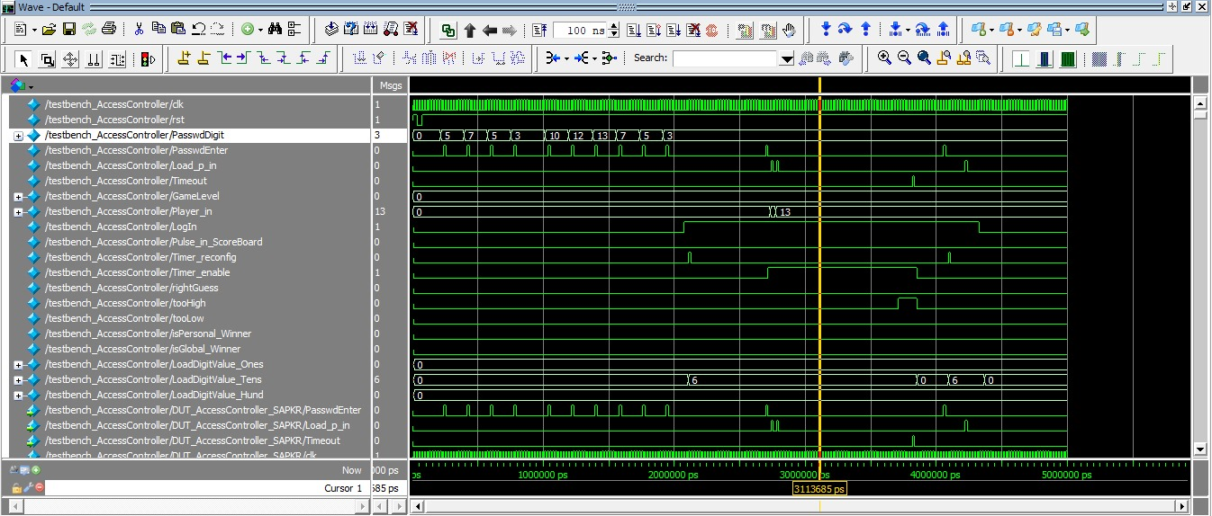

Figure 3.3.1. AccessController Module Simulation.

Figure 3.3.1 displays the simulation outcomes of the AccessController module. Here, a single gameplay round is emulated by entering the default password, resetting it to a new password by pushing the RNG button, after entering the new reset password, to test it, we implemented logout function by pushing the Load player button and then logging in again with the new reset password. The player's load button, random number generating button, and game start/restart button were also simulated. It is evident that these signals aren't passed on to the output until the player is logged in and the game start button is clicked. After the timeout signal is given, we can see that Timer_enable becomes low, again password entering button is pushed to reconfig the timer and logout function is implemented finally to logout from the system.

**3.4. Authentication:**

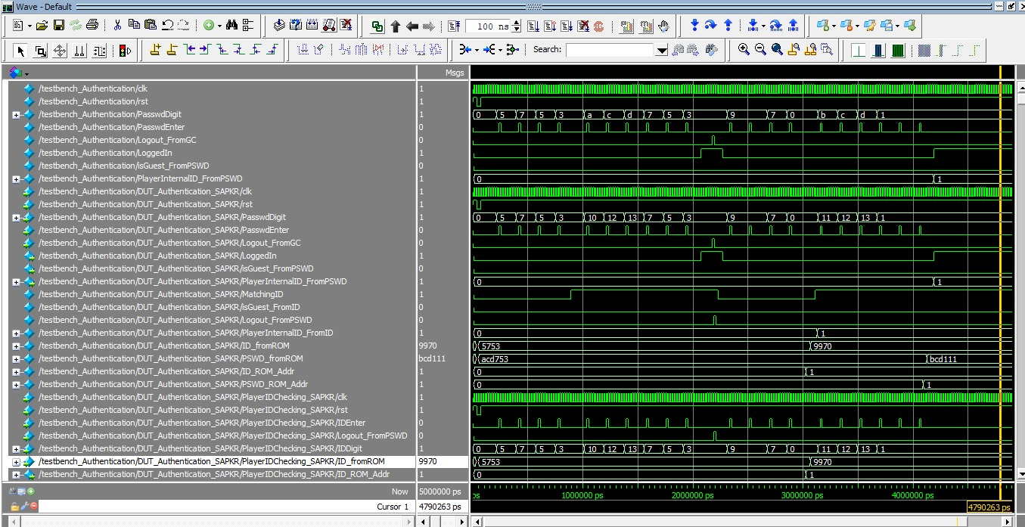

Figure 3.4.1. Authentication Module Simulation.

Figure 3.4.1 displays the simulation outcomes of the Authentication module. The Password Authentication module ensures that the player can only go to the GameController module after their password has been verified. The player's entered password is compared to the password stored in the on-chip ROM. Only if the password match, the user will be logged in successfully. Additionally, when the module receives a password reset signal from the GameController module, it updates the password to the new password and saves it in the on-chip RAM. The user can only log in using this newly reset password until the entire system is reset. Upon receiving a logout signal, this module initiates the process of logging out the user from the system.

**3.5. GameController:**

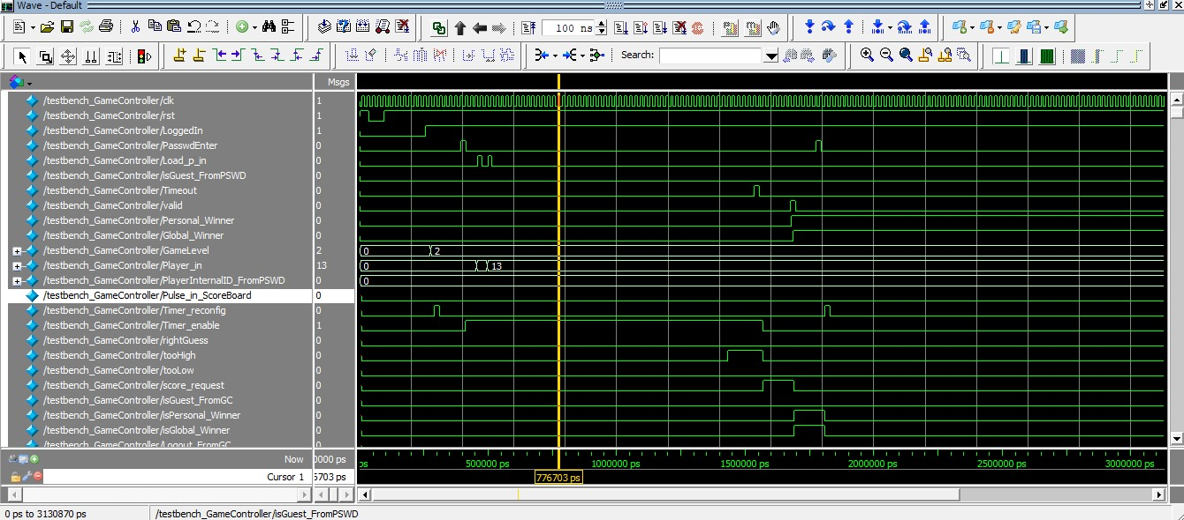

Figure 3.5.1. GameController Module Simulation. (1 of 2)

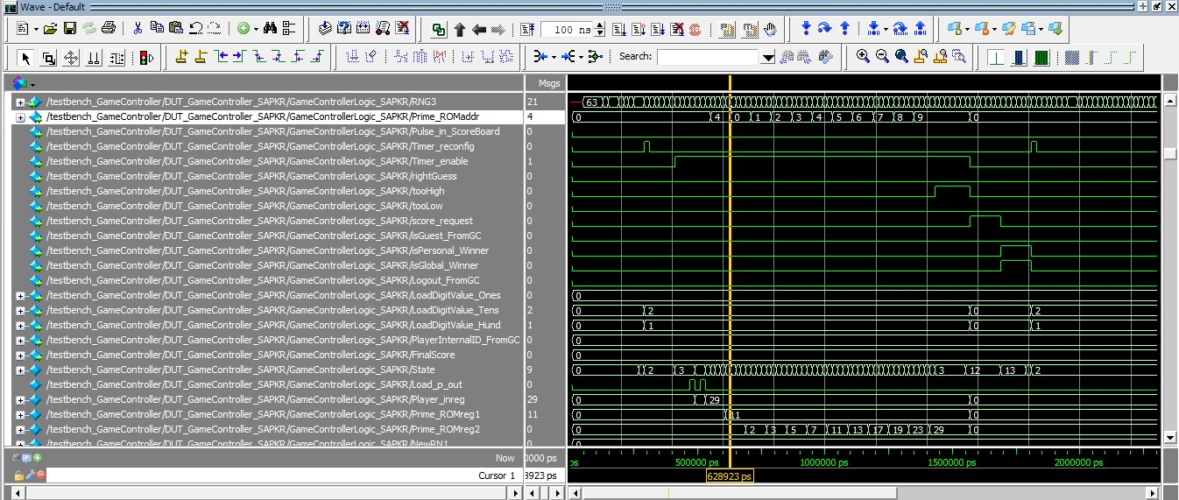

Figure 3.5.2. GameController Module Simulation. (2 of 2)

Figure 3.5.1. shows the results of the simulations for the GameController module. The user authenticates and sends the Passed_Auth signal to the GameController module. The timer is reconfigured and ready to start when this signal is high. Before the game starts, the RNG button and the Load player button are pressed to test the reset password and logout functions. The player started the game by pressing the "Password Enter" button after successfully logging in again with the new reset password. You can see that the RNG_Gen_in and Load_p_in signals are now being sent to the output until the timeout signal is high.

**3.6. RNG:**

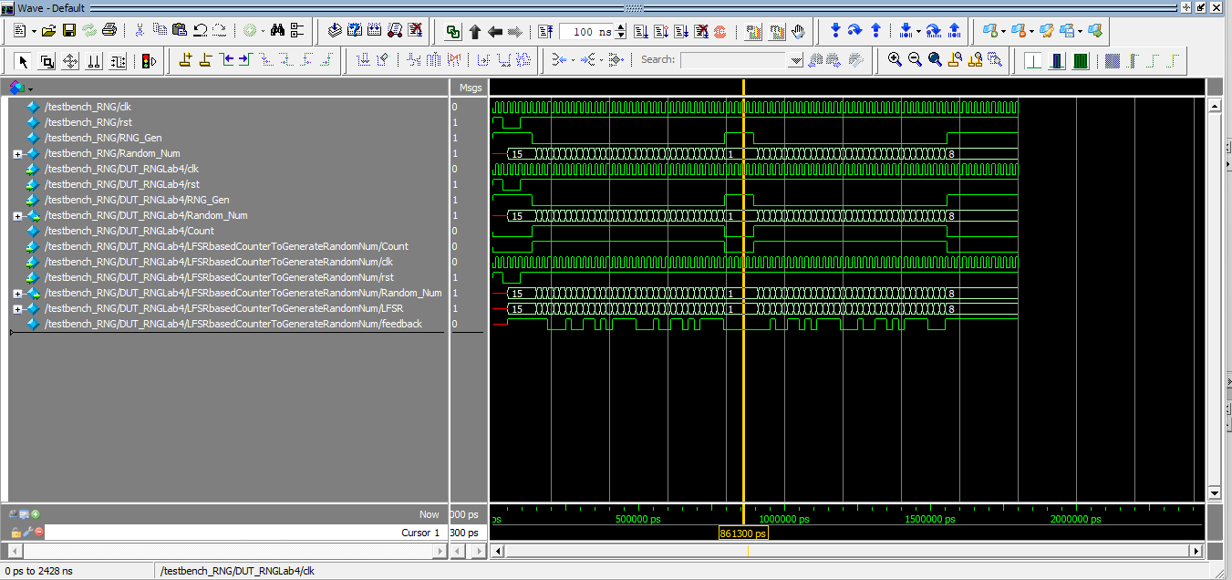

Figure 3.6.1. RNG Module Simulation.

Figure 3.6.1. displays the simulation results of the random number generator module. When the raw RNG_Gen signal stays active for an undefined period, the internal LFSRbasedCounter will begin counting the next number. The initial value for the LFSRbasedCounter is 0xF. Once the counter reaches the last value in the sequence, the output is reset to 0xF and keeps counting the next number as long as the RNG_Gen signal remains low. Since the LFSRbasedCounter doesn't follow a regular number sequence, using it results in greater randomization than using a standard 4-bit binary counter.

**3.7. LFSRbasedOnemsTimer:**

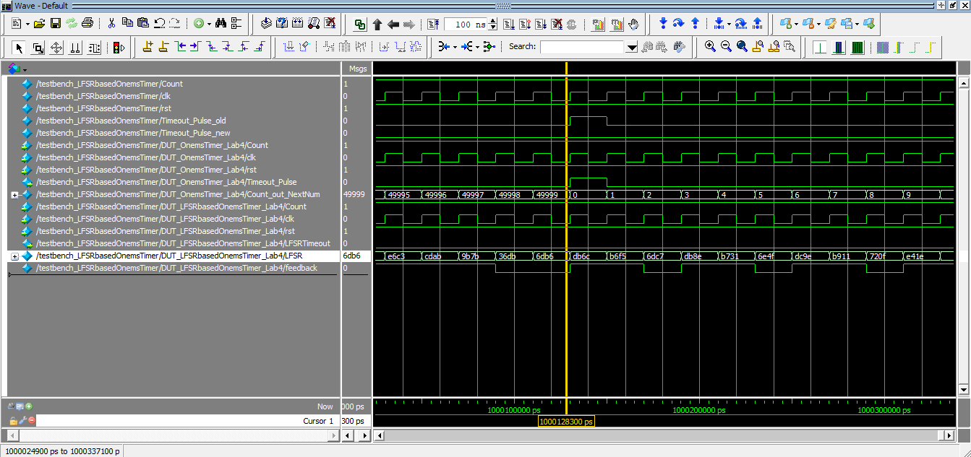

Figure 3.7.1. Regular OnemsTimer vs LFSRbasedOnemsTimer simulation to determine the terminal value for LFSR.

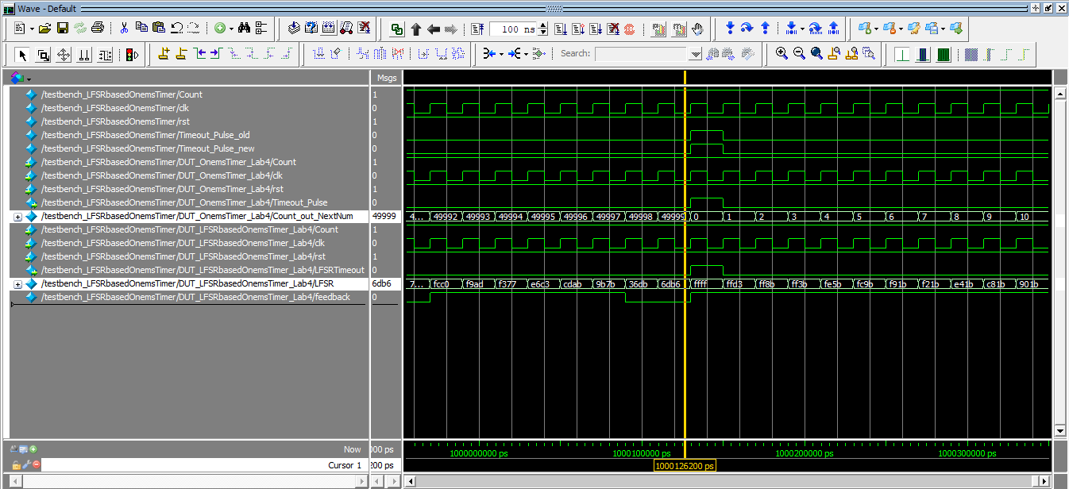

Figure 3.7.2. LFSRbasedOnemsTimer Simulation after adding terminal in the Verilog module.

To determine the terminal value of the LFSR counter, a 16-bit binary counter was used inside the OnemsTimer. Figure 3.7.1. illustrates that the Timeout_Pulse_old signal reaches a high state after reaching the value 49,999 in the 16-bit binary counter based OnemsTimer. The corresponding value at the 16-bit LFSR counter is 16'h6db6. This value was set as the terminal value in the design module of LFSRbasedOnemsTimer, and figure 3.7.2. shows that when the Timeout_Pulse_old becomes high, the Timeout_Pulse_new likewise becomes high, confirming that the LFSR module is functioning well and is suitable for replacement with a 16-bit binary counter.

**3.8. OneSecTimer:**

For the submodules LFSRbasedOnemsTimer, the terminal value of the counter should occur for every 50,000 cycles when terminal value is at 16'h6db6. For the countTo100 module, this pulse serves as the driving signal. The countTo100 function produces a single cycle pulse on a count to 100 bases, occurring during a time interval of 100ms. This pulse signal is responsible for driving the countTo10 module, which generates a single cycle pulse for a count of 10 within a one-second timeframe.

The OneSec_Timeout signal should occur once every 50 million cycles as the clock frequency is 50MHZ, Hundredms_Timeout signal should occur once every 5 million cycles and Onems_Timeout signal should occur once every 50,000 cycles as per their raw terminal values.

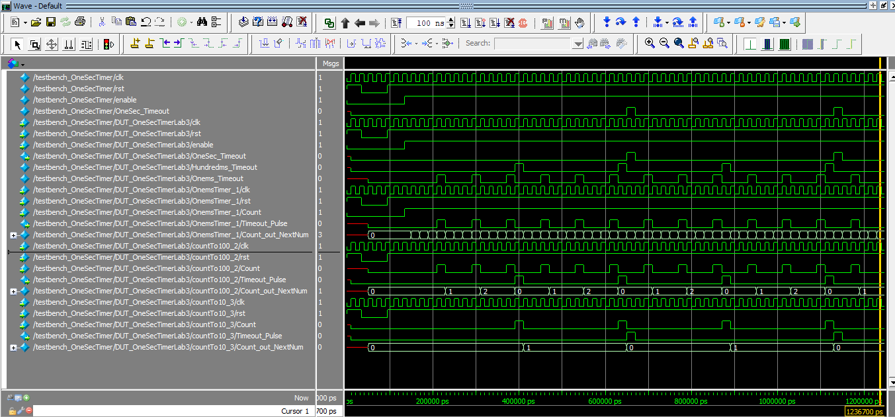

Figure 3.8.1. OneSecTimer Module Simulation

**3.9. threeDigitTimer:**

The threeDigitTimer module comprises three DigitTimer instances that decrease from 9 to 0 upon receiving a one-second pulse signal. When a pulse of the Timer_reconfig signal is received, we can observe that both the one's digit and the tens digit are set to 9. The timer begins to operate and one's digit begins to decrease every one second when the Timer_enable signal is asserted high. Figure 3.9.1. illustrates this. Figure 3.9.2. illustrates that when the One’s digit reaches 0, the Borrow_ReqToUP signal is transmitted from the ones digit module to the tens digit module. Subsequently, the ones digit is reset to 9. This Borrow_ReqToUP signal is a single-cycle pulse signal that is utilized in the Ten’s digit module to decrement the value in the tens digit.

The Ten's Digit module asserts the NoBorrow_RepFromUP signal when the Ten's becomes zero, as shown in figure 3.11.3. When the One's Digit reaches zero, the Borrow_ReqToUP pulse is not asserted; instead, the NoBorrow_RepToDN signal, also known as the timeout signal, is asserted high, indicating that the timer is stopped.

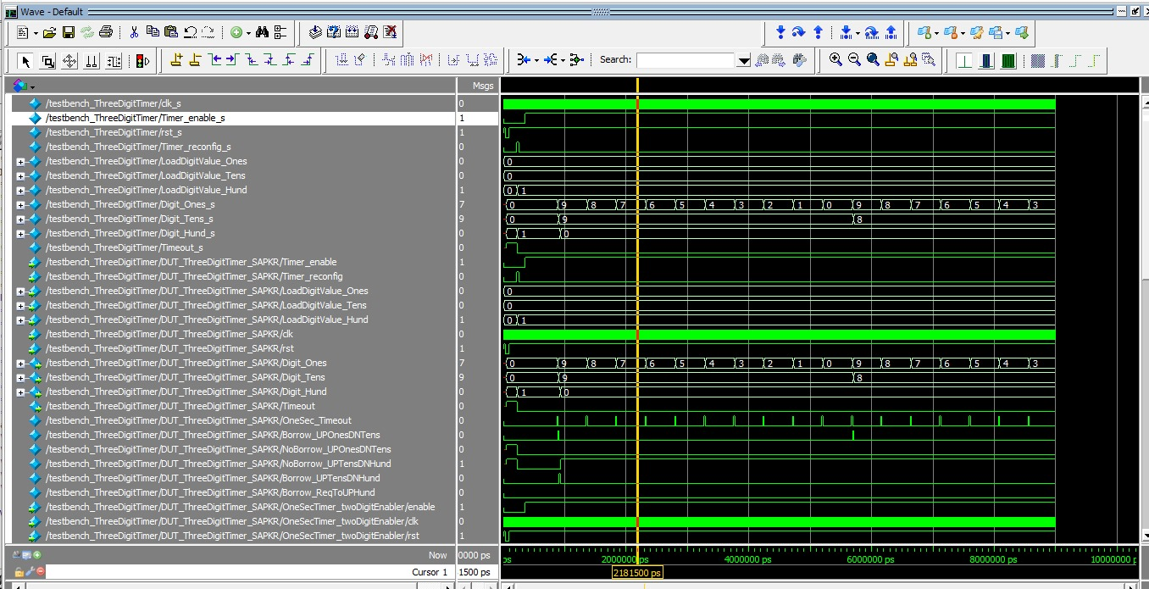

Figure 3.9.3. threeDigitTimer Module Simulation (3).

**3.10. DigitTimer:**

Figure 3.10.1. displays the simulation results of DigitTimer. It is evident that when the DigitTimer is reset, its value becomes 0 until it receives a Timer_reconfig pulse, at which point the value of DigitTimer is set to 9. Every time a Borrow_ReqFromDN signal occurs, the DigitTimer counts down to zero. It remains at zero until the NoBorrow_RepFromUP signal is high; if not, it will roll back to nine.

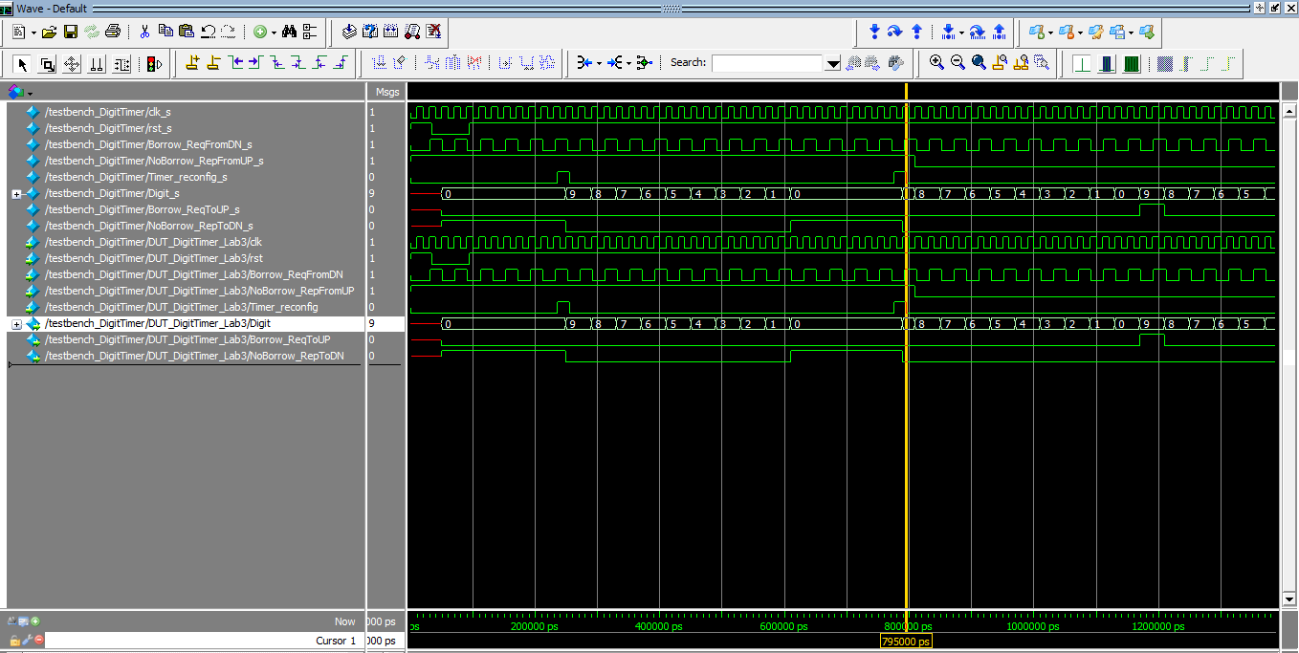

Figure 3.10.1. DigitTimer Module Simulation.

**3.12. PseudoRNG:**

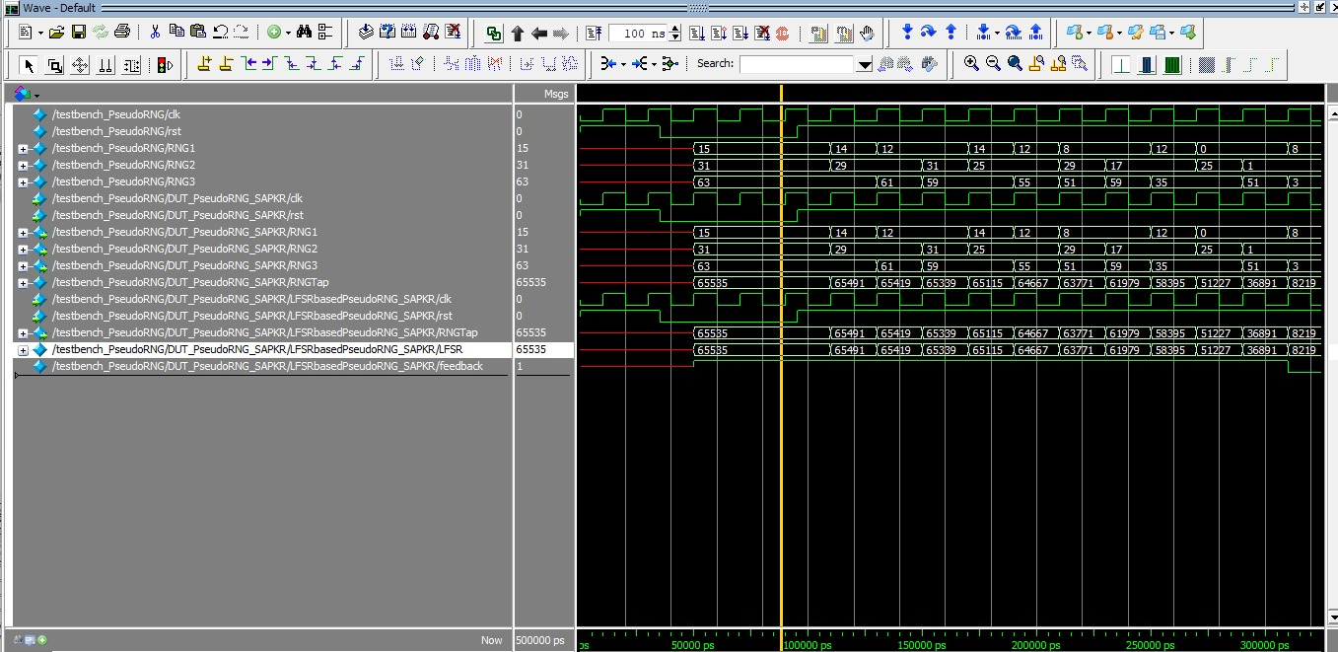

Figure 3.12.1 Pseudo RNG Generator waveform

When the reset button is pressed, the LFSR (Linear Feedback Shift Register) will reach the maximum value of 16'hFFFF and then start over from 16'hFFFF. It will keep changing its value every clock cycle, which is every 20 nanoseconds, providing more randomness for the players. During the simulation, it will operate normally for the first two clock cycles. Then, for the next three cycles, it will reset with a value of F. After that, it will generate random numbers again for the next two cycles.

**3.13. Score Tracking**

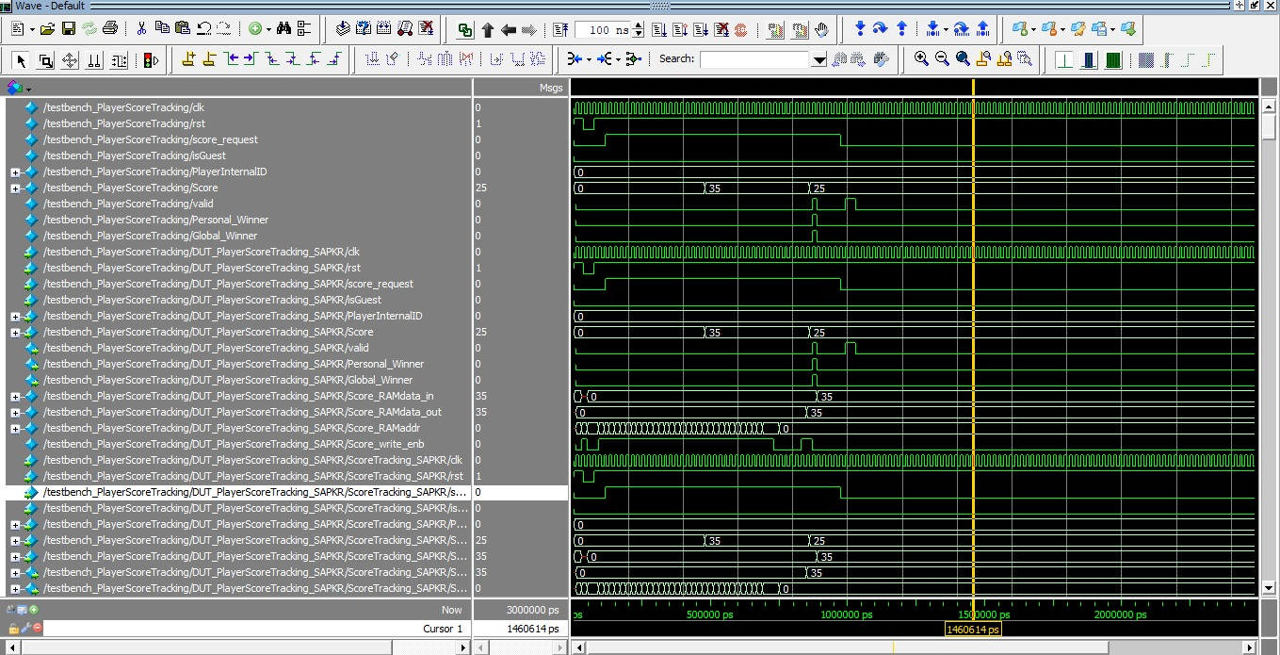

Figure 3.13.1 score Tracking Waveform

The simulation results demonstrate the functionality of the PlayerScoreTracking module in tracking player scores, computing personal and global best scores.

**3.14 Password Checking**

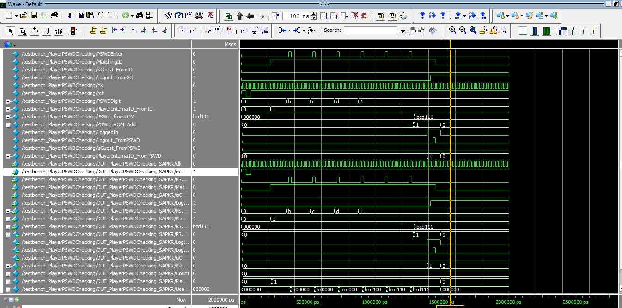

The simulation results show the simulation successfully emulated the entry of the correct default password, triggering the system to authenticate the user and allow access to the gaming application. When an incorrect password was entered, the module appropriately denied access and awaited a new password entry.

**3.15 Reconfigtimer**

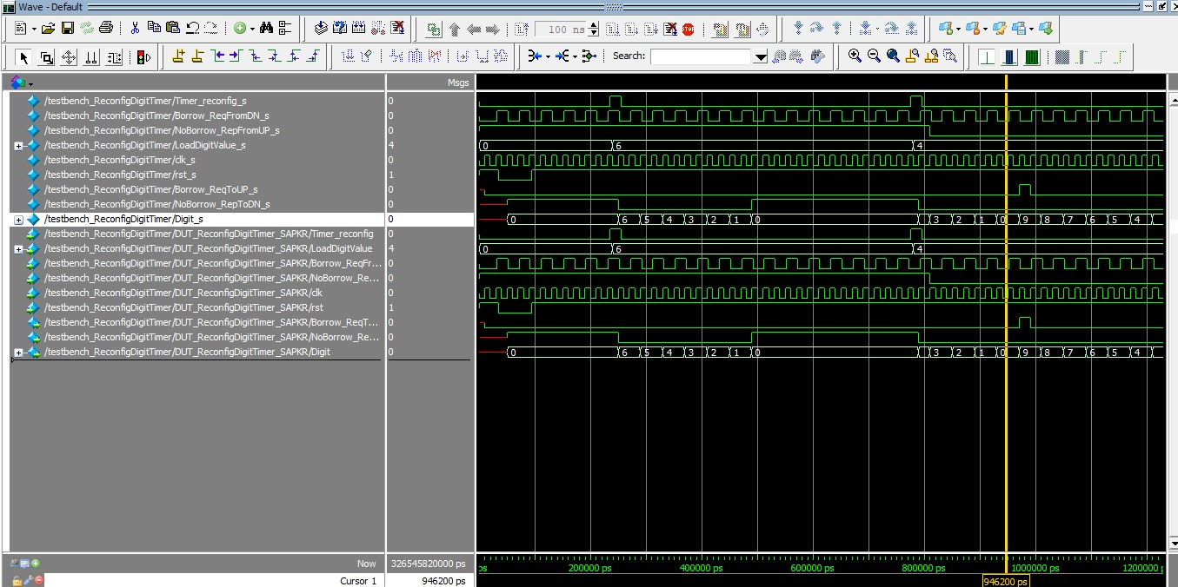

The simulation results demonstrate the effective functioning of the Digit Timer Reconfiguration module in managing digit reconfiguration and handling timeout scenarios.

**3.16 Scoreboard**

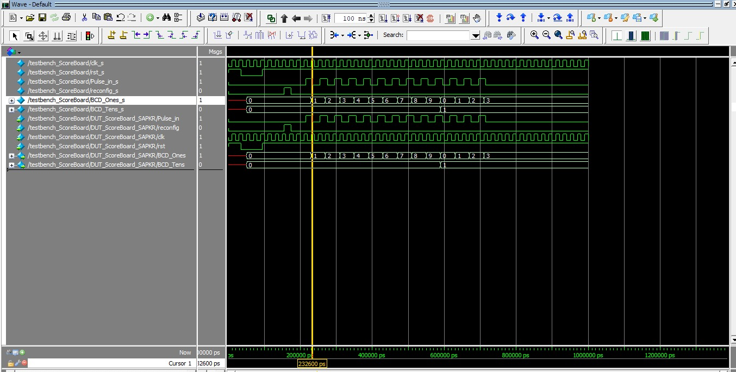

This figure illustrates the simulation of the Scoreboard module where the score of the player is updated each time when there is pulse_in signal. The output then displays the ones and tens digit of the score.

**4.0. FPGA Board Testing Results:**

The process of testing an FPGA board is as follows.

1. The FPGA was configured to operate in run mode and when the reset button is pressed, figure 4.0.1 displays the default condition.

2. The user inputs the password to log in. The timer is set to 60 and remains idle until the player presses the Game Start button.

3. The player initiates the game by pressing the "Game Start" button, which triggers the countdown of the timer.

4. The player pushes the switches the switches to give the predicted number and then pushes the load button.

5. The player inputs a number to get the led blink showing if the predicted number is too high, too low, and right guess.

6. The system generates a new prime number when given the right guess again while the timer is counting down.

7. The player inputs a new number to match the latest generated random number. In this round, the player has successfully matched the random generated number twice.   
8. The timer has expired, and the player is unable to input a number or generate a new random number. The FPGA will now exhibit the scoreboard and await the player's initiation of game restart.

9. The player activates the restart function, causing the game to be reset and logout.  
10. The player initiates round 2 by pressing the Game Start button, causing the timer to begin counting down.

11. Once the timer ceases to operate, the user reconfigured the timer to 60 by pushing the password entering button and will log out by pushing the Player's Load/Logout button. They can then log back in using the default password, as they have not yet reset the password.

12. To reset the password before the game starts, the player should click the Random Number/Password Reset button. This reset process is identical to entering the password while logging in.

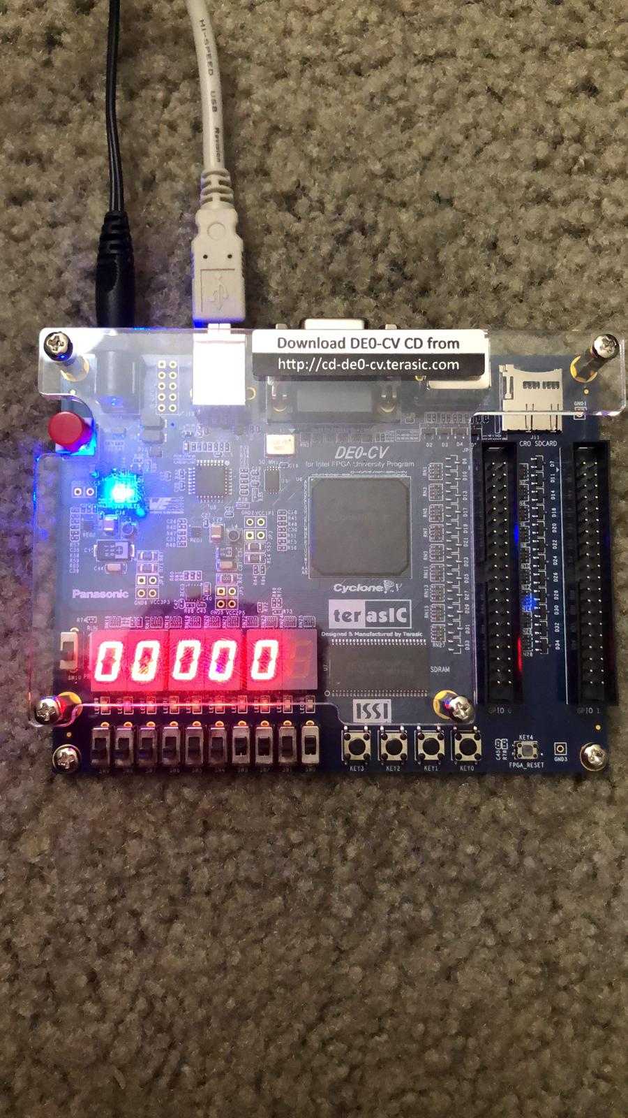

Game before Logged in

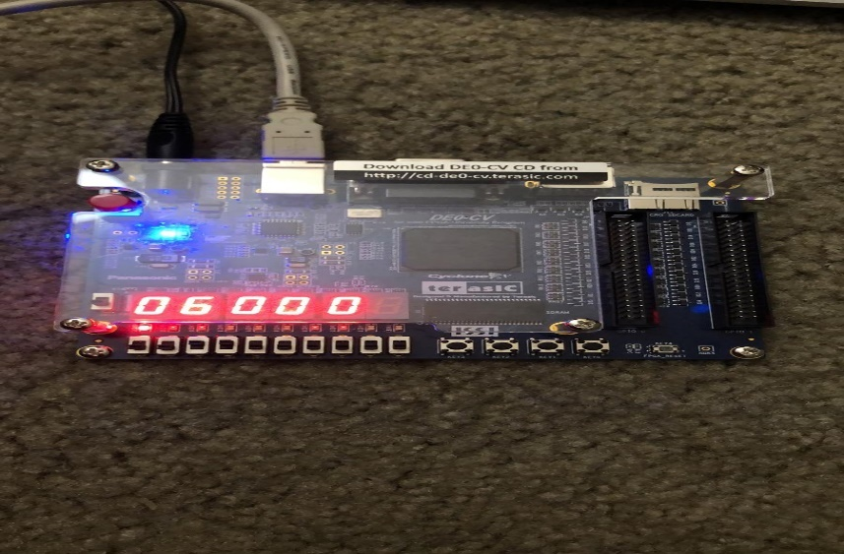

Game after Log In

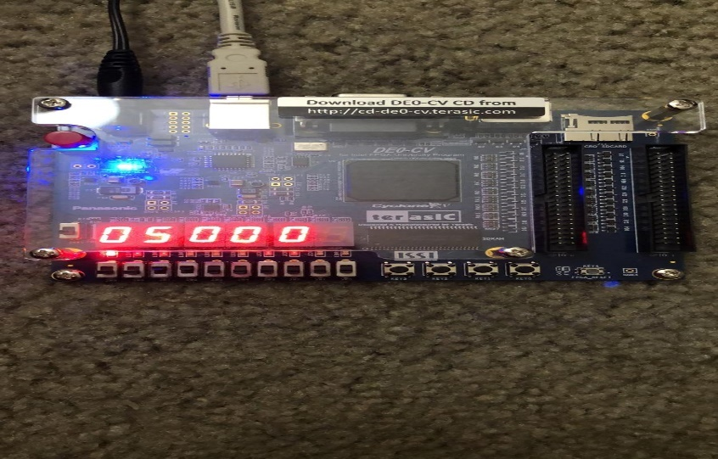

Game Start and Timer begins

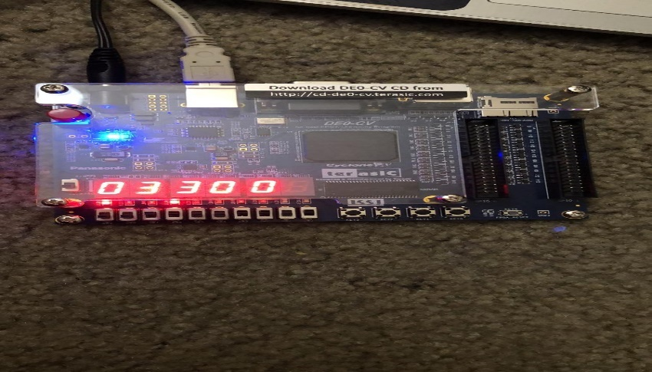

Check whether the prime is too high is too low or right guess

**5.0. Video Demo:**

[**https://uofh.sharepoint.com/sites/Addproject970/_layouts/15/stream.aspx?id=%2Fsites%2FAddproject970%2FShared%20Documents%2FGeneral%2FRecordings%2FView%20Only%2FMeeting%20in%20%5FGeneral%5F%2D20240510%5F232631%2DMeeting%20Recording%2Emp4&referrer=StreamWebApp%2EWeb&referrerScenario=AddressBarCopied%2Eview%2E4abe29a5%2Dcd02%2D4895%2Da300%2D3ea9eae69dcd**](https://uofh.sharepoint.com/sites/Addproject970/_layouts/15/stream.aspx?id=%2Fsites%2FAddproject970%2FShared%20Documents%2FGeneral%2FRecordings%2FView%20Only%2FMeeting%20in%20%5FGeneral%5F%2D20240510%5F232631%2DMeeting%20Recording%2Emp4&referrer=StreamWebApp%2EWeb&referrerScenario=AddressBarCopied%2Eview%2E4abe29a5%2Dcd02%2D4895%2Da300%2D3ea9eae69dcd)

**6.0. Conclusion:**

All the features mentioned in the project manual, including the features PlayerScoreTracking, scoreboard, Authentication interfacing with on-chip ROM and RAM for storing the password, Password reset function, Logout function, LFSR-based counter for Random prime number generation were incorporated into the creation and testing of the mental binary math game. The outcome of the tests performed on the FPGA board is as follows:

* The player's default password, saved in the ROM, is compared to the password entered by the player for authentication. If the player resets their password, the new password is kept in the RAM and used for the next log in.
* The player has the option to logout and then login again using either the default password or the reset password, depending on which password was most recently used for Logging in.
* The game also introduced the concept of guest user id and password for authentication for the good user experience.
* A 1-second timer was developed using an LFSR counter as its core to generate 1ms pulses.
* The game is initiated only when the player inputs the correct password. Until then, the player's number or a random number will not be displayed even if the load button or random number generator button is activated.
* A random prime number generator based on a ROM we designed to generate random prime numbers dependent on the duration of pushing the button.
* A timer with three digits was created to count down by 1 every second.
* The FPGA board records the number of successful tries and presents the scoreboard at the end of each round of the game.
* The game also indicates if the score of the player is the personal best and the global winner

In general, the Prime Number Game has achieved success.

* 1. **Appendix:**

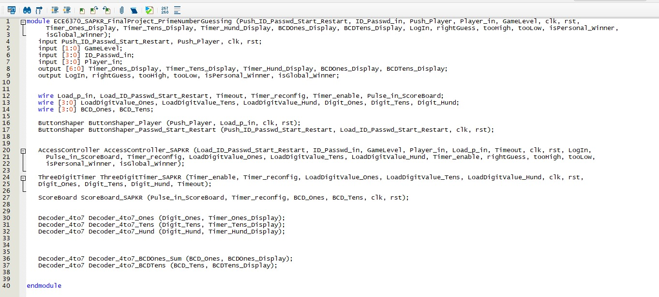

**Top Module**

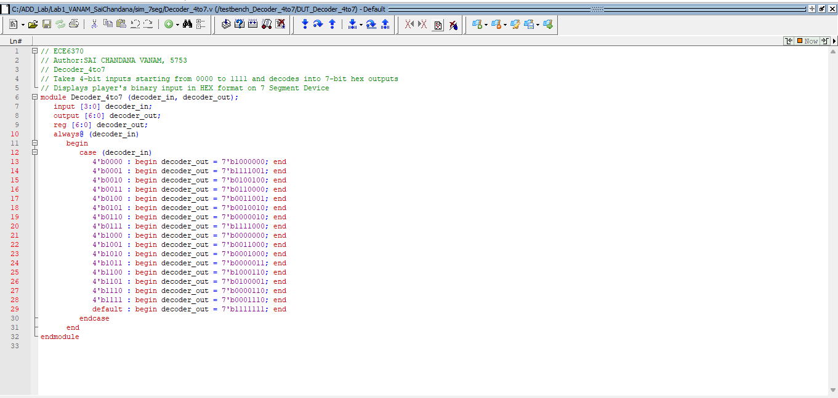

Decoder_4to7 Module.

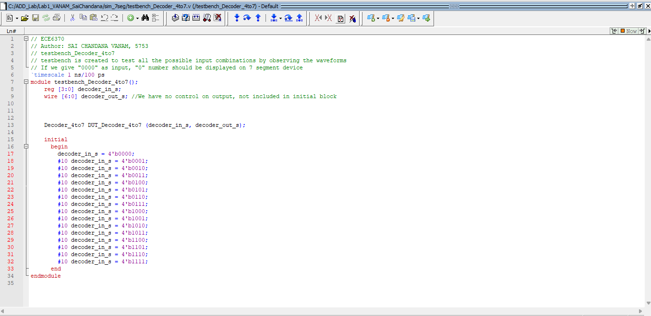

Decoder_4to7 testbench Module.

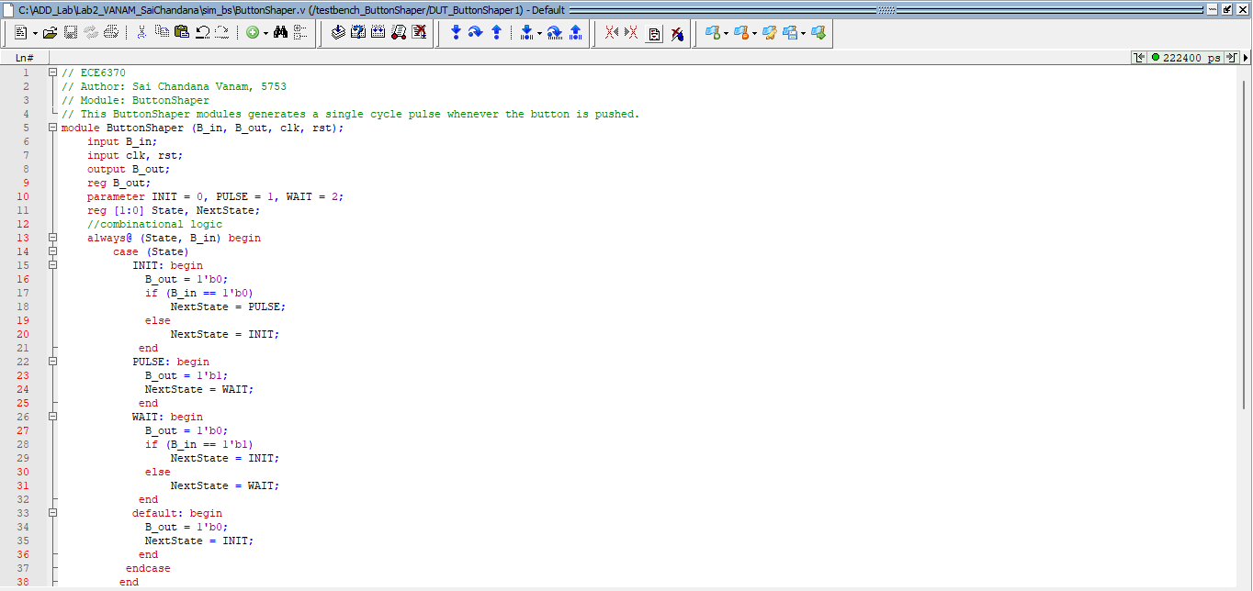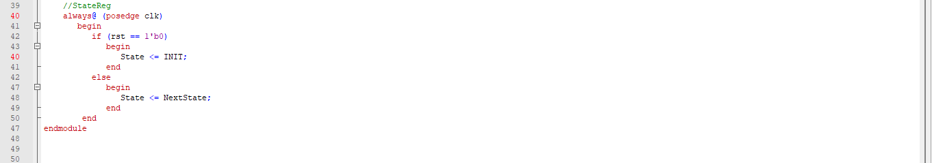

ButtonShaper Module.

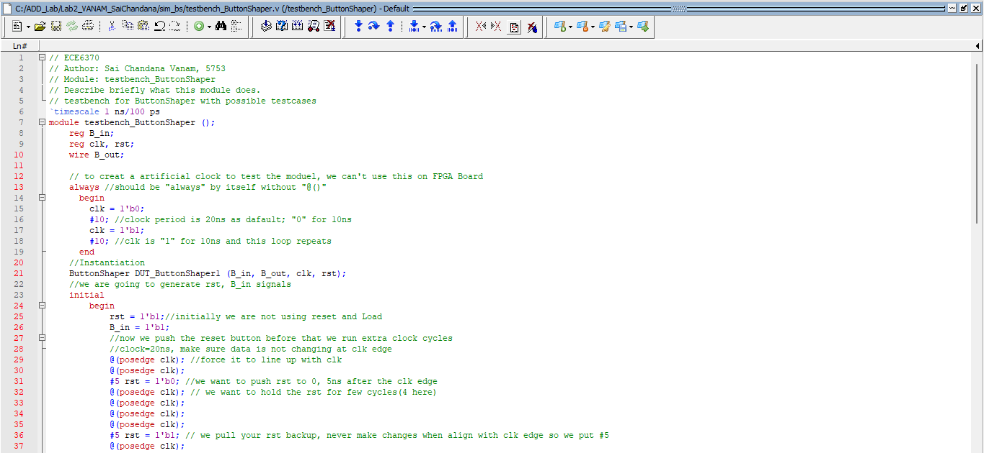

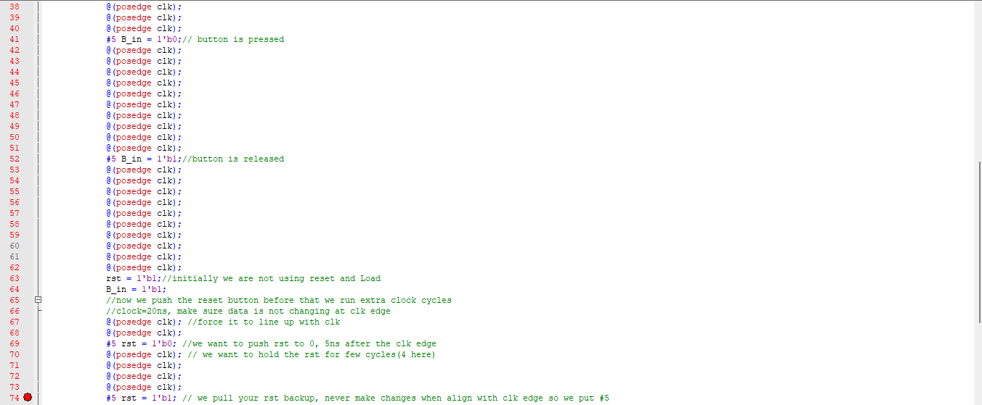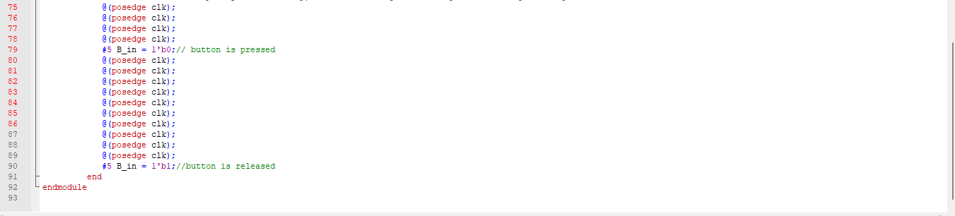

. ButtonShaper testbench Module.

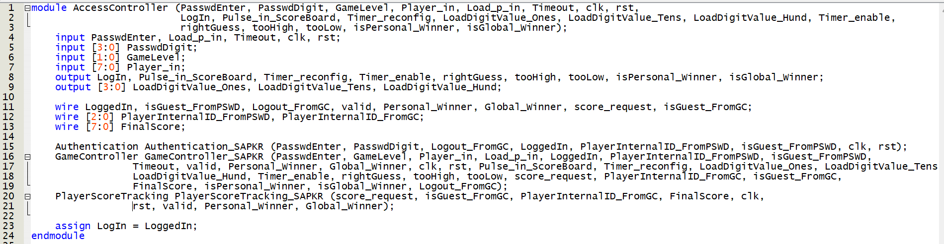

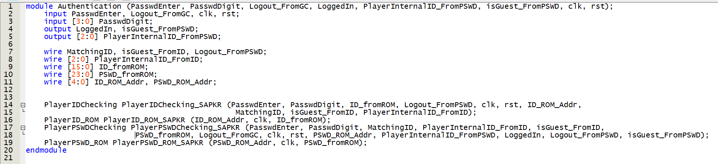

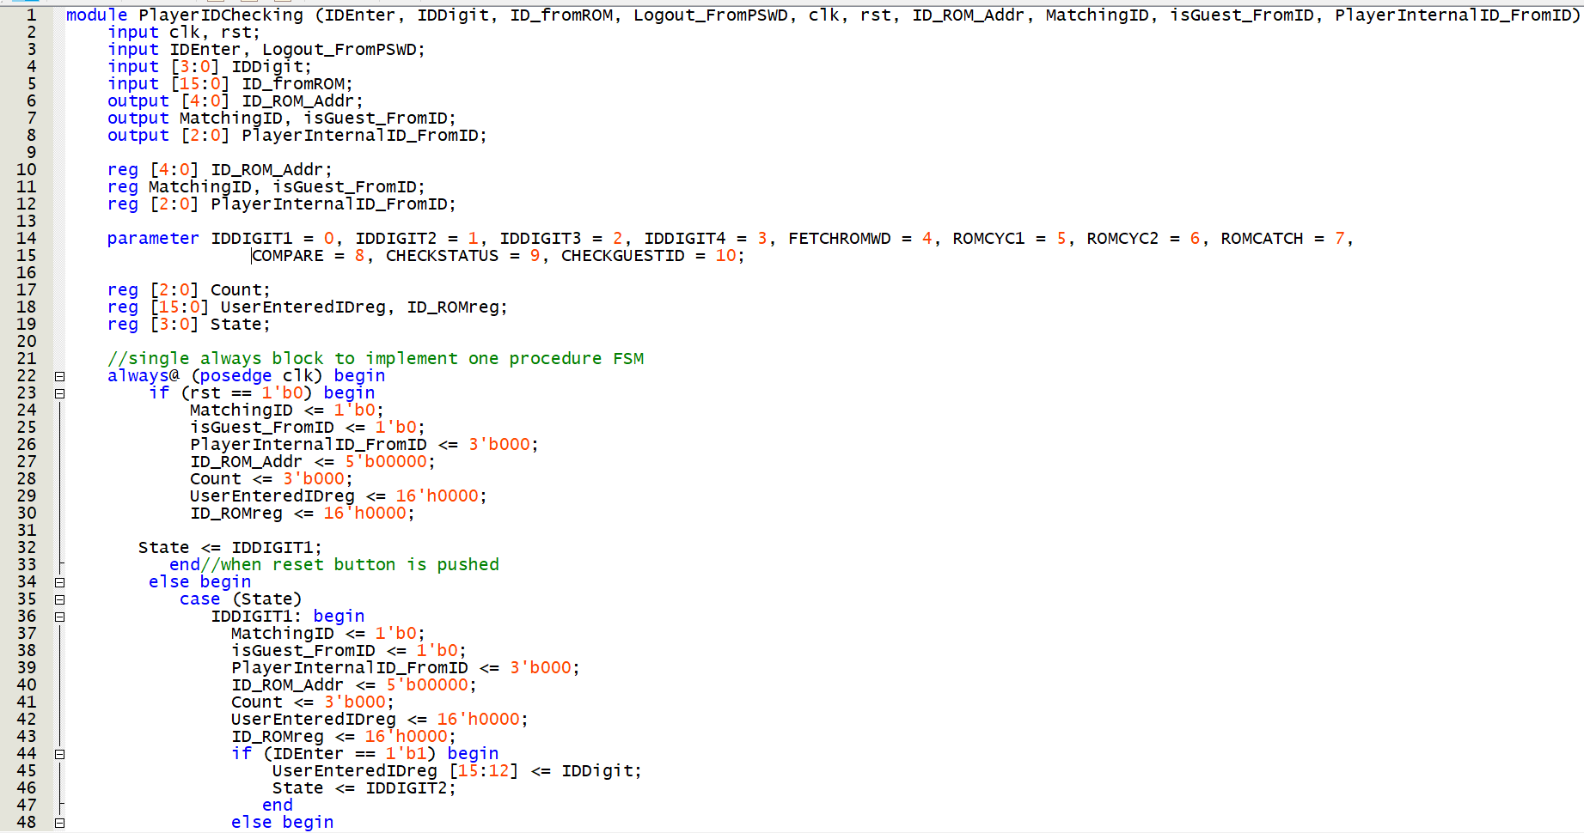

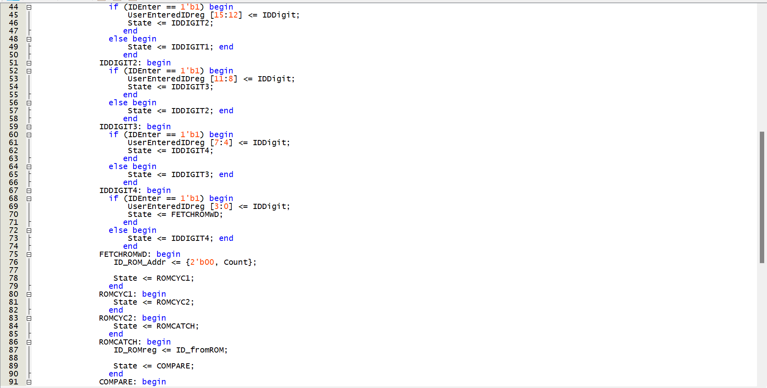

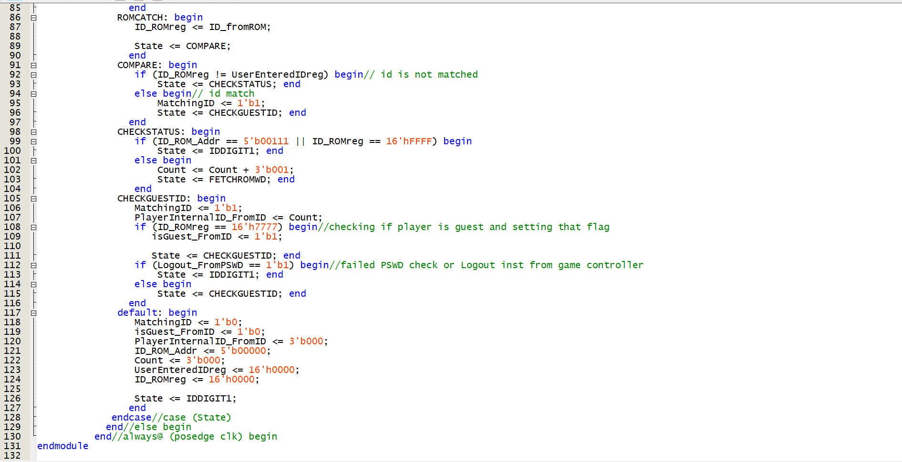

Player ID Checking module

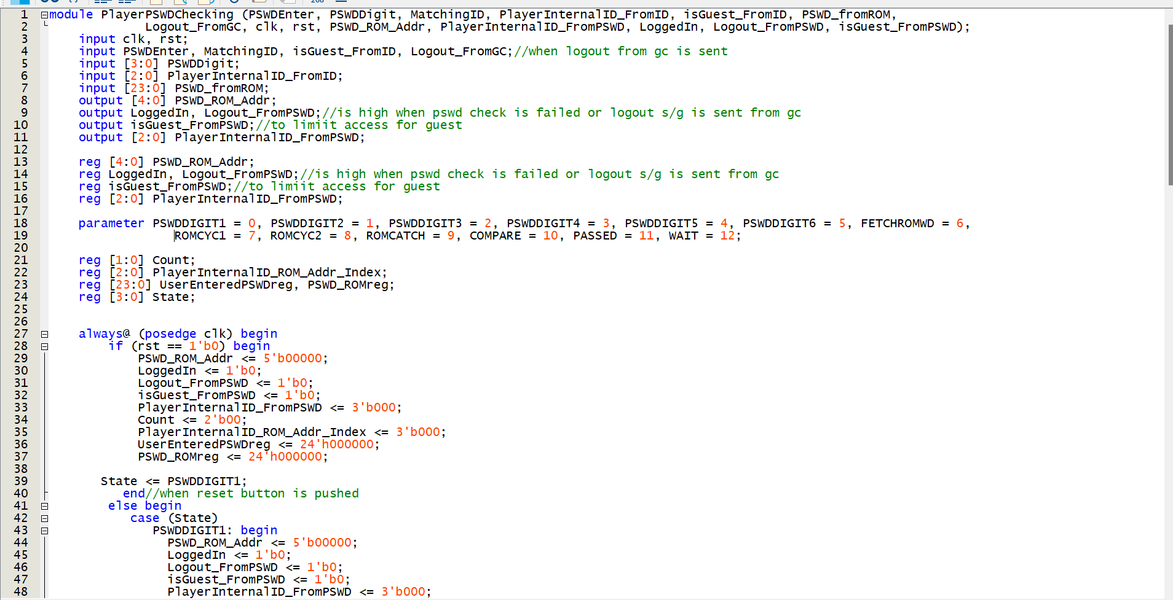

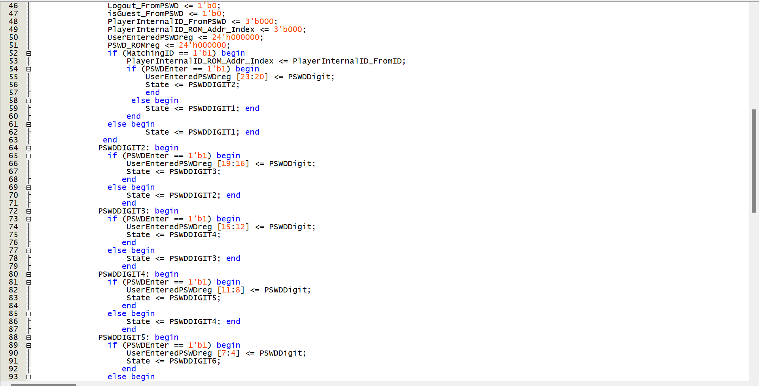

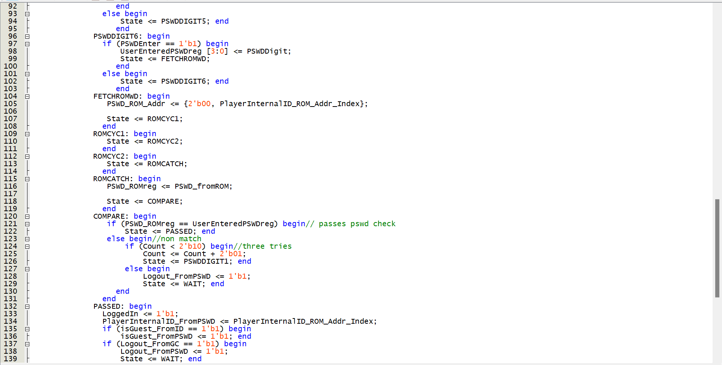

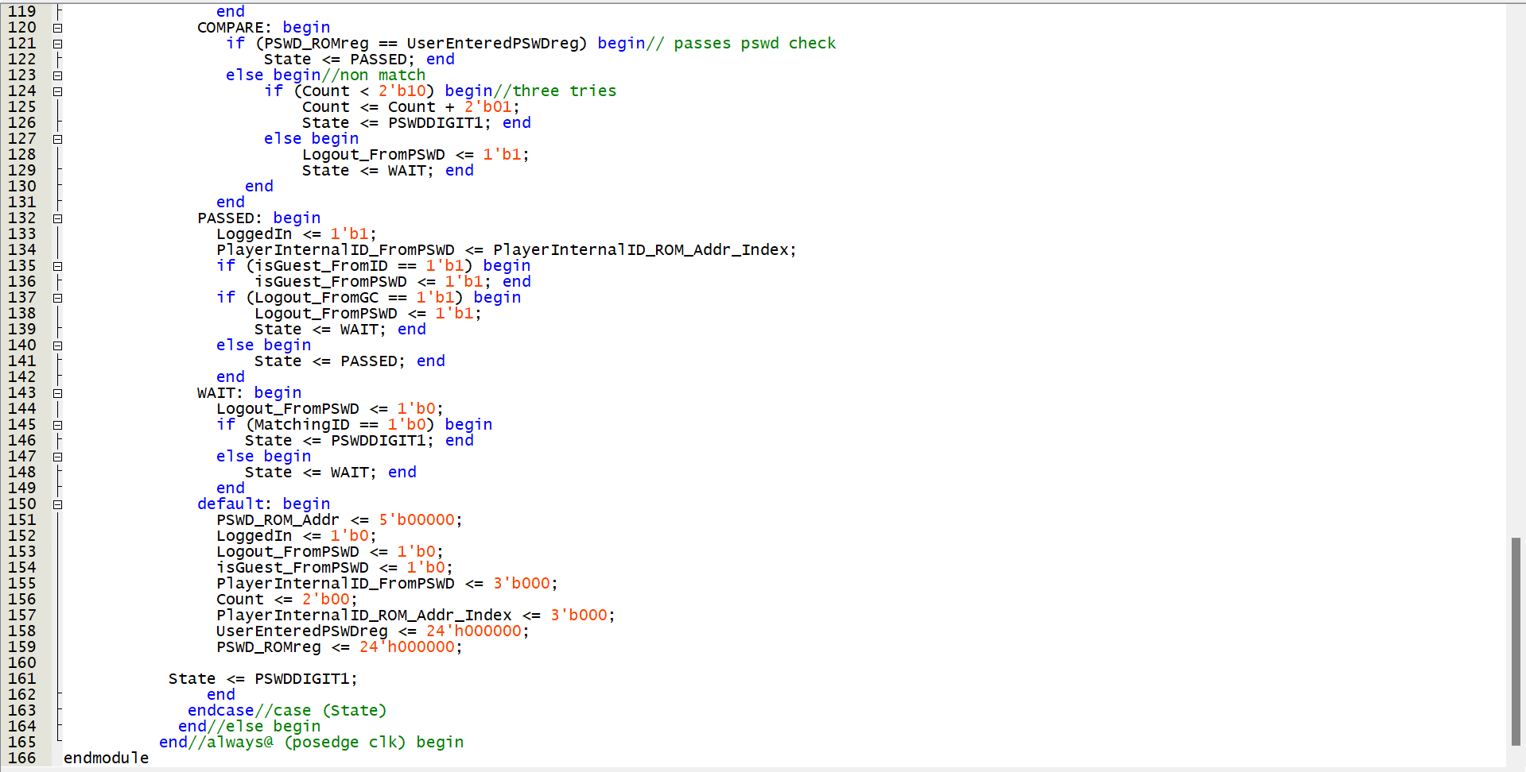

Player PSWD Checking

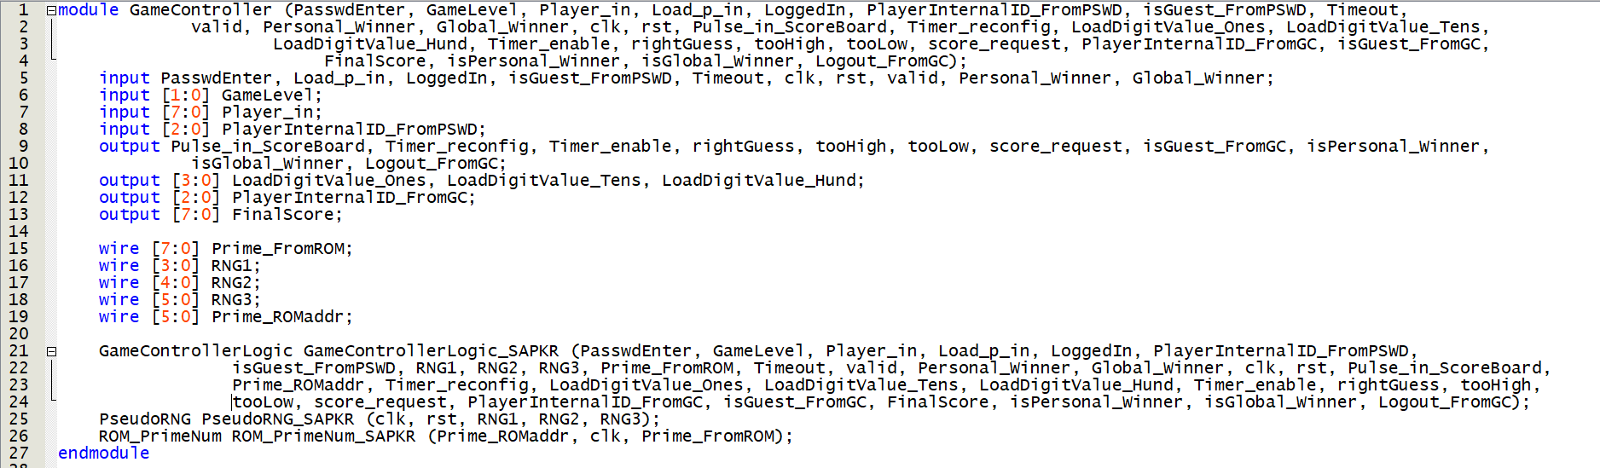

Game Controller(1)

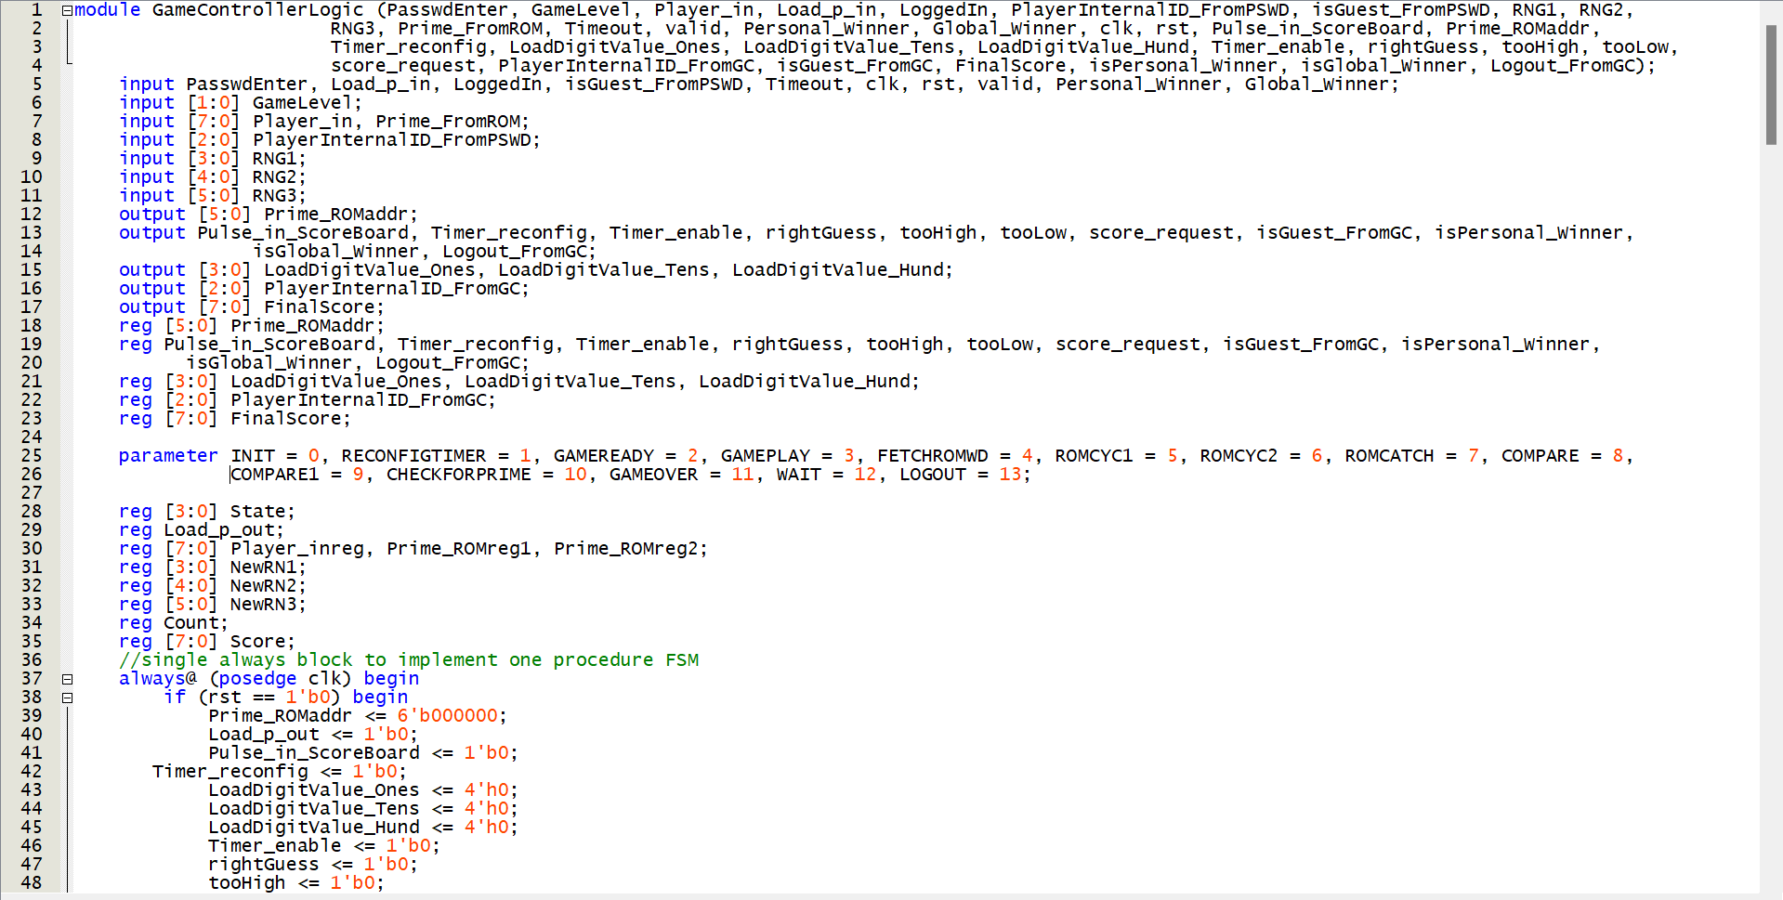

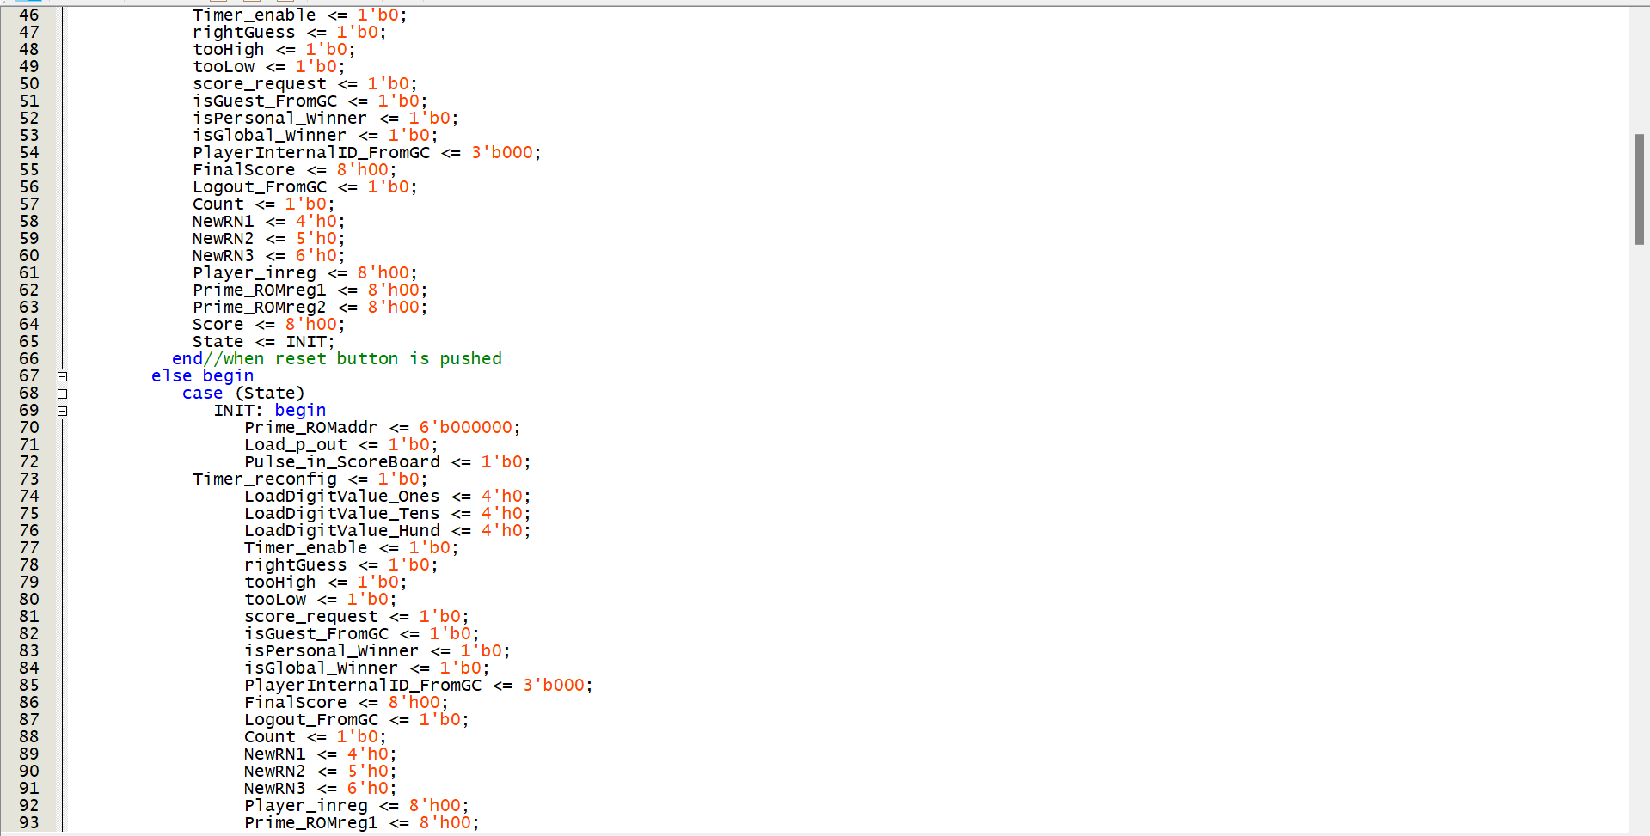

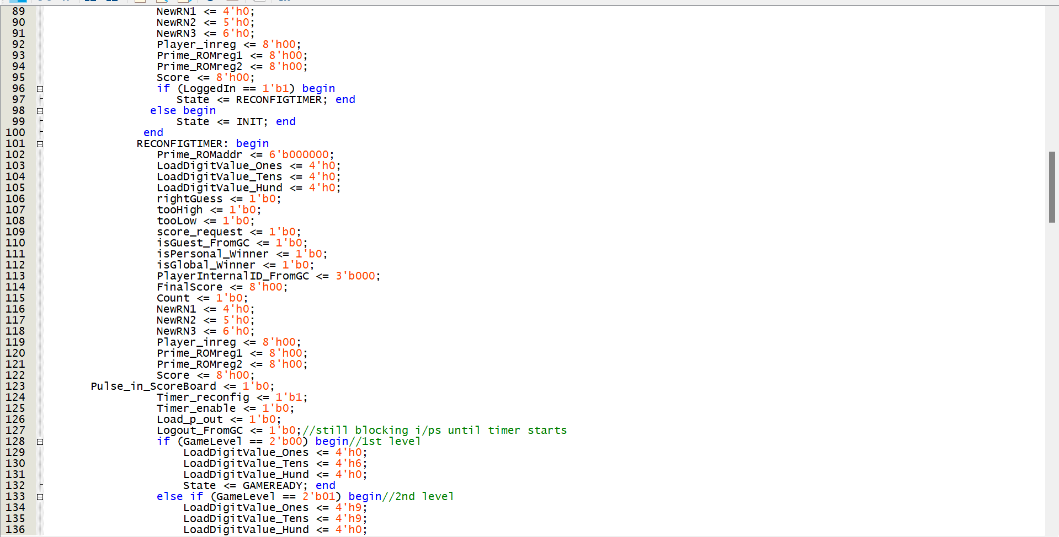

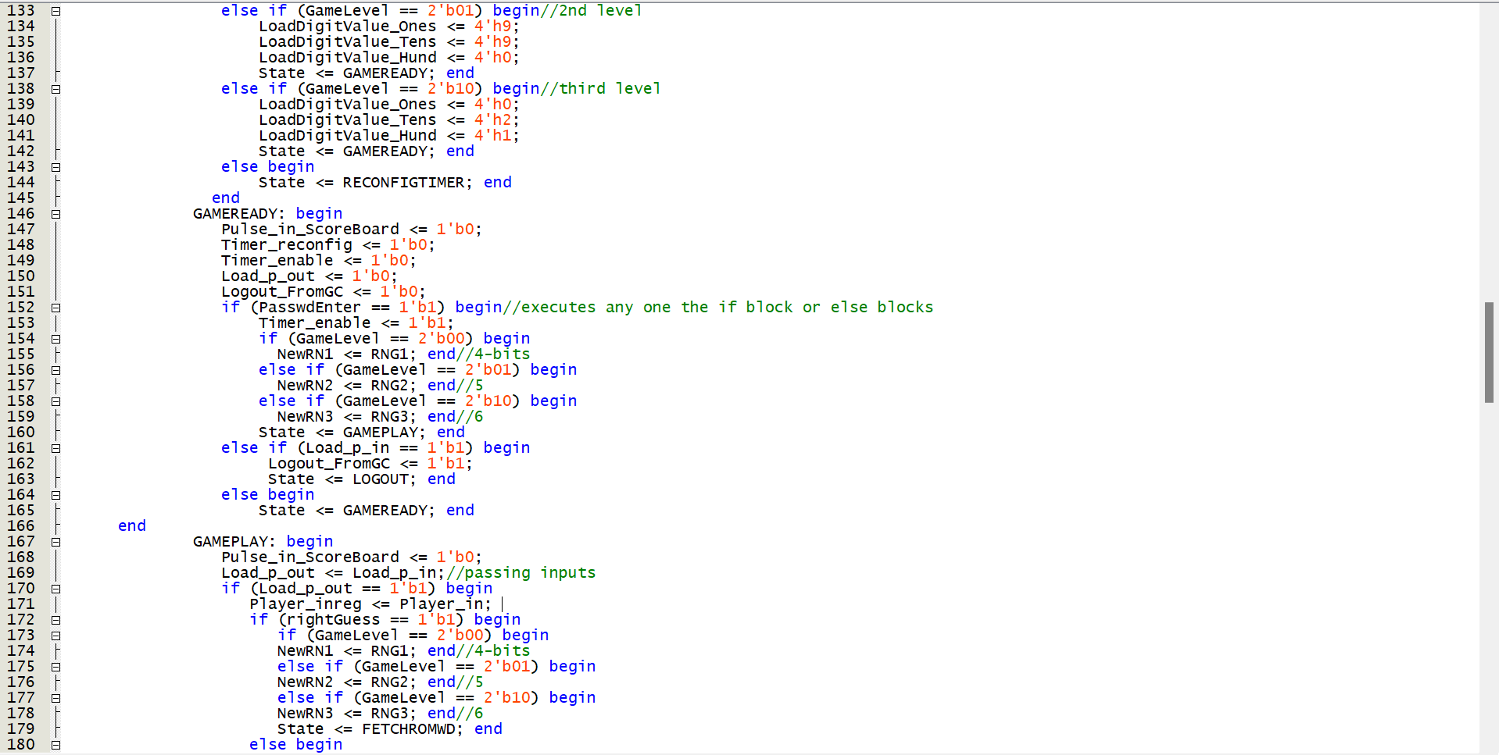

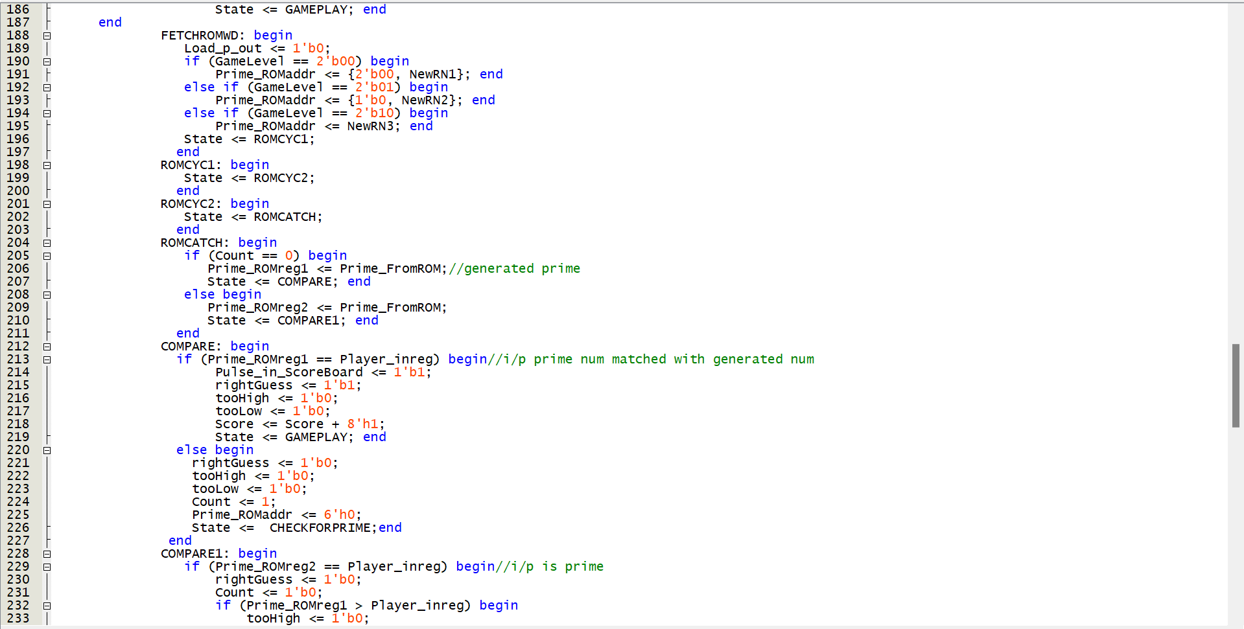

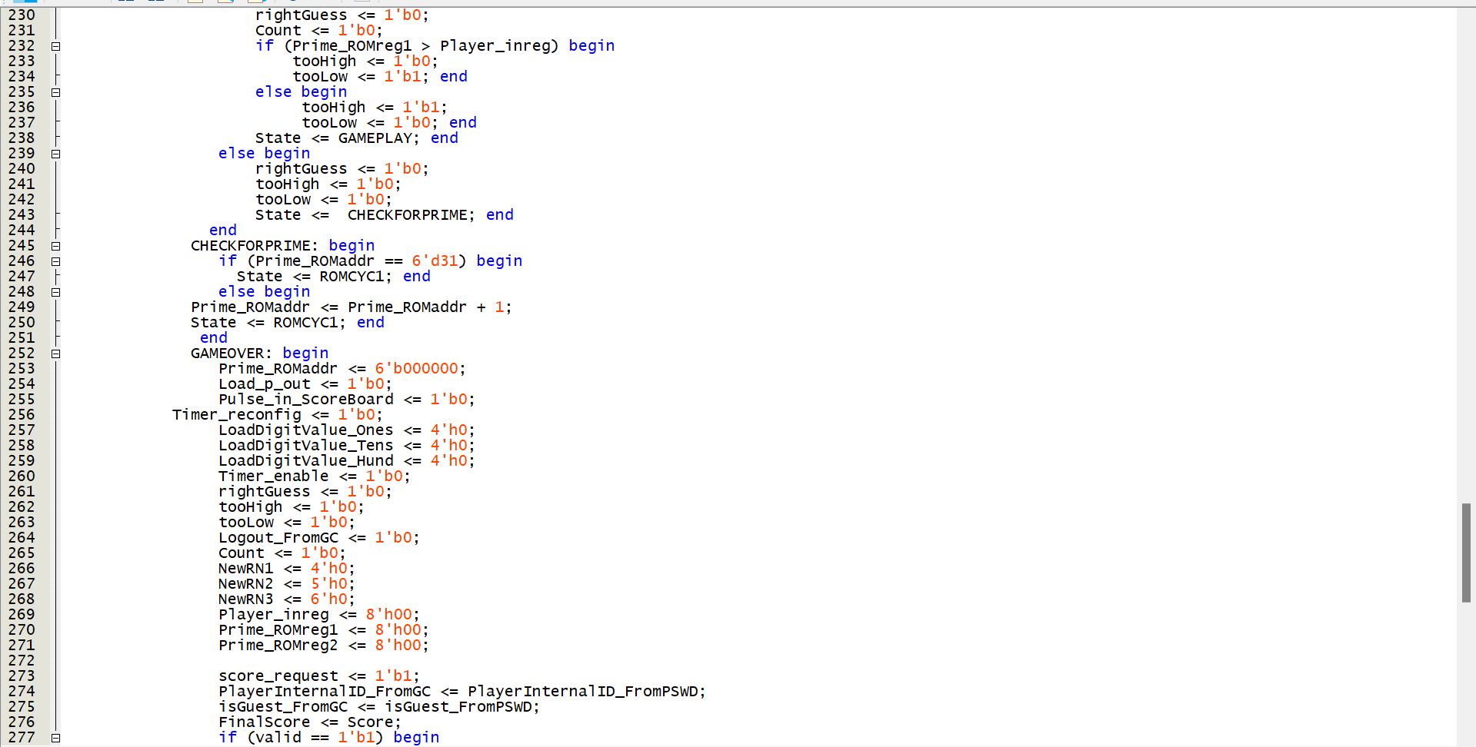

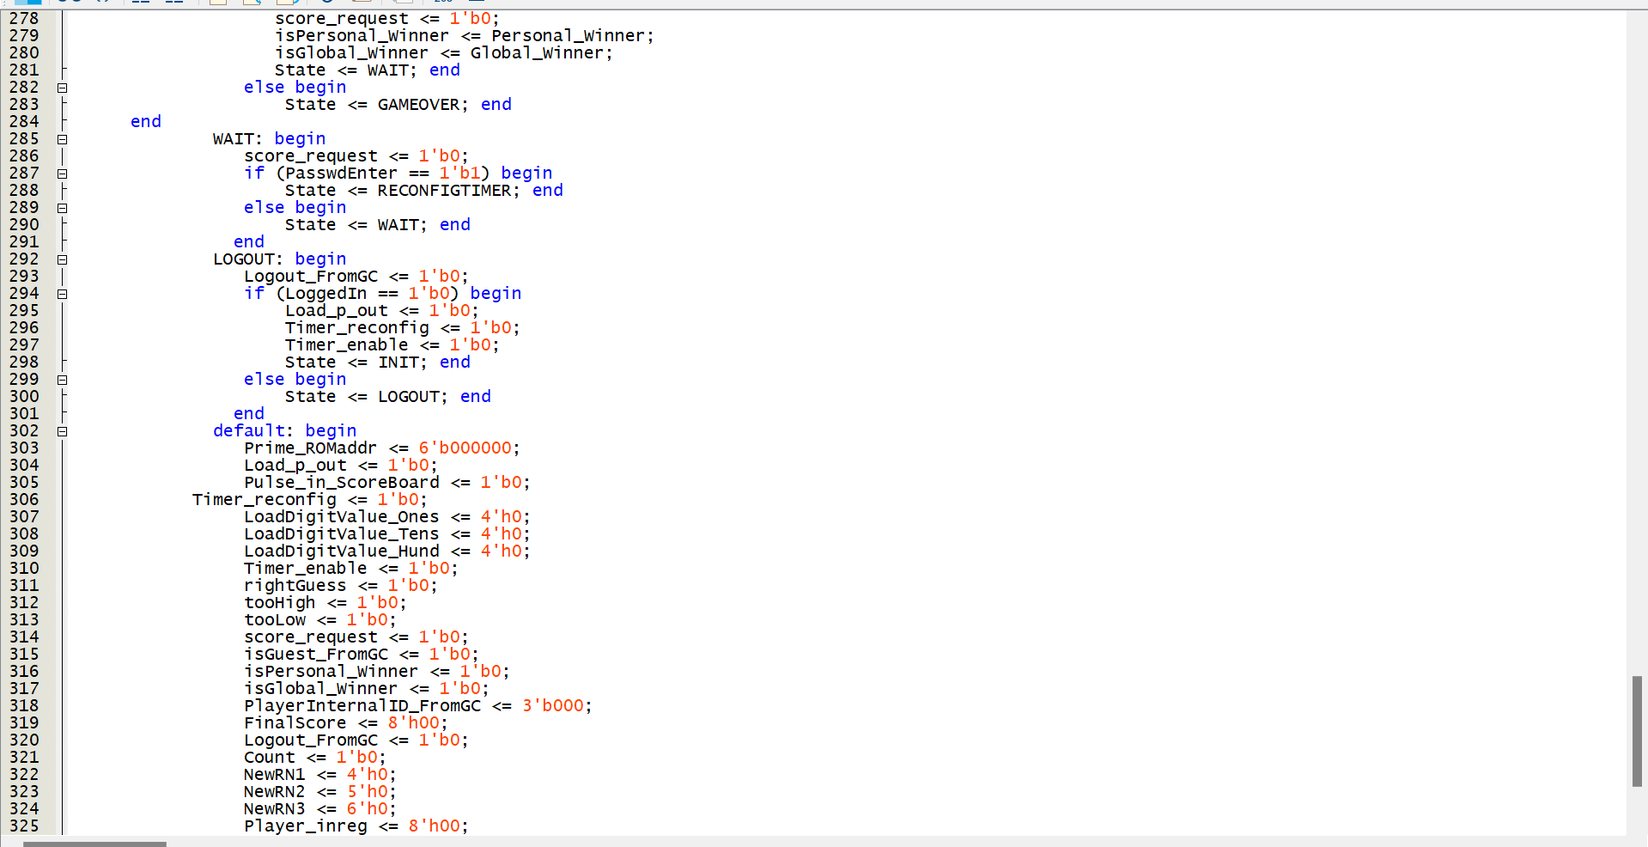

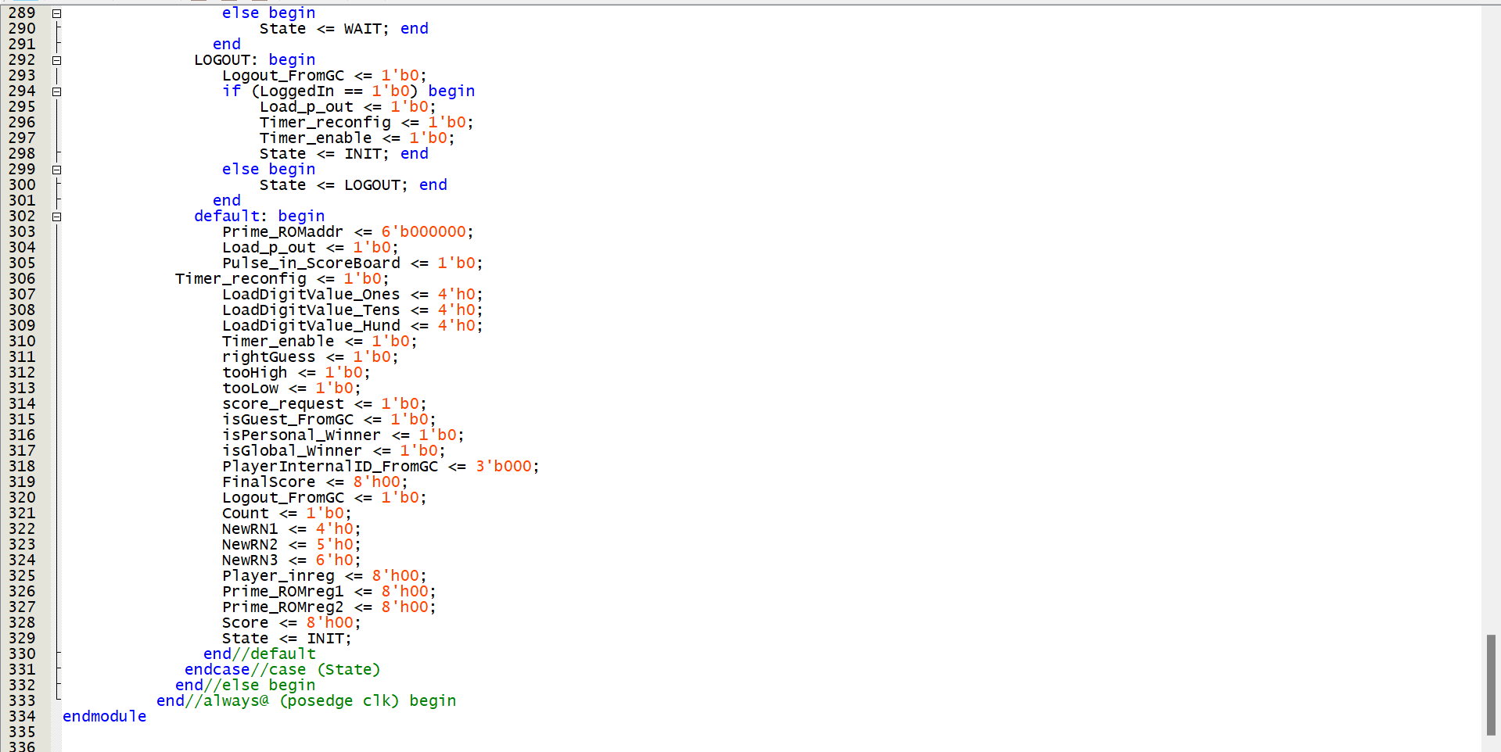

Game Controller Logic

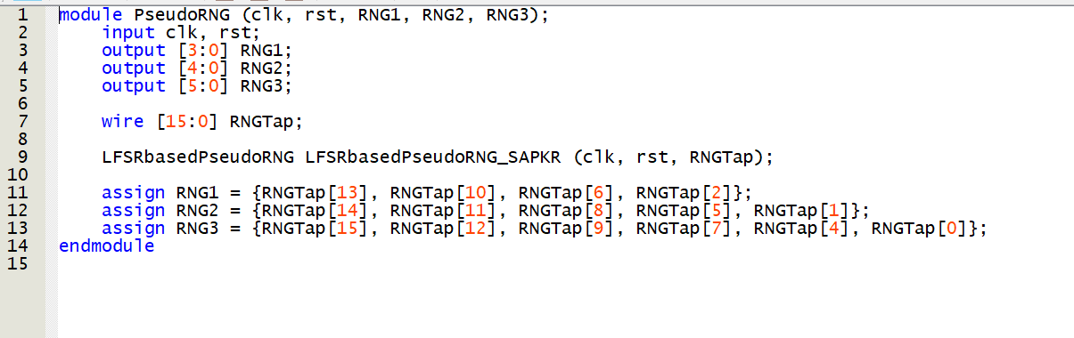

Pseudo RNG

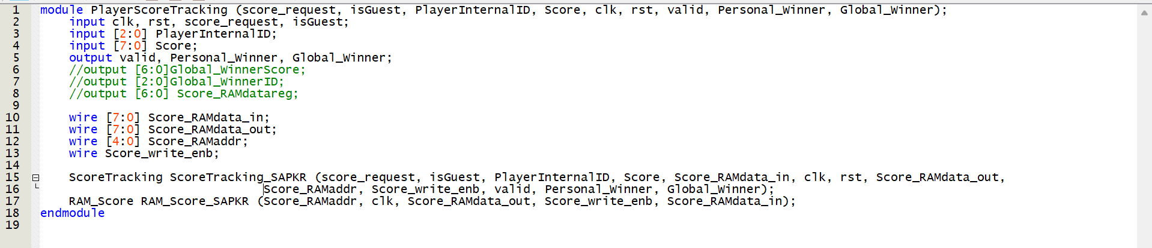

PlayerScoreTracking

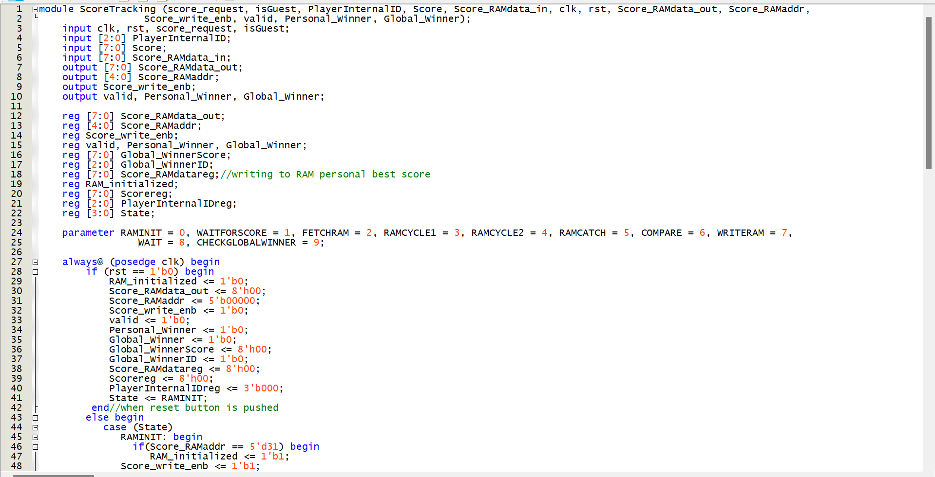

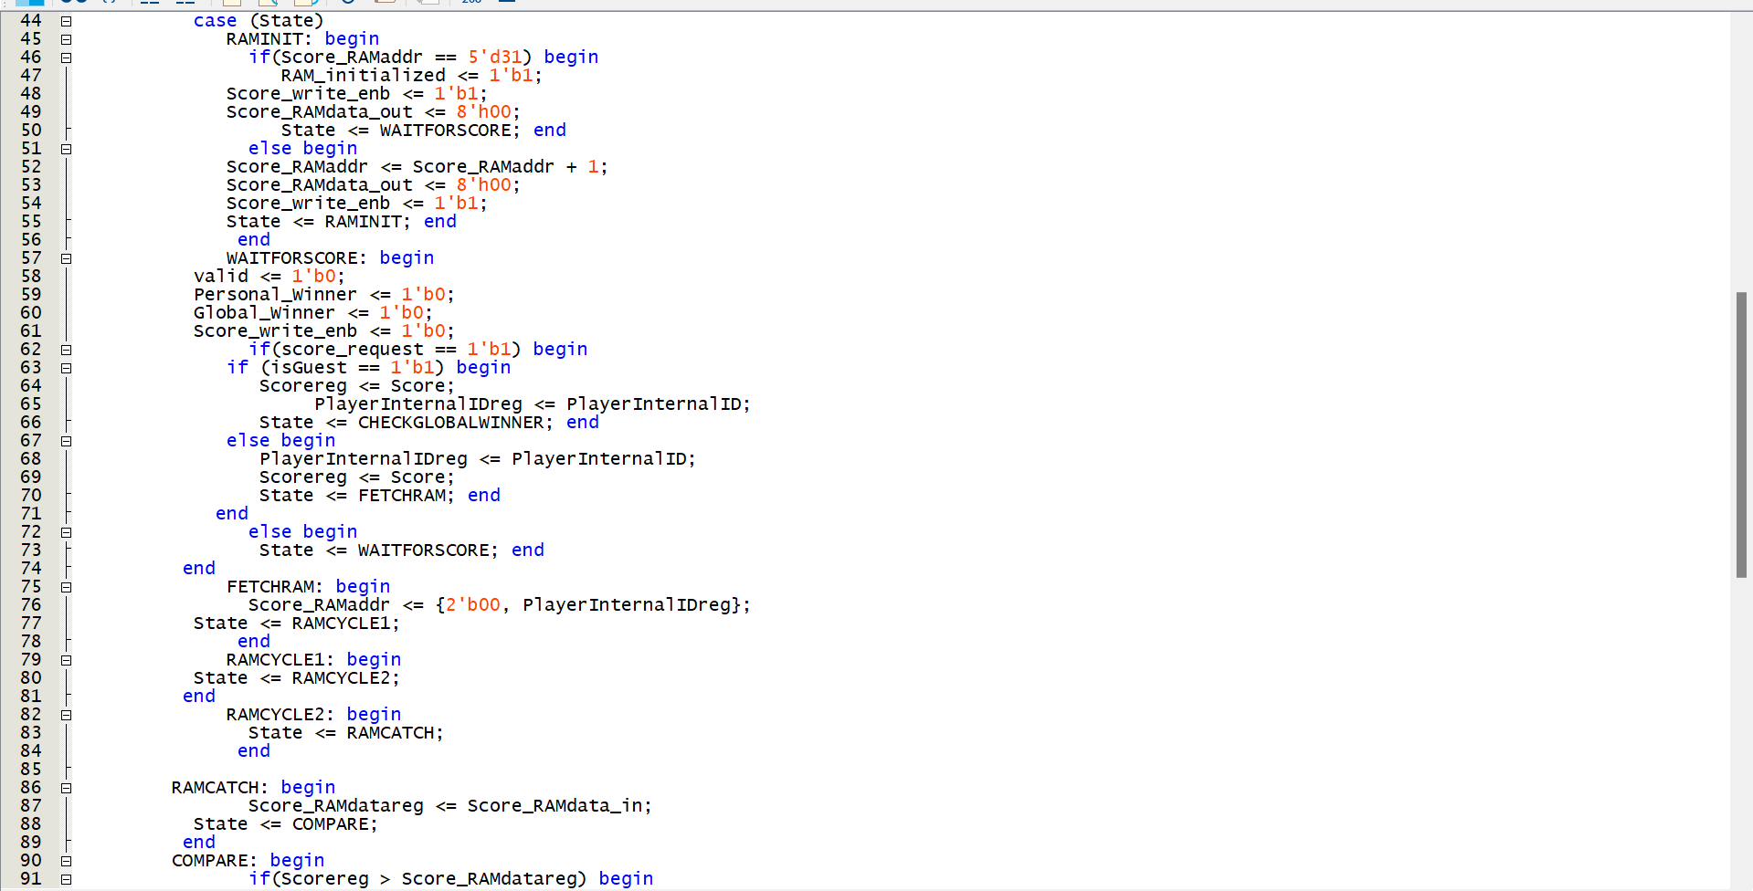

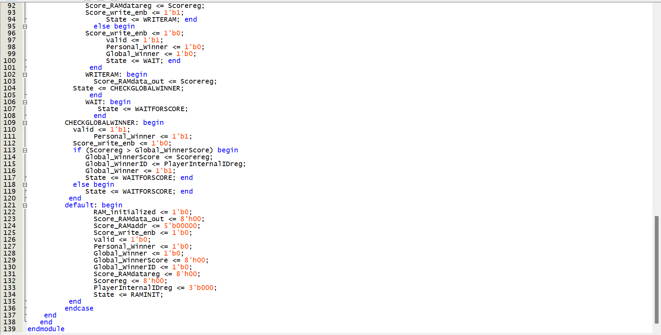

score Tracking

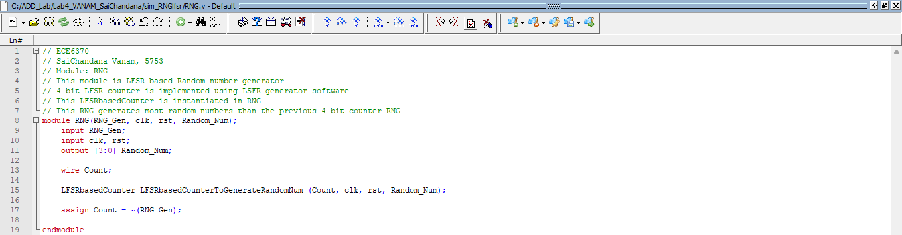

RNG Module.

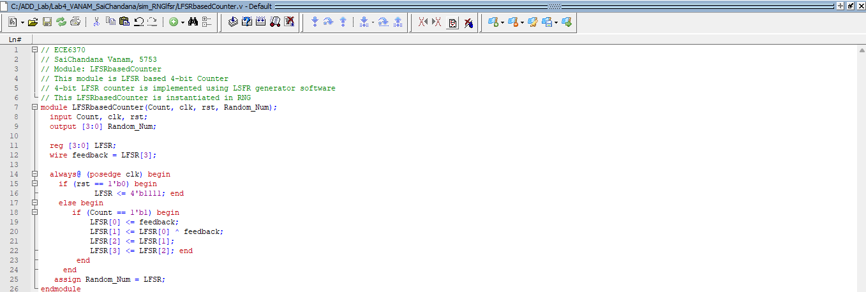

LFSRbasedCounter Module.

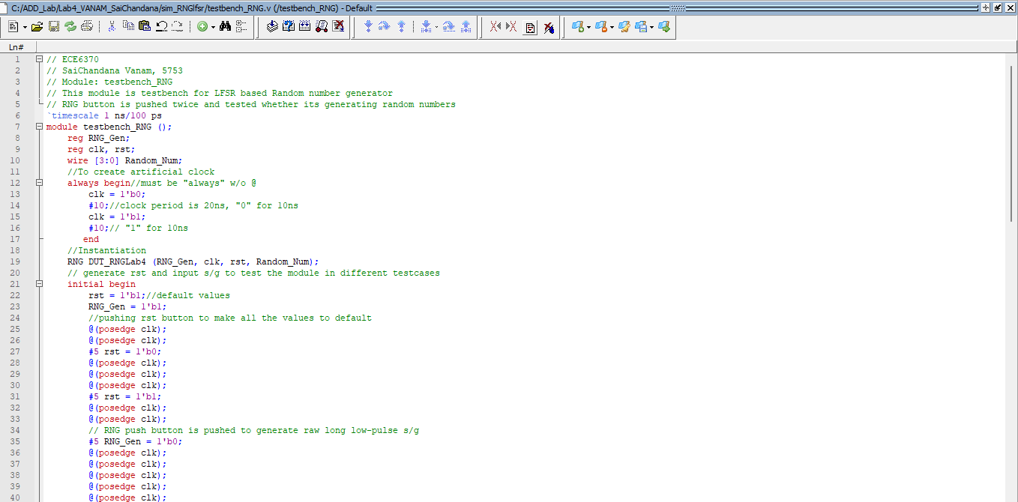

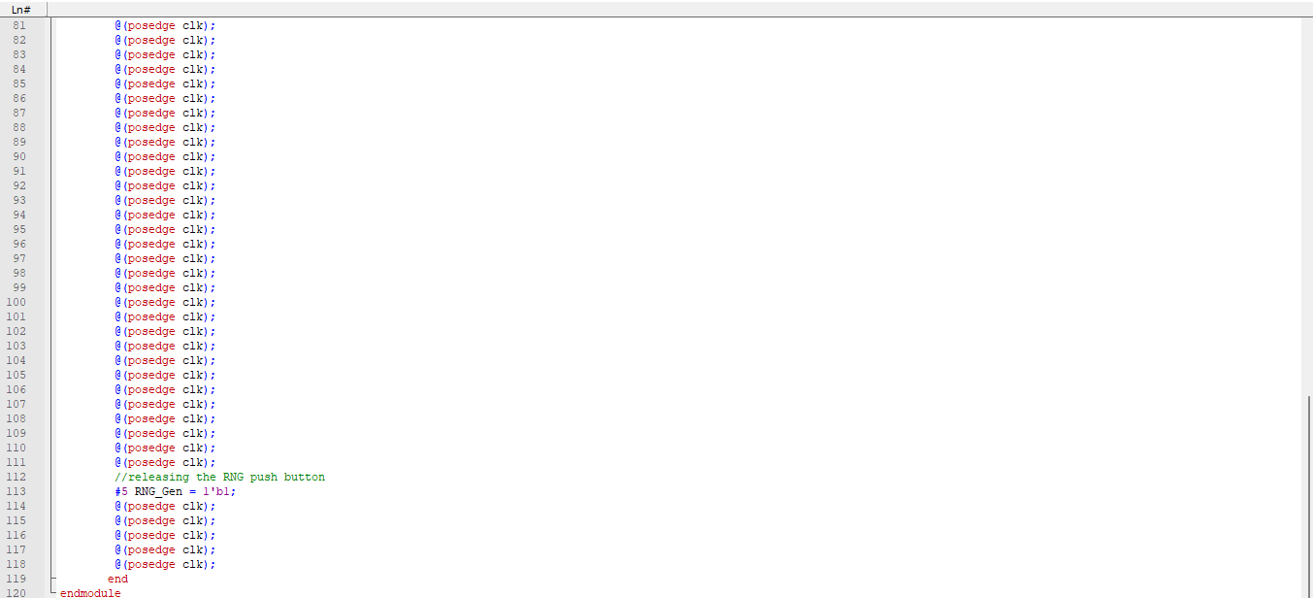

RNG testbench Module.

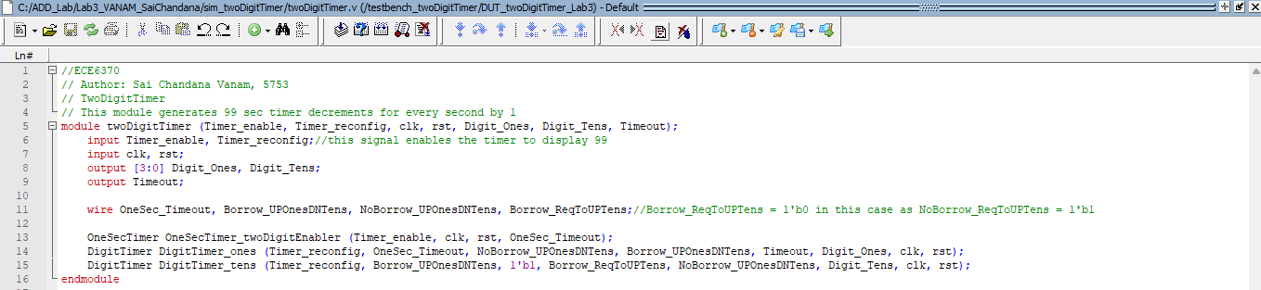

twoDigitTimer Module.

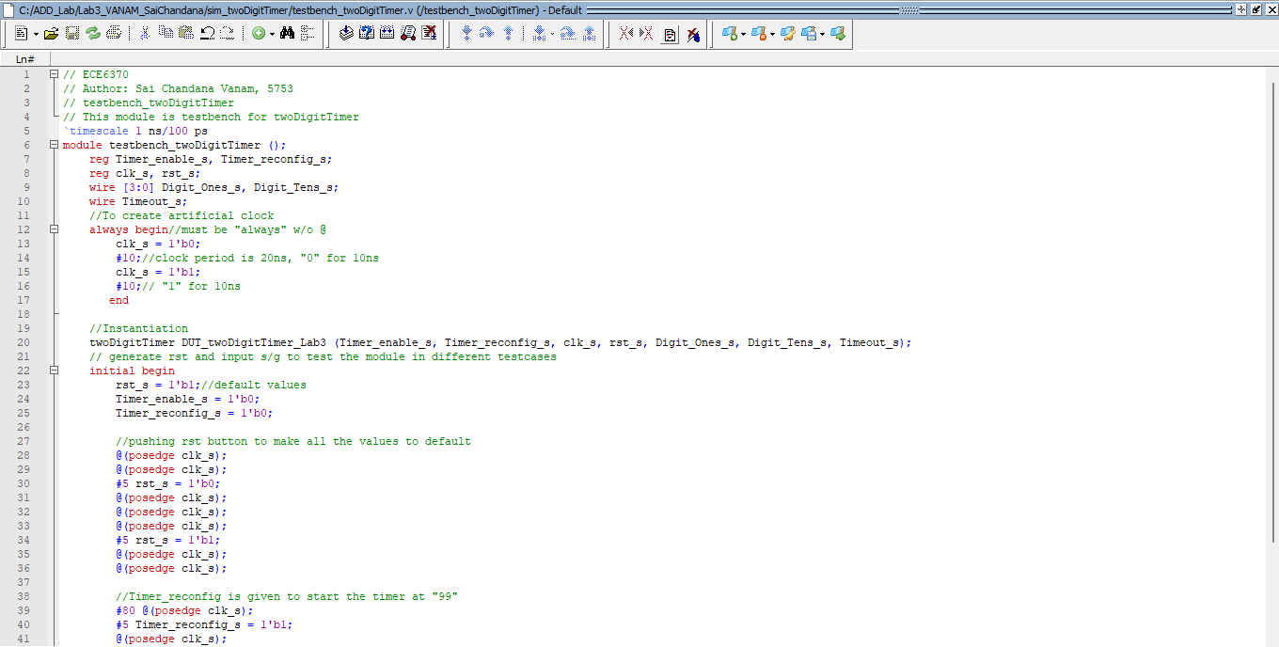

twoDigitTimer testbench Module.

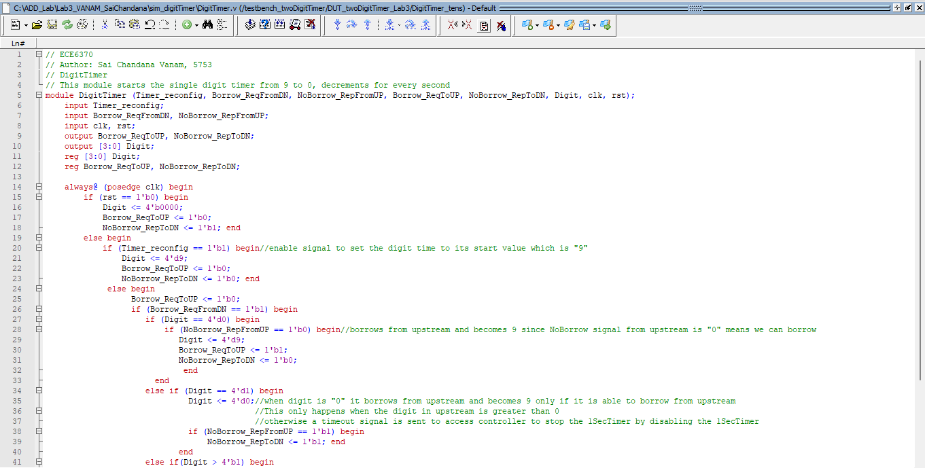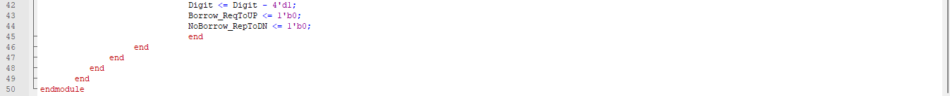

DigitTimer Module.

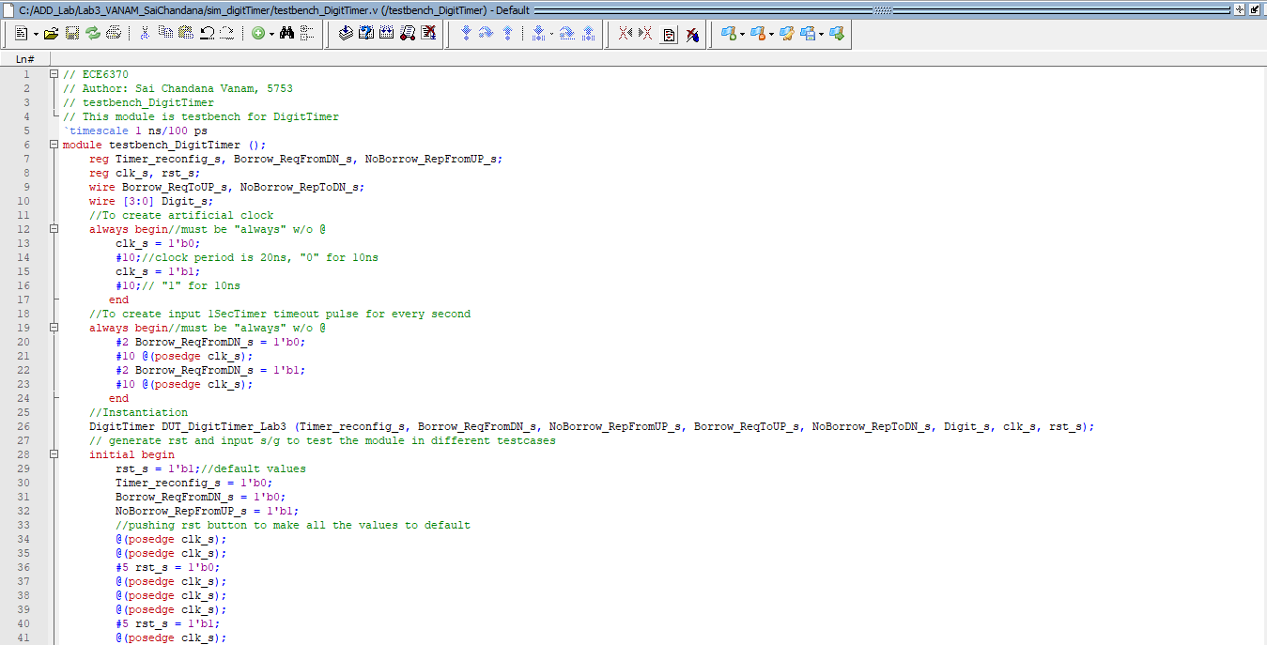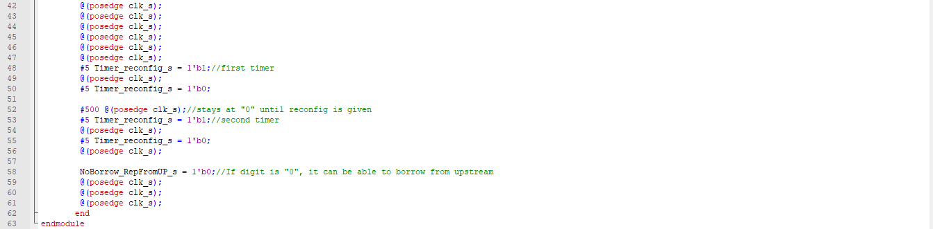

. DigitTimer testbench Module.

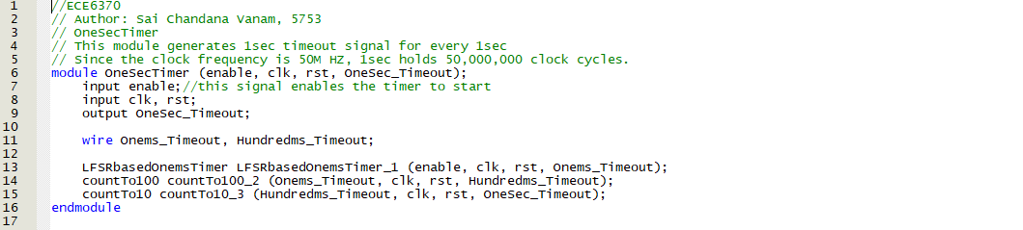

OneSecTimer Module.

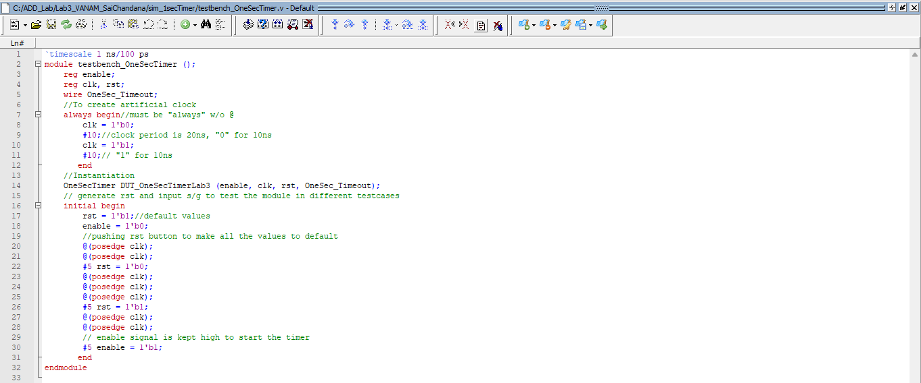

OneSecTimer testbench Module.

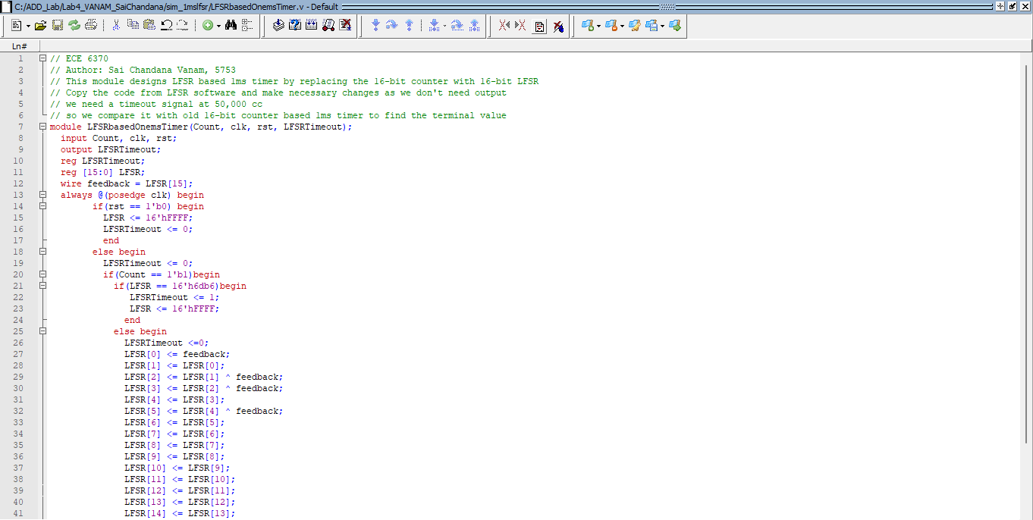

.

LFSR based OnemsTimer Module.

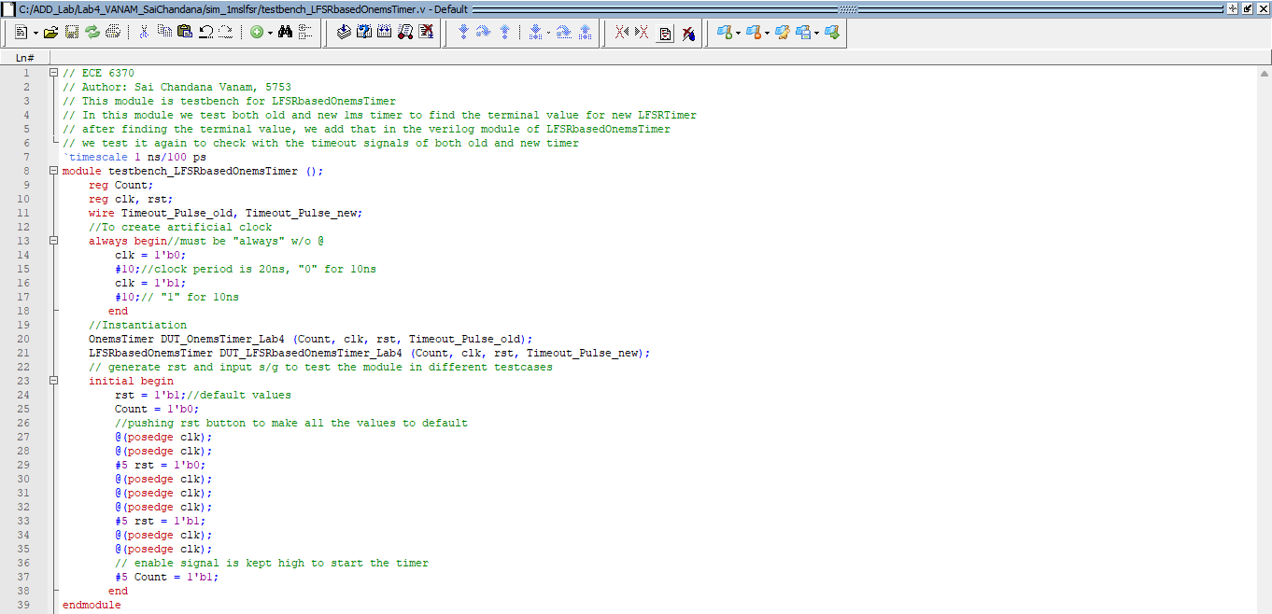

LFSRbasedOnemsTimer testbench Module.

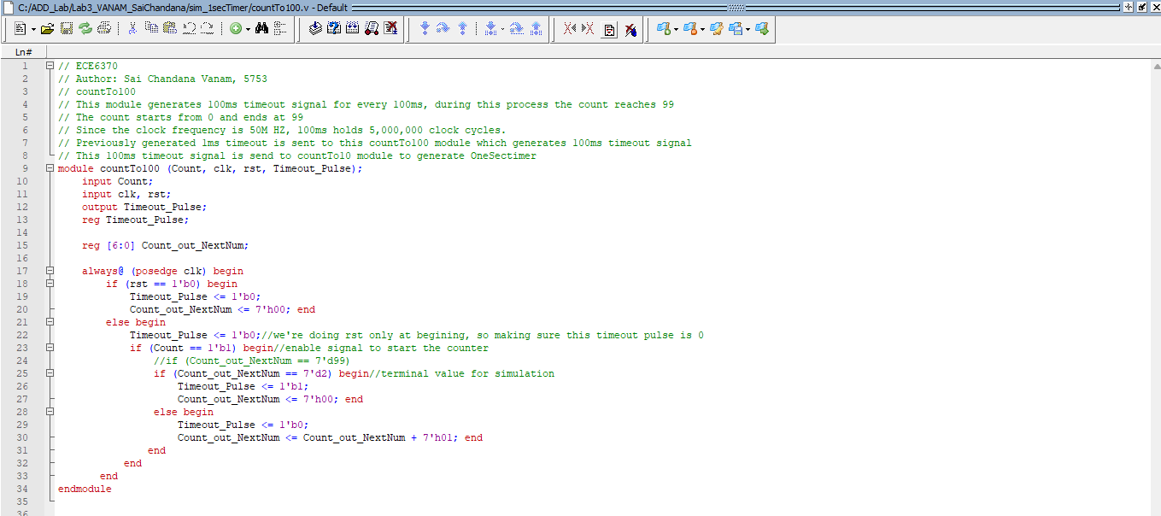

countTo100 Module.

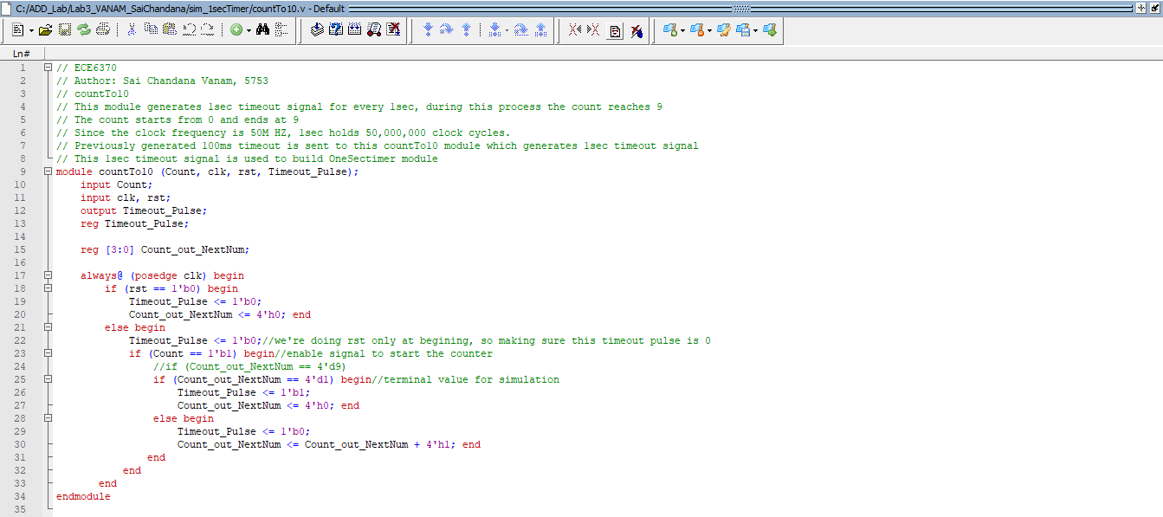

countTo10 Module.

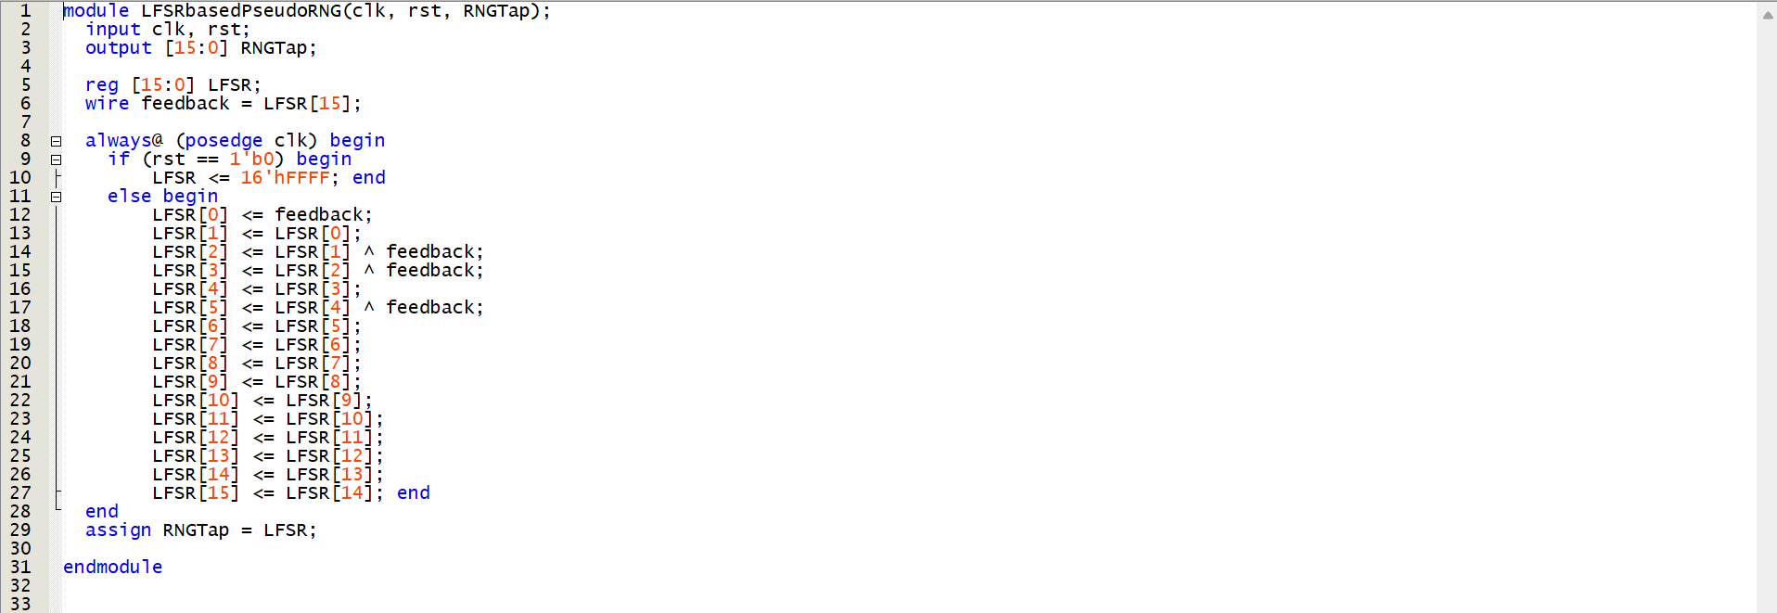

LFSR based Pseudo RNG

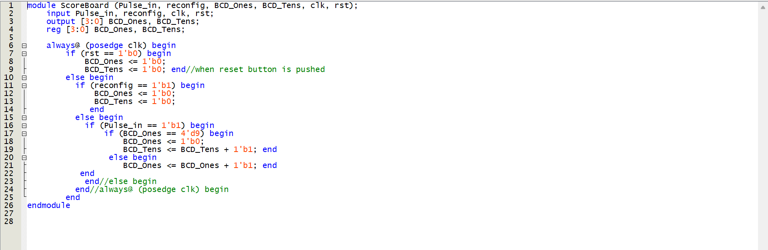

Scoreboard

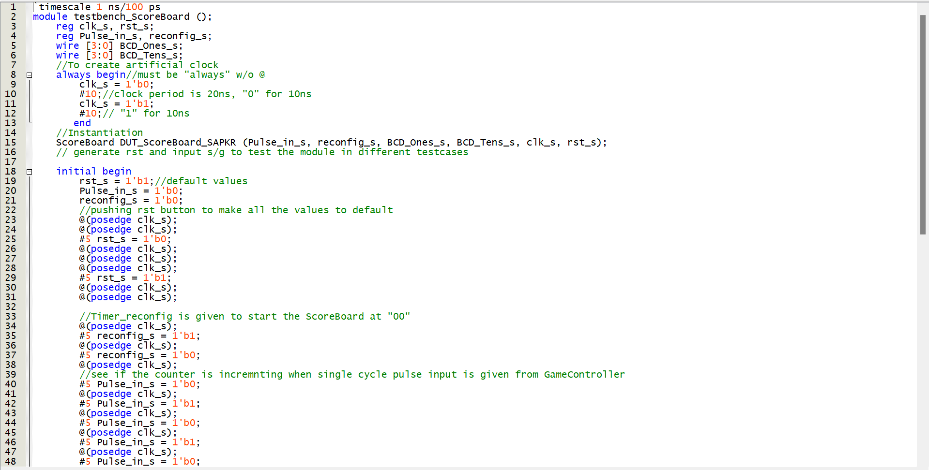

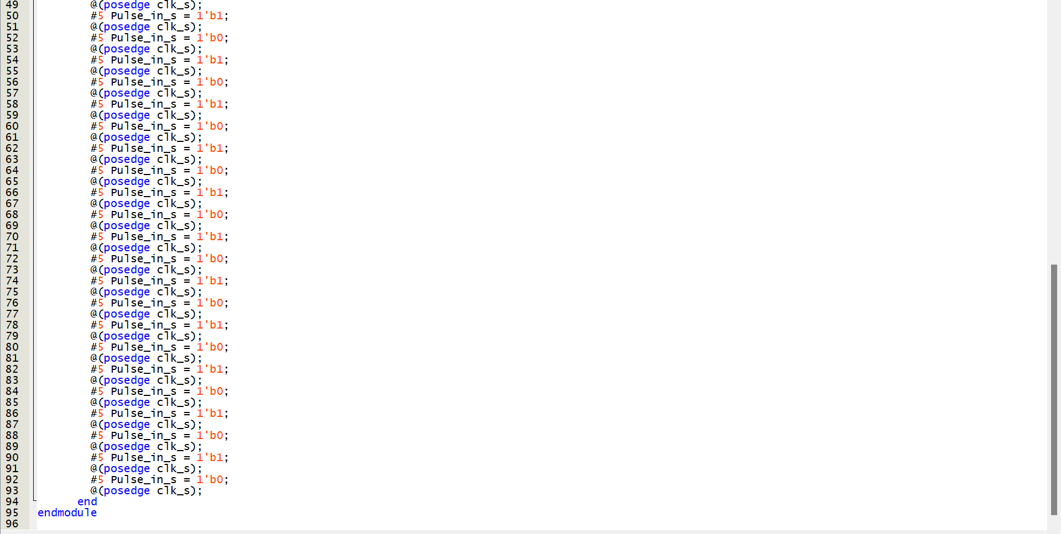

Testbench Scoreboard

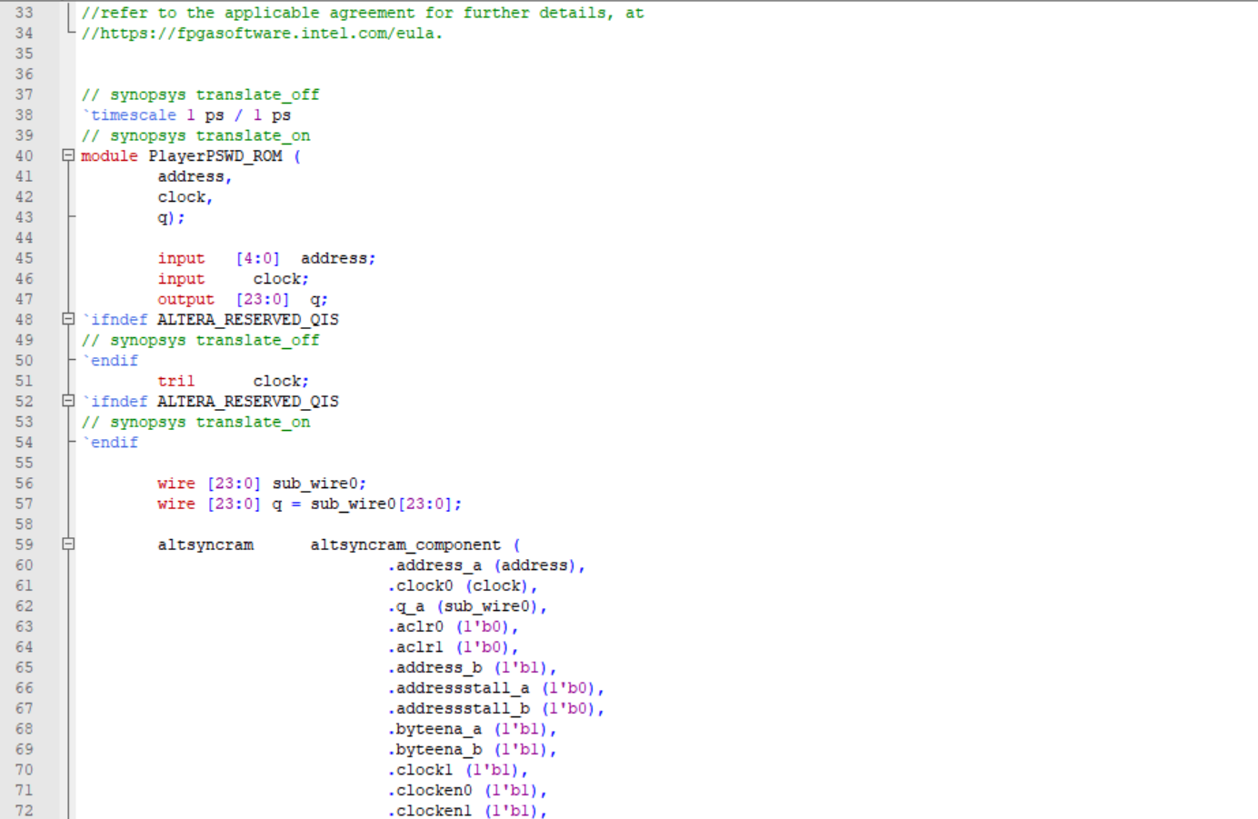

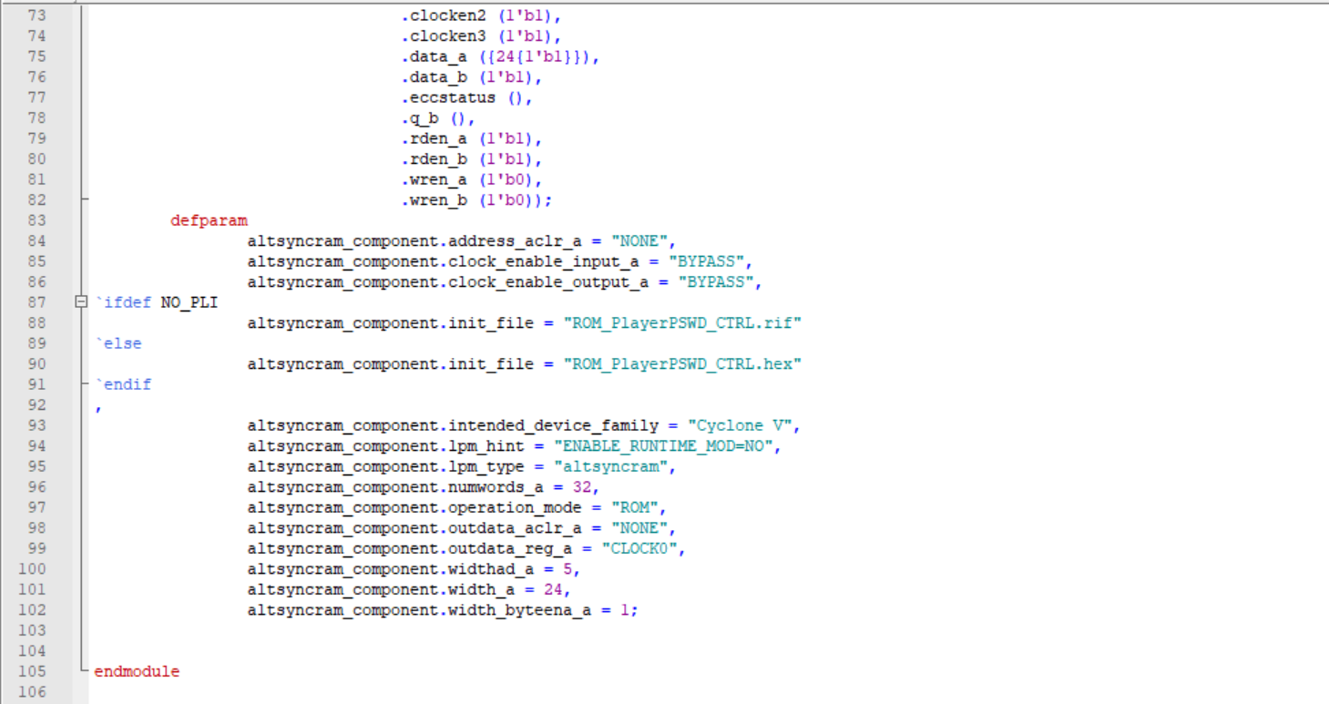

Player PSWD_ROM

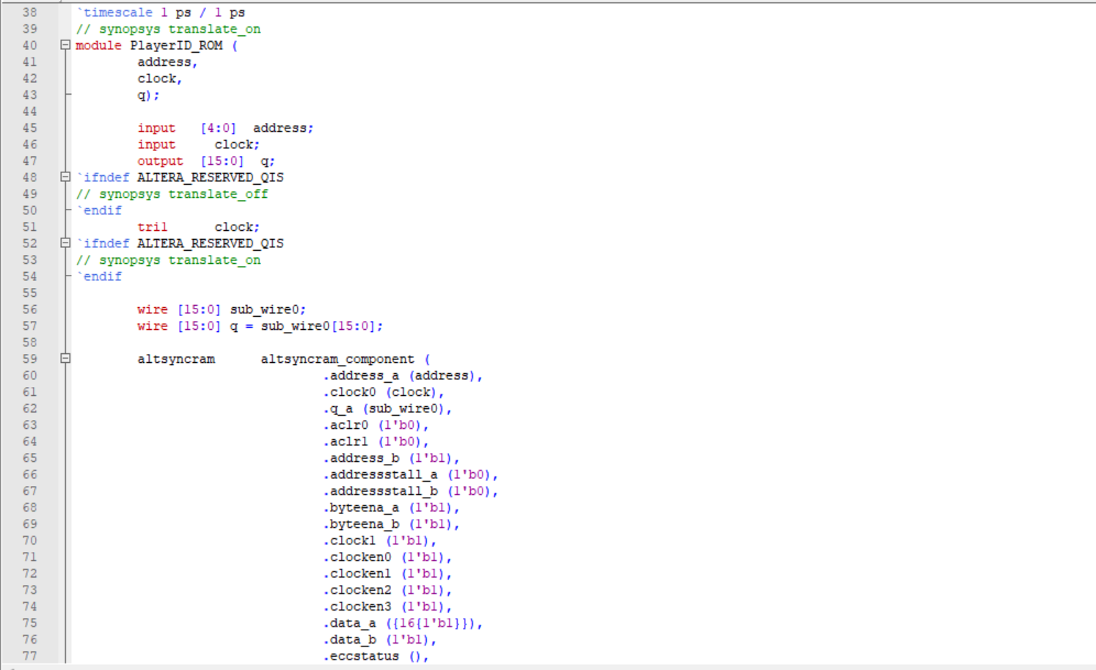

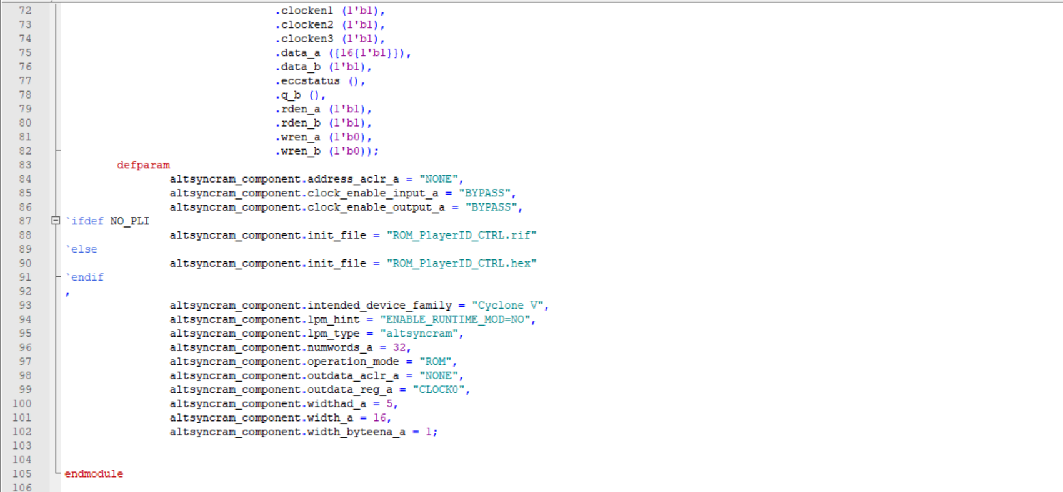

Player ID_ROM

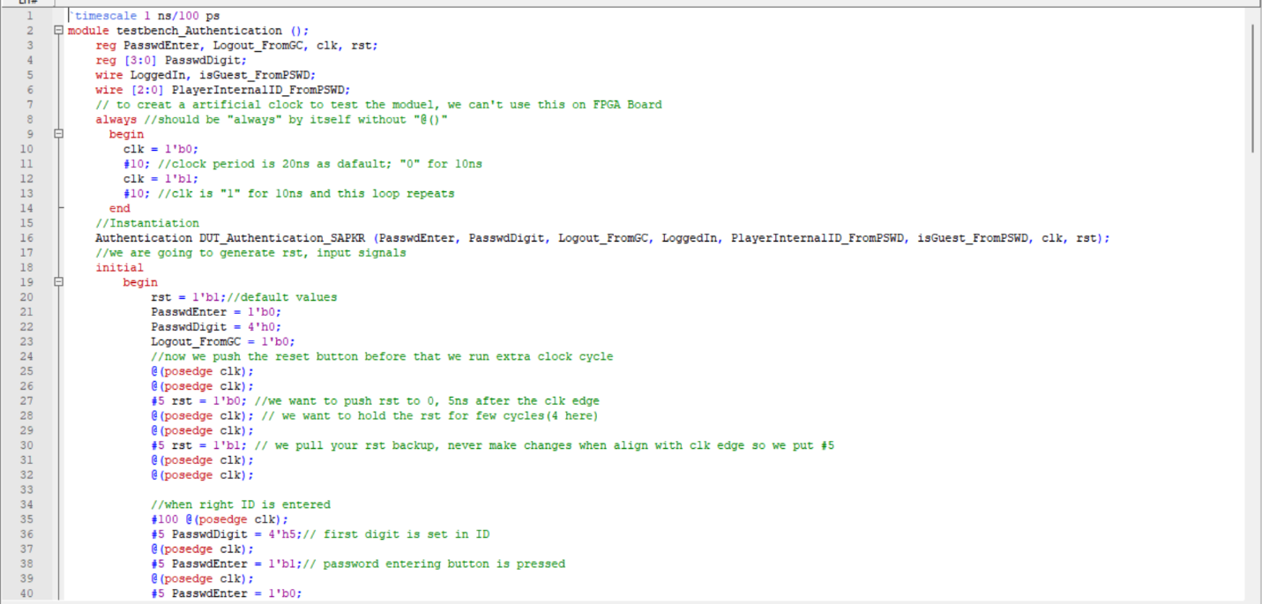

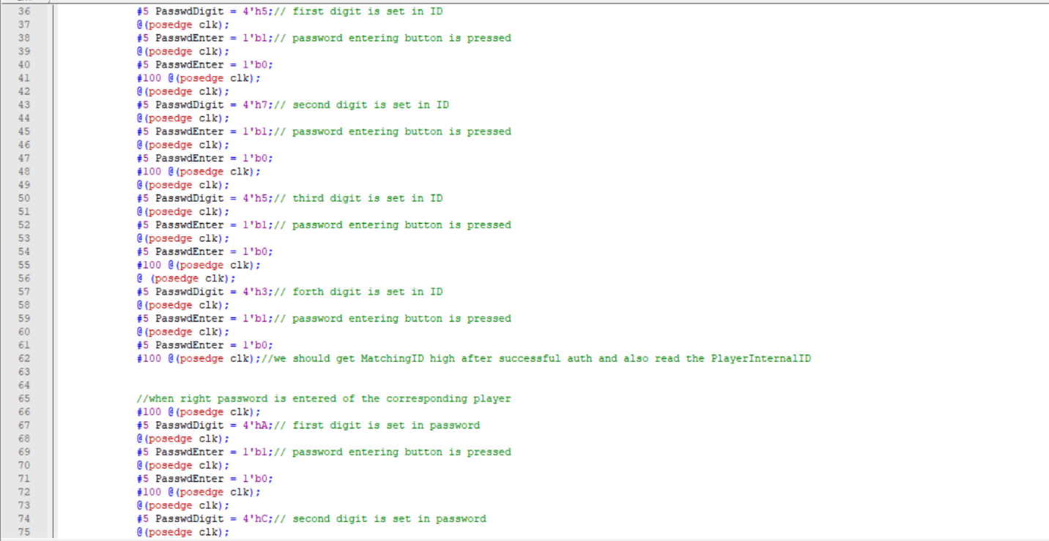

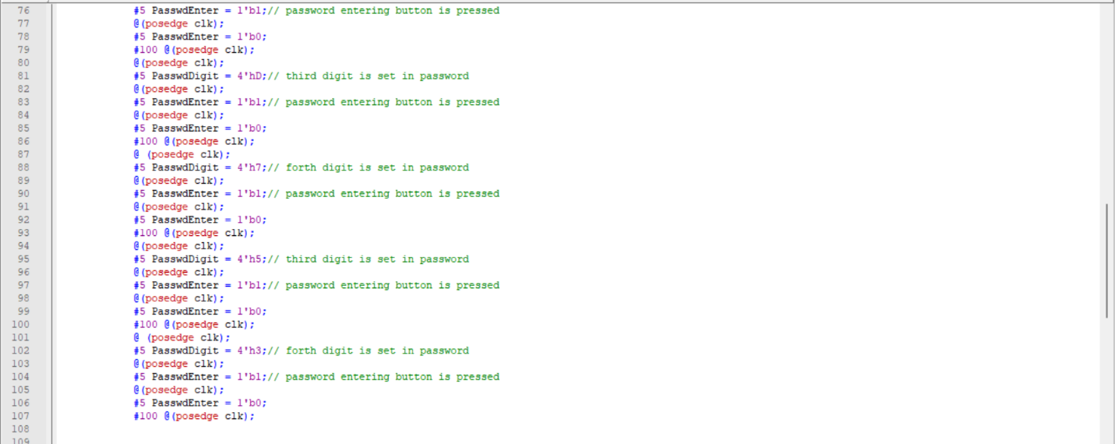

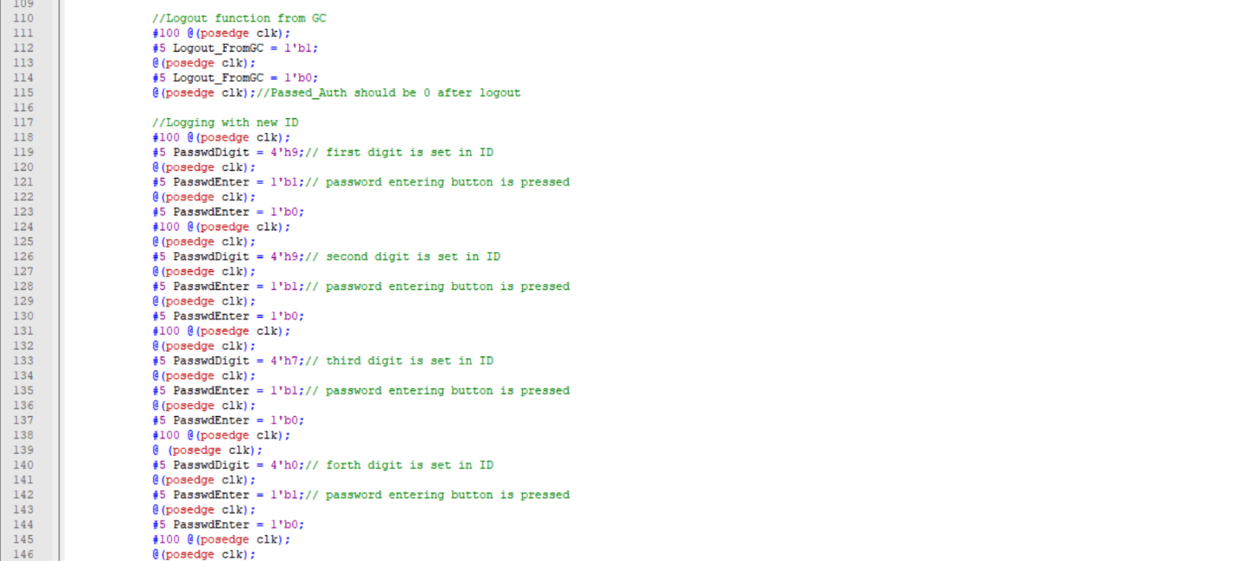

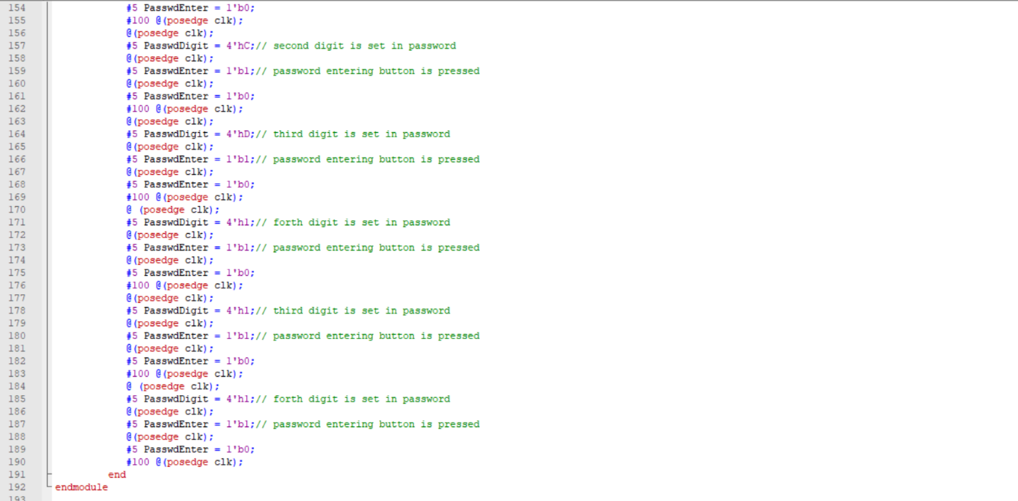

Testbench_Authentication

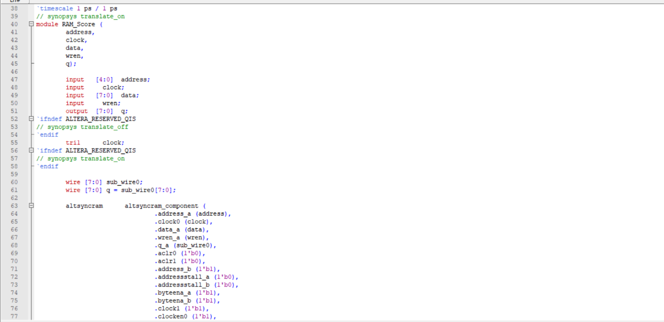

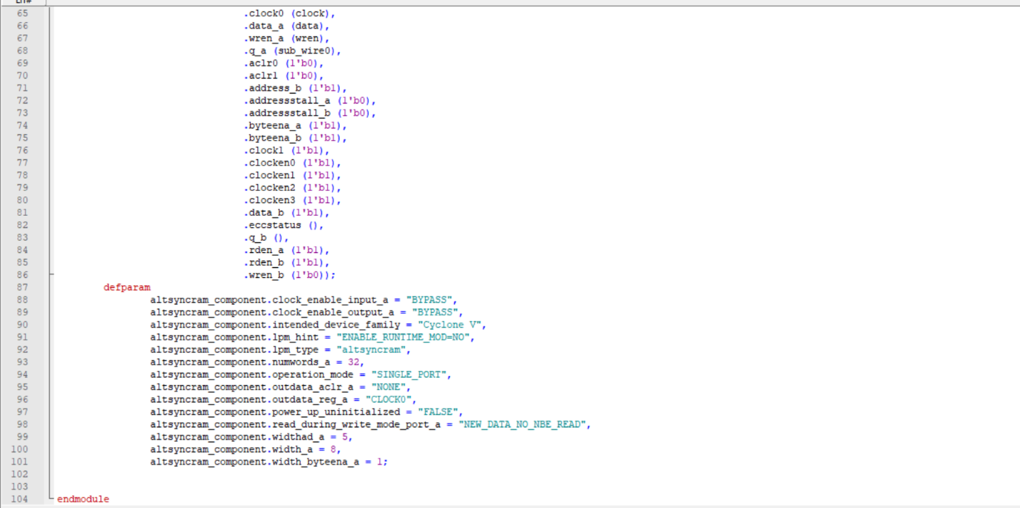

RAM_Score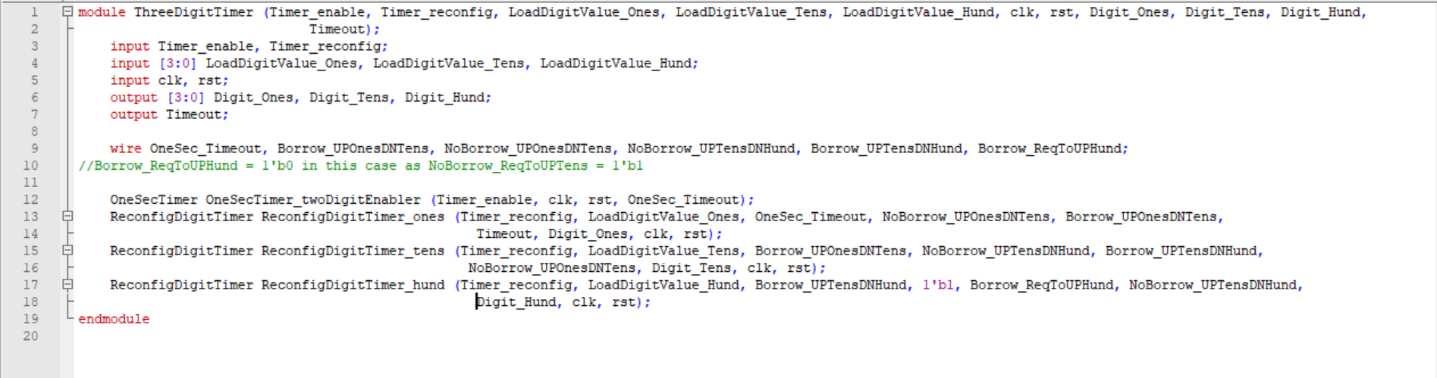

ThreeDigitTimer

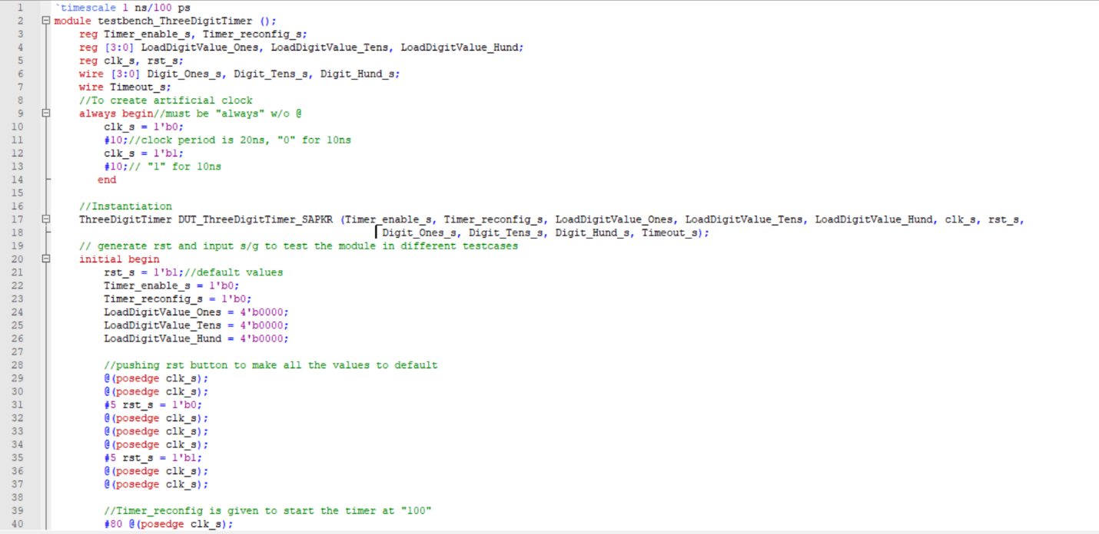

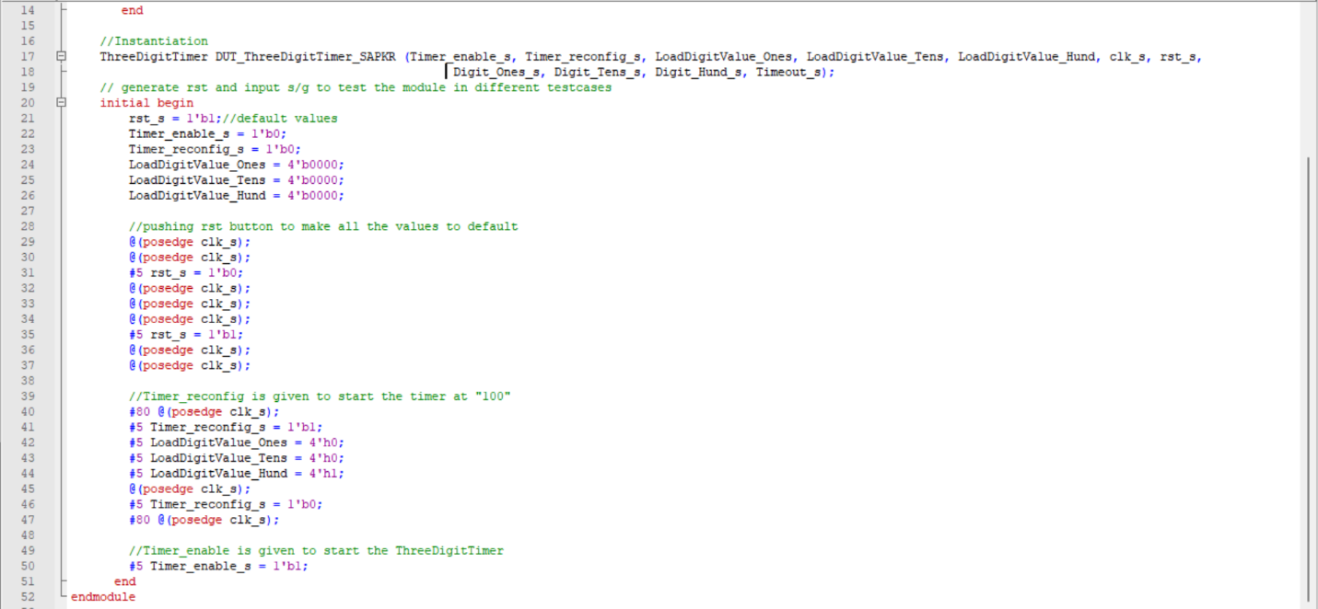

Testbench_ThreedigitTimer